PRACTICUM-1

**Contact Tracing System for Epidemiologists and Epidemiological Research**

**Aman Batra**

**NUID: 001877232**

**Class: CS5200**

**Academic Term: Summer-2, 2020**

**Instructor: Dr. Martin Schedlbauer**

**Email** : [Batra.am@northeastern.edu](mailto:Batra.am@northeastern.edu)

**Individual Submission**

**GITHUB Repository** :<https://github.com/predictbay/amancs5200>

**1. Problem Definition - Contact Tracing**

**1.1 What is Contact Tracing?**

According to WHO: Contact tracing is the process of identifying, assessing, and managing people who have been exposed to a disease to prevent onward transmission.

**1.2 What is the purpose of Contact Tracing?**

When systematically applied, contact tracing will break the chains of transmission of COVID-19 to prevent future waves or surges of cases, and to enable us to get back to work in a much safer way. Contact Tracing is an essential public health tool for controlling the virus.

**1.3 How does Contact Tracing work?**

Contact tracing for COVID-19 requires identifying people who may have been exposed to COVID-19 and following them up daily for 14 days from the last point of exposure.

The goal is to create a spider web of coronavirus transmission

Multiple Approaches To Trace Contacts:

1. An application approach, Continuous subject monitoring and data gathering is achieved using a mobile-application. Patients use the application to self-assess symptoms and report their interactions with other contacts, which can then be notified via the app, and put in incubation. For Example, a portable contact tracing application with real-time threat notifications based on GPS location/Bluetooth tracking, daily self-assessments, and contact reporting.
2. A general approach, where infected person contacts local Public Health Authorities and notifies them, PHAs then takes report of the person via calls & interviews, and prescribes test or medical assessments. Daily reports and health updates are taken by the assigned personnel until the incubation period is active. All the contract tracing is done manually by the PHAs, who then feed the data into a central reporting system.
3. A combined approach, where both self-assessments and manual assessments are possible. Patients choose if they would like to contact and schedule meetings with PHAs or prefer the use of a real-time contact tracing app regularly. PHAs gather and anonymise all the data, and put it in a graph database. The graph databases are then analysed to create heatmaps of the COVID-19 affected areas, which are later turned into containment zones.

**2 Most Efficient Approach - Contact Tracing**

**(Combined Approach)**

**Combined approach assumes that the local, regional, or national Public Health body of a geographical area, has offered three ways, to keep a check on COVID-19 epidemic: a mobile application, a website, and a dedicated COVID-19 helpline to implement contact tracing measures.**

1. **Automated**: A self-assessment and self-reporting based portable application, capable of running on multiple types of devices such as mobile phones, tablets, and laptops with real-time geolocation and Bluetooth based proximity tracing of other users, running the same application of their devices. Each user’s ***HealthStatus*** tokens are broadcasted within a 30 metres radius, and every user of the application in the proximity range will receive these tokens. If a sick user is nearby, all the users in the vicinity will get a threat alert. The total interaction time or visit time of a user will be recorded whenever he or she, meets or passes by, a sick person, or visits a place. If a user is not feeling and suspects that he or she might have been exposed to COVID-19, then there is a self-assessment option which contains a predefined set of questions, that can predict the likelihood of infection. If the assessment score bypasses the defined threshold, all users in the vicinity are notified of potential threat; Local health authority(LHA) is notified via the application. The LHA then prescribes a suitable COVID-19, and if the user tests positive, an incubation period of 14 days is initiated, which contains daily self-assessments, self-quarantining, and self-reporting of every place visited, every person in touch, and every notable interaction made within the past 14 days.

1. **Semi-Automated:** Some users have privacy issues when it comes to using applications that continuously record user data, and keep surveillance over their activities. For such users, a website or a similar app without monitoring is a better option, to implement contact tracing. When such a user feels sick, he can go to the LHA website, and take a self-assessment test, if the test results indicate potential infection, their identity is anonymised and location data is fed into the central database(common to all strategies). The user has to take a daily self-assessment until he or she is marked ‘healthy’ again, and all the contact reporting is done on the website. The central database is used to create heatmaps of coronavirus stricken areas, the website users can manually check the heatmap zones online, whereas it is inbuilt in the application.
2. **Manual:** For users, who have no viable means to use the website or application, there is a dedicated helpline number, which takes care of daily assessments, and contact reporting. Things are done manually, via phone conversations or administered meetings, and all the gathered data is then manually uploaded to the database.

**3.Database Tools Specification**

**Overview**

The database for a Contact Tracing system is can be implemented using many relational and non-relational DBMS such MySQL, PostgreSQL, MongoDB, Neo4j, Oracle DB. Parts of the project can be implemented using graph-databases, because they will be best suited for running depth queries and discovering links at greater depths, but for this particular Practicum, we will be using MySQL as a DBMS tool ubiquitously, and R Studio for running Analytics. MySQL has many advantages and some limitations, as given below:

**Advantages of MySQL**

1. Open source, inexpensive and readily available.
2. Industry Standard, and very popular.
3. Extensive support available online.
4. Ease, Intuitiveness and Usability
5. Outstanding InnoDB engine.

**Drawbacks**

1. Scalability issues can arise with time.
2. Not very easy to debug.
3. Does not support very large databases efficiently.

**Advantages of R**

1. Open source, Platform Independent
2. Rapid, and quality plotting
3. Non-Coder friendly, anyone can start plotting within a hours
4. Rich and continuously growing sets of packages (>10000) in the CRAN repository

**Drawbacks**

1. R Utilizes more memory as objects are stored in the memory.
2. Slower than other programming languages like Python and Matlab
3. Does not support very large scale applications efficiently.

**4. Overall Assumptions & Constraints.**

**Assumptions:**

1. Only some parts of the whole application will be reflected in the relational database, some data will stored locally on the host devices, such as state variables, local variables, events data, device permissions details, etc.
2. There can be many use cases, but the database is designed keeping in mind only some of these use cases, hence some parts of the database can be missing For Example. The assessment-survey module can have 4 more classes, but we are only using one for now.
3. The depth of queries will be set to 5, because MySQL is not a graph-database, it takes a good amount of time and processing power to create Joins, and make connections.
4. Application logic and host application will be created at a later time.

**Constraints:**

* **Domain Level:**

**1.** **Varchar** for string data

**2.** **Integer** for whole numbers

**3.** **Boolean** for binary choices (True or False, Yes or No, Correct or Incorrect, these kind of choices will be implemented using 0s & 1s

**4.** **Enum** for Lists or categorical attributes

**5.** **Text** for descriptions

* **Referential Integrity:**

**1.** *Place* extends to *Interactions, AppUser, Visits, PublicHealthAuthority*

**2.** *Person* extends to *AppUser* and *PublicHealthWorker*

**3.** *AppUser* extends to *Place, Interactions, Assessment, HealthReportCheck* and *Person*

**4.** *UserEvents* extends to *Visits*, *Interactions* and *ContactHistoryLog*

**5.** *PersonNotification, AppUserEmail, PersonPhone* are linking tables.

* **Entity Integrity**

1. All classes have primary keys, all primary keys are set to NOT NULL
2. Key constraints are enabled SET FOREIGN_KEY_CHECKS = 1

**5.UML Class Diagram**

**Conceptual Model Link** 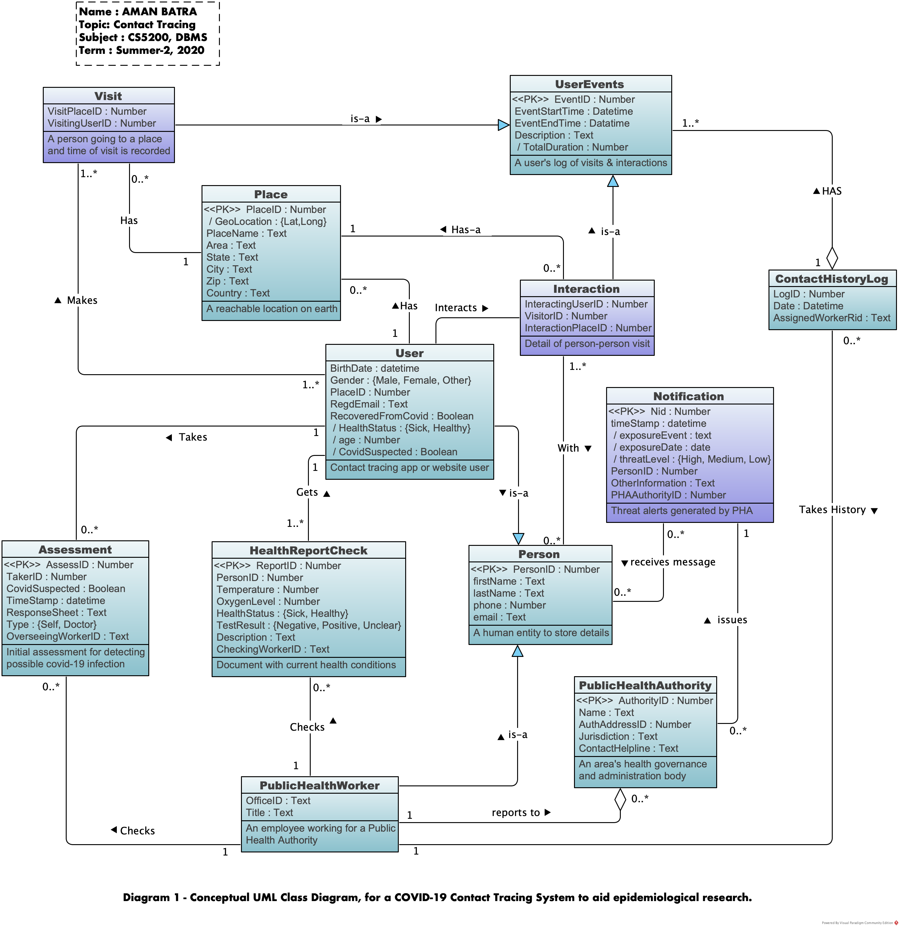

**Design Tool Used: Visual Paradigm Community Edition for Mac**

**Link to Files:** <https://github.com/predictbay/amancs5200>

**6. Entity Relationship Diagram**

**Link to LucidChart**: [“Logical Model LUCIDCHART Link”](https://app.lucidchart.com/documents/view/982d3b7d-538a-4993-9511-126f0853bb6e/0_0)

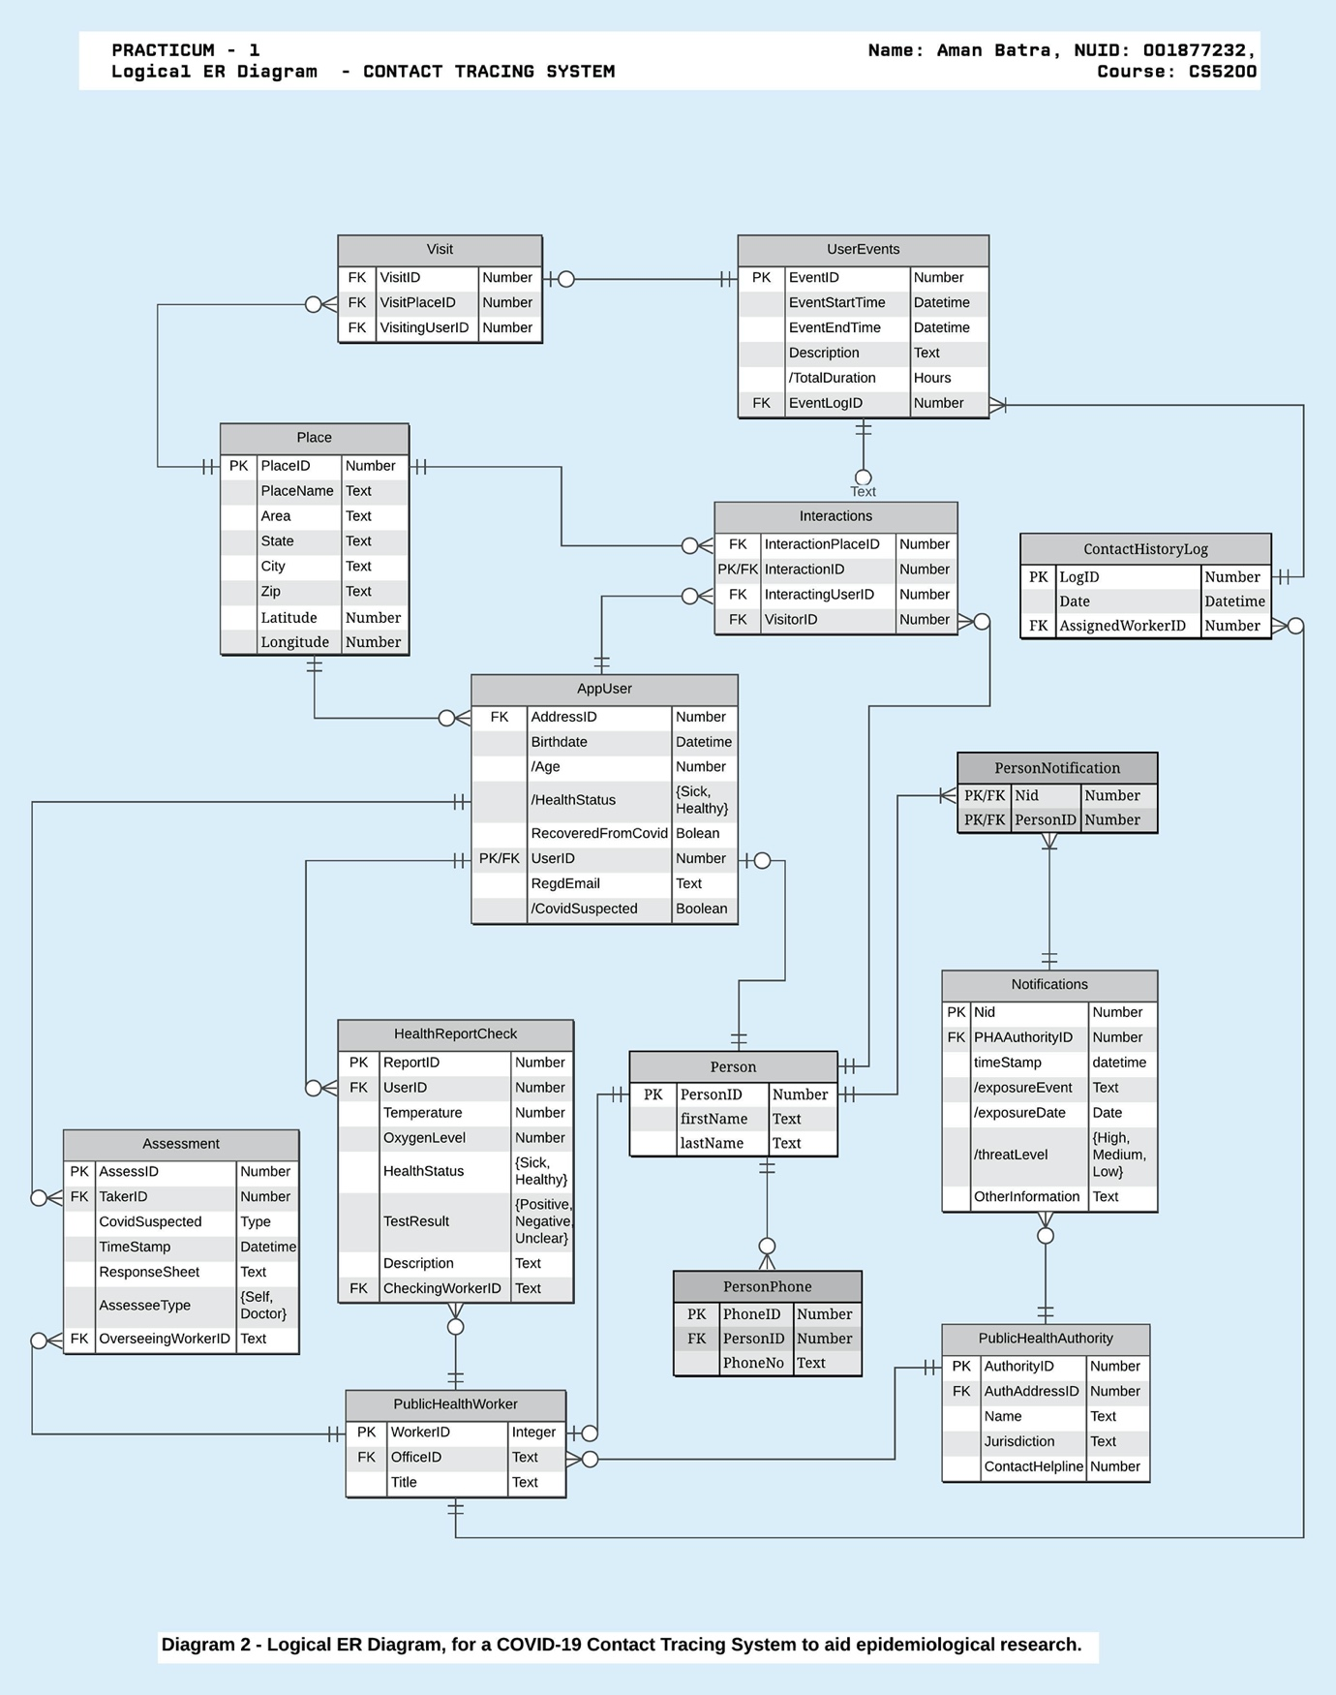

**7.** **Schema Generation & Normalization Check Results**

**Relational Schema:**

Place(*placeint* ,placename,streetarea,city,state,zip,latitude,longitude)

Person(*PersonID*,firstName,lastName)

PersonPhone(PhoneNo,PersonID)

AppUser(*UserID*,*AddressID*,RecoveredFromCovid)

AppUserEmail(EmailID, UserID)

PublicHealthWorker(WorkerID*,*title,*officeID* ,PublicAuthID)

PublicHealthAuthority(*AuthorityID* ,AuthAddressID,Name,Jurisdiction)

PublicHealthAuthorityHelpline(HelplineNo,AuthorityID)

UserEvent(*EventID*,EventStartTime,EventEndTime,Description)

Visits(VisitID,VisitingUserID,VisitPlaceID)

Interactions(InteractionID ,interactingUserID,VisitorID,InteractionPlaceID)

Notifications(*Nid* ,PHAAuthorityID,timestamp,OtherInformation)

HealthReportCheck(*ReportID* ,UserID,Temperature,OxygenLevel,HealthStatus,TestResult,Descriptions,CheckingWorkerID, ReportDate)

Assessment(AssessID,TakerID,CovidSuspected,TimeStamp,ResponseSheet, AssesseeType, OverseeingWorkerID)

PersonNotification(Nid, PersonID)

**Normalization to BCNF**

This following table lists out every relation in the database and provides proof to make sure its in BCNF. There Is no need to prove lower normal forms like 1NF, 2NF and 3NF because, if a relationship in BCNF, it IMPLIES that it is already normalized in lower forms.

The relationships shows below, comply with all of the following criterion, needed for validating BCNF.

1. Every relationship has a valid candidate key as their determinants( All determinants are candidate keys)
2. There is no partial dependency of any kind
3. No composite candidate keys with overlapping attributes
4. No multivalued attributes exist
5. No transitive dependency.

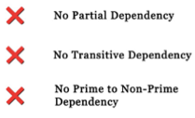 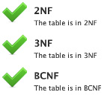

1

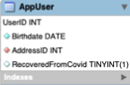

“AppUser”

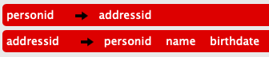 UserID=>addressid UserID=>=>name UserID=>birthdate

* **UserID** is a candidate key and Primary key which uniquely identifies Birthdate, AddressID, RecoveredFromCovid.
* **AddressID** is a Candidate Key, because it can uniquely identify an AppUser
* No Partial Dependency or Multivalued Attribute exist in this relationship
* There is no non-trivial FD without a candidate key. Hence table is in BCNF

2

“AppUserEmail”

“AppUserEmail”

EmailID -> UserId

* **UserID** is a candidate key and Primary key which uniquely identifies Birthdate, AddressID, RecoveredFromCovid.
* **AddressID** is a Candidate Key, because it can uniquely identify an AppUser
* No Partial Dependency or Multivalued Attribute exist in this relationship
* There is no non-trivial FD without a candidate key. Hence table is in BCNF

3

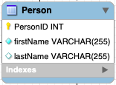

“Person”

“BCNF” PersonID=>firstname PersonID=>lastname

* **PersonID** is a candidate key and Primary key which uniquely identifies firstname, lastname
* No Partial Dependency or Multivalued Attribute exist in this relationship
* There is no non-trivial FD without a candidate key. Hence table is in BCNF

4

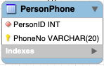

“PersonPhone”

“BCNF” PhoneNo=>PhoneID - **PhoneNo** is a candidate key and Primary key which uniquely identifies PersonID - PersonID is not unique here because a user can have multiple phone numbers. - No Partial Dependency or Multivalued Attribute exist in this relationship - There is no non-trivial FD without a candidate key. Hence table is in BCNF

5

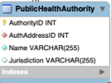

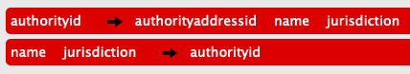 AuthorityID=>AuthAddressID AuthorityID=>Name AuthorityID=>Jurisdiction

* **authorityid** is a candidate key and Primary key which uniquely identifies all other attributes
* name, jurisdiction for a secondary relationship that can identify authorityid
* No Partial Dependency or Multivalued Attribute exist in this relationship
* There is no non-trivial FD without a candidate key. Hence table is in BCNF

6



 helplineno=>authoritid - **helplineno** is a candidate key and Primary key which uniquely identifies AuthorityID, because a number cannot be shared by multiple authorities in our assumption - authorityID has multiple numbers hence not unique to relationship - No Partial Dependency or Multivalued Attribute exist in this relationship - There is no non-trivial FD without a candidate key. Hence table is in BCNF

7

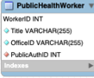

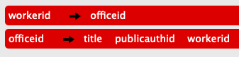 Workerid => officeid Workerid => Title Workerid => publicauthid - **WorkerID** is a candidate key and Primary key which uniquely identifies Title, OfficeID, publicauthID - **OfficeID** is a candidate key which uniquely identified the PK - PubliAuthID has multiple workers so not unique to relationship - No Partial Dependency or Multivalued Attribute exist in this relationship - There is no non-trivial FD without a candidate key. Hence table is in BCNF

8

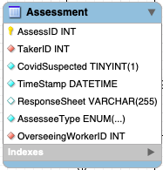

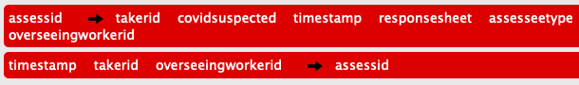 AssessId=>takerid AssessId=>covidsuspected AssessId=>timestamp AssessId=>responsesheet AssessId=>assesseetype AssessId=>overseeingworkerid - **WorkerID** is a candidate key and Primary key which uniquely identifies all the attributes - Same TakerID is on multiple assessments so not unique to relationship - Timestamp, takerid and overseeingworkerid form a secondary relationship (non-primes to key) - No Partial Dependency or Multivalued Attribute exist in this relationship - There is no non-trivial FD without a candidate key. Hence table is in BCNF

9

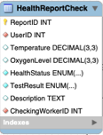

 ReportID=>userid ReportID=>temperature ReportID=>oxygenlevel ReportID=>healthstatus ReportID=>testresult ReportID=>description ReportID=>checkingworkerid ReportID=>reportdate

* **ReportID** is a candidate key and Primary key which uniquely identifies all the attributes
* Same UserID is on multiple Reports so not unique to relationship
* No Partial Dependency or Multivalued Attribute exist in this relationship
* There is no non-trivial FD without a candidate key. Hence table is in BCNF

10

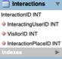

 InteractionID=>interactinguserid InteractionID=>interactingplaceid InteractionID=>visitid

* **InteractionID** is a candidate key and Primary key which uniquely identifies all the attributes
* Same InteractingUseID, VisitorID and InteractionPlaceID can exist on multiple interactions so not unique to relationship
* No Partial Dependency or Multivalued Attribute exist in this relationship
* There is no non-trivial FD without a candidate key. Hence table is in BCNF

11

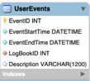

 eventid=>logbookid eventid=>description eventid=>eventstarttime eventid=>eventendtime - **EventID** is a candidate key and Primary key which uniquely identifies logbookid, description, eventstarttime, eventendtime - Same set of start time, end time and logbookid can exist in case the database is really large so they are not unique to relationship - No Partial Dependency or Multivalued Attribute exist in this relationship - There is no non-trivial FD without a candidate key. Hence table is in BCNF

12

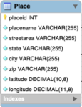

 placeid=>placename placeid=>streetarea placeid=>state placeid=>city placeid=>coountry placeid=>latitude placeid=>longitude - **placeid** is a candidate key and Primary key which uniquely identifies logbookid, description, eventstarttime, eventendtime - Same set of address and coordinates can exist in case for multiple persons sharing an address, so they are not unique to relationship - No Partial Dependency or Multivalued Attribute exist in this relationship - There is no non-trivial FD without a candidate key. Hence table is in BCNF

13

 Nid,PersonID - (Nid,PersonID) is the only candidate key and a primary key, no non-prime attribute exist, so no dependency - No Partial Dependency or Multivalued Attribute exist in this relationship - There is no non-trivial FD without a candidate key. Hence table is in BCNF

14

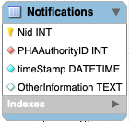

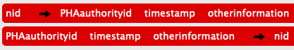 nid=>PHAauthorityid nid=>timestamp nid=>otherinformation - **nid** is a candidate key and Primary key which uniquely identifies PHAAuthorityID, timestamp, otherinformation - trivial attributes (phaauthorityid, timestamp, otherinformation) form a secondary relationship. (Non-prime to key) - No Partial Dependency or Multivalued Attribute exist in this relationship - There is no non-trivial FD without a candidate key. Hence table is in BCNF

15

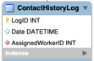

 logid=>date logid=>assignedworkerid - **logid** is a candidate key and Primary key which uniquely identifies date and assignedworker - AssignedWorkerID can exist on multiple logs, so it is not unique to this relationship - No Partial Dependency or Multivalued Attribute exist in this relationship - There is no non-trivial FD without a candidate key. Hence table is in BCNF

16

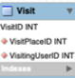

 visitid=>visitinguserid visitid=>visitplaceid - **VisitID** is a candidate key and Primary key which uniquely identifies VisitPlaceID and VisitingUserID - (VisitPlaceID,VisitingUserId) do not uniquely identify a visit because, there can be multiple visits, even on the same day - No Partial Dependency or Multivalued Attribute exist in this relationship - There is no non-trivial FD without a candidate key. Hence table is in BCNF

**8. Integrity Checking Trials & Proofs**

***1.)Referential Integrity : Foreign Key Check***

**Test #1**

Attempt to deleted a referenced record:

Text Box: DELETE from AppUser where userid = 1499;

Text Box: DELETE from AppUser where userid = 1499;

Response:

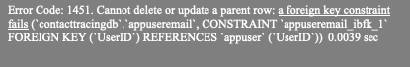

Text Box: Error Code: 1451. Cannot delete or update a parent row: a foreign key constraint fails (contacttracingdb.appuseremail, CONSTRAINT appuseremail_ibfk_1 FOREIGN KEY (UserID) REFERENCES appuser (UserID)) 0.0039 sec

**Test#2**

Attempt to insert an unreferenced record:

Text Box: INSERT INTO PublicHealthWorker VALUES(1600,‘MisterA’,131245,13112);

Text Box: INSERT INTO PublicHealthWorker VALUES(1600,‘MisterA’,131245,13112);

Response:

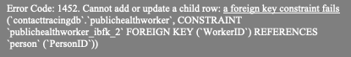

Text Box: Error Code: 1452. Cannot add or update a child row: a foreign key constraint fails (contacttracingdb.publichealthworker, CONSTRAINT publichealthworker_ibfk_2 FOREIGN KEY (WorkerID) REFERENCES person (PersonID))

2.) Domain Integrity : Alien Value Check***

**Test #1**

Attempt to insert a non-allowed value:

Text Box: INSERT INTO Assessment VALUES(3899,1600,0,‘2020-05-29 08:37:55’,‘a random description’,‘Friend’,1511)

Text Box: INSERT INTO Assessment VALUES(3899,1600,0,‘2020-05-29 08:37:55’,‘a random description’,‘Friend’,1511)

Response:

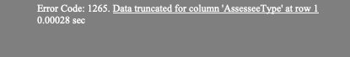

Text Box: Error Code: 1265. Data truncated for column ‘AssesseeType’ at row 1 0.00028 sec

  *** Test#2

Attempt to INSERT a value outside bounds:

Text Box: INSERT INTO Place VALUES(1002,‘Parua’,‘RODQ PLACE’,‘EAST BOSTON’,‘MA’,‘2128’,42.36443246,-731234568910);

Text Box: INSERT INTO Place VALUES(1002,‘Parua’,‘RODQ PLACE’,‘EAST BOSTON’,‘MA’,‘2128’,42.36443246,-731234568910);

Response:

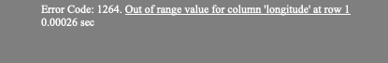

Text Box: Error Code: 1264. Out of range value for column ‘longitude’ at row 1 0.00026 sec

***3.)*** ***Entity Integrity and Key Constraints : Primary Key Null check***

Test #1

Attempt to INSERT a NULL value for PRIMARY KEY :

Text Box: INSERT INTO AppUserEmail(UserID, EmailID) VALUES (1101,null);

Text Box: INSERT INTO AppUserEmail(UserID, EmailID) VALUES (1101,null);

Response:



Text Box: Error Code: 1048. Column ‘EmailID’ cannot be null

Test#2

Attempt to INSERT a VALUE in AUTO_INCREMENT Primary key field: We can clearly see that the Primary Key was autogenerated when a NULL value was passed.

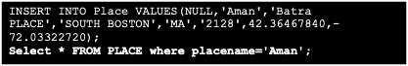

Text Box: INSERT INTO Place VALUES(NULL,‘Aman’,‘Batra PLACE’,‘SOUTH BOSTON’,‘MA’,‘2128’,42.36467840,-72.03322720); Select * FROM PLACE where placename=‘Aman’;

Response:

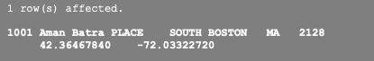

Text Box: 1 row(s) affected. 1001 Aman Batra PLACE SOUTH BOSTON MA 2128 42.36467840 -72.03322720

Test#3: Checking Uniqueness of Keys

Counting primary keys of Places

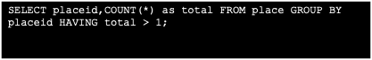

Text Box: SELECT placeid,COUNT(*) as total FROM place GROUP BY placeid HAVING total > 1;

Response:



Text Box: 0 row(s) returned

**9 . Create Tables and Insert Values**

library(RMySQL)

## Warning: package 'RMySQL' was built under R version 4.0.2

## Loading required package: DBI

library(DBI)  
library(RColorBrewer)  
conn = dbConnect(MySQL(), userName="root", password="atcbtra123", dbname="ContactTracingDB", host="localhost",port = 3306)

dbSendQuery(conn,'CREATE TABLE IF NOT EXISTS Place (  
 placeid INT NOT NULL AUTO_INCREMENT,   
 placename VARCHAR(255) NOT NULL,   
 streetarea VARCHAR(255) NOT NULL,   
 state VARCHAR(255) NOT NULL,   
 city VARCHAR(255) NOT NULL,   
 zip VARCHAR(255) NOT NULL,  
 latitude decimal(10,8) signed NOT NULL,  
 longitude decimal(11,8) signed NOT NULL,  
 PRIMARY KEY (placeid)  
);')

## <MySQLResult:-813415656,0,0>

dbSendQuery(conn,'CREATE TABLE IF NOT EXISTS Person (  
 PersonID INT NOT NULL AUTO_INCREMENT,   
 firstName VARCHAR(255) NOT NULL,   
 lastName VARCHAR(255),   
 PRIMARY KEY (PersonID)  
);')

## <MySQLResult:-795721656,0,1>

dbSendQuery(conn,'CREATE TABLE IF NOT EXISTS AppUser (  
 UserID INT NOT NULL,   
 Birthdate date NOT NULL,   
 AddressID INT NOT NULL,   
 RecoveredFromCovid Boolean,   
 PRIMARY KEY (UserID),   
 FOREIGN KEY(UserID) REFERENCES Person(PersonID),   
 FOREIGN KEY (AddressID) REFERENCES Place(PlaceID)  
);')

## <MySQLResult:2,0,2>

dbSendQuery(conn,'CREATE TABLE IF NOT EXISTS PublicHealthAuthority (  
 AuthorityID INT NOT NULL AUTO_INCREMENT,   
 AuthAddressID INT NOT NULL,   
 Name VARCHAR(255) NOT NULL,   
 Jurisdiction VARCHAR(255),   
 PRIMARY KEY (AuthorityID),   
 FOREIGN KEY (AuthAddressID) REFERENCES Place(PlaceId)  
);')

## <MySQLResult:-2,0,3>

dbSendQuery(conn,'CREATE TABLE IF NOT EXISTS PublicHealthWorker (  
 WorkerID INT NOT NULL,   
 Title VARCHAR(255) NOT NULL,   
 OfficeID VARCHAR(255) NOT NULL,   
 PublicAuthID INT NOT NULL,  
 PRIMARY KEY (WorkerID),  
 FOREIGN KEY (PublicAuthID) REFERENCES PublicHealthAuthority(AuthorityID),  
 FOREIGN KEY (WorkerID) REFERENCES Person(PersonId)  
);')

## <MySQLResult:0,0,4>

dbSendQuery(conn,'CREATE TABLE IF NOT EXISTS ContactHistoryLog (  
 LogID INT NOT NULL AUTO_INCREMENT,   
 Date datetime,   
 AssignedWorkerID INT NOT NULL,   
 PRIMARY KEY (LogID),   
 FOREIGN KEY (AssignedWorkerID) REFERENCES PublicHealthWorker(WorkerId)  
);')

## <MySQLResult:-830405576,0,5>

dbSendQuery(conn,'CREATE TABLE IF NOT EXISTS UserEvents (  
 EventID INT NOT NULL AUTO_INCREMENT,   
 EventStartTime Datetime NOT NULL,   
 EventEndTime Datetime NOT NULL,  
 LogBookID INT NOT NULL,  
 Description VARCHAR(1200),   
 PRIMARY KEY (EventID),  
 FOREIGN KEY (LogBookID) REFERENCES ContactHistoryLog(LogID)  
);')

## <MySQLResult:-830138960,0,6>

dbSendQuery(conn,"CREATE TABLE IF NOT EXISTS HealthReportCheck(  
 ReportID INT NOT NULL AUTO_INCREMENT,   
 UserID INT NOT NULL,   
 Temperature decimal(10, 3),   
 OxygenLevel decimal(10, 3),   
 HealthStatus ENUM ('sick','healthy') NOT NULL,   
 TestResult enum('Positive','Negative','Unclear') NOT NULL,   
 Description Text,   
 CheckingWorkerID INT NOT NULL,   
 ReportDate date,  
 PRIMARY KEY (ReportID),   
 FOREIGN KEY (UserID) REFERENCES AppUser(UserID),   
 FOREIGN KEY(CheckingWorkerID) REFERENCES PublicHealthWorker(WorkerId)  
);")

## <MySQLResult:-744834160,0,7>

dbSendQuery(conn,"CREATE TABLE IF NOT EXISTS Assessment (  
 AssessID INT NOT NULL AUTO_INCREMENT,   
 TakerID INT NOT NULL,   
 CovidSuspected boolean NOT NULL,   
 TimeStamp Datetime NOT NULL,   
 ResponseSheet VARCHAR(255),   
 AssesseeType enum('self','doctor','others') NOT NULL,   
 OverseeingWorkerID INT NOT NULL,   
 PRIMARY KEY (AssessID),   
 FOREIGN KEY (TakerID) REFERENCES AppUser(UserId),   
 FOREIGN KEY (OverseeingWorkerID) REFERENCES PublicHealthWorker(WorkerId)  
);")

## <MySQLResult:12,0,8>

dbSendQuery(conn,'CREATE TABLE IF NOT EXISTS AppUserEmail (  
 UserID INT NOT NULL,   
 EmailID VARCHAR(255) NOT NULL,   
 PRIMARY KEY (EmailID),   
 FOREIGN KEY(UserID) REFERENCES AppUser(UserID)  
);')

## <MySQLResult:12,0,9>

dbSendQuery(conn,'CREATE TABLE IF NOT EXISTS PublicHealthAuthorityHelpline(  
 HelplineNo VARCHAR(255) NOT NULL,   
 AuthorityID INT NOT NULL,   
 PRIMARY KEY(HelplineNo),   
 FOREIGN KEY(AuthorityID) REFERENCES PublicHealthAuthority(AuthorityID)  
);')

## <MySQLResult:12,0,10>

dbSendQuery(conn,'CREATE TABLE IF NOT EXISTS Interactions (  
 InteractionID INT NOT NULL,   
 InteractingUserID INT NOT NULL,   
 VisitorID INT NOT NULL,   
 InteractionPlaceID INT NOT NULL,   
 PRIMARY KEY (InteractionID),   
 FOREIGN KEY (InteractionID) REFERENCES UserEvents(EventID),   
 FOREIGN KEY (InteractingUserID) REFERENCES AppUser(UserID),   
 FOREIGN KEY (VisitorID) REFERENCES Person(PersonID),   
 FOREIGN KEY (InteractionPlaceID) REFERENCES Place(PlaceId)  
);')

## <MySQLResult:8,0,11>

dbSendQuery(conn,'CREATE TABLE IF NOT EXISTS Visit (  
 VisitID INT NOT NULL,   
 VisitPlaceID INT NOT NULL,   
 VisitingUserID INT NOT NULL,   
 PRIMARY KEY (VisitID),   
 FOREIGN KEY (VisitID) REFERENCES UserEvents(EventID),   
 FOREIGN KEY (VisitPlaceID) REFERENCES Place(PlaceID),   
 FOREIGN KEY(VisitingUserID) REFERENCES AppUser(UserID)  
);')

## <MySQLResult:1,0,12>

dbSendQuery(conn,'CREATE TABLE IF NOT EXISTS Notifications (  
 Nid INT NOT NULL AUTO_INCREMENT,   
 PHAAuthorityID INT NOT NULL,   
 timeStamp datetime NOT NULL,   
 OtherInformation Text,   
 PRIMARY KEY (Nid),   
 FOREIGN KEY (PHAAuthorityID) REFERENCES PublicHealthAuthority(AuthorityId)  
);')

## <MySQLResult:1,0,13>

dbSendQuery(conn,'CREATE TABLE IF NOT EXISTS PersonNotification (  
 Nid INT NOT NULL,   
 PersonID INT NOT NULL,   
 PRIMARY KEY (Nid, PersonID),   
 FOREIGN KEY(Nid) REFERENCES Notifications(Nid),   
 FOREIGN KEY(PersonID) REFERENCES Person(PersonID)  
);')

## <MySQLResult:-806711016,0,14>

dbSendQuery(conn,'CREATE TABLE IF NOT EXISTS PersonPhone(  
 PersonID INT NOT NULL,   
 PhoneNo VARCHAR(20) NOT NULL,   
 PRIMARY KEY (PhoneNo),   
 FOREIGN KEY (PersonID) REFERENCES Person(PersonID)  
);')

## <MySQLResult:-793148464,0,15>

dbDisconnect(conn)

## Warning: Closing open result sets

## [1] TRUE

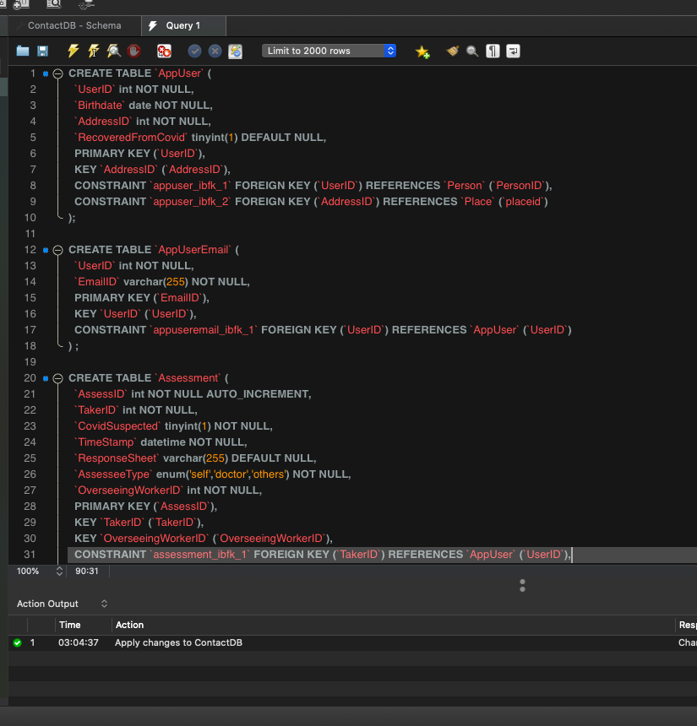 <br> 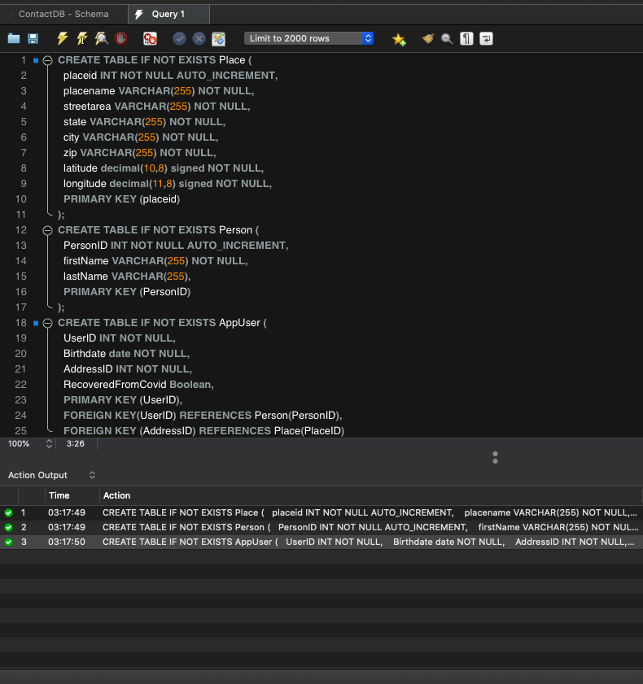 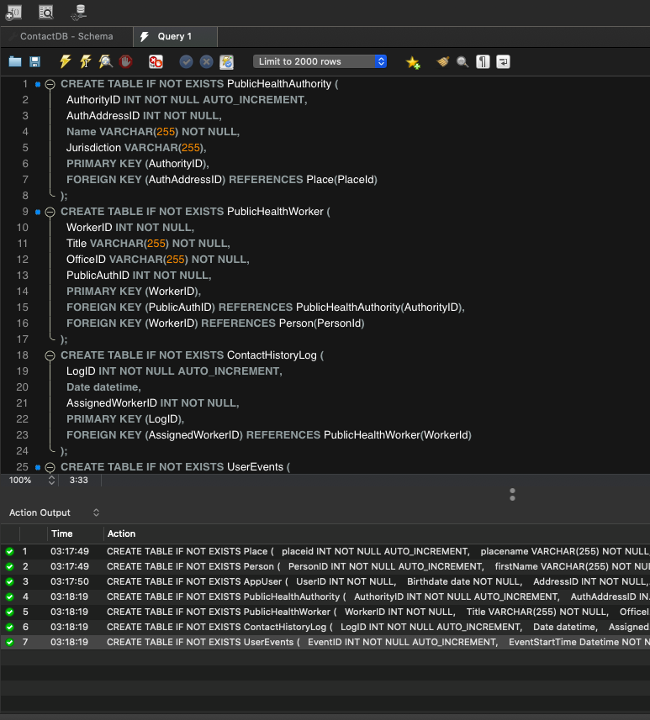 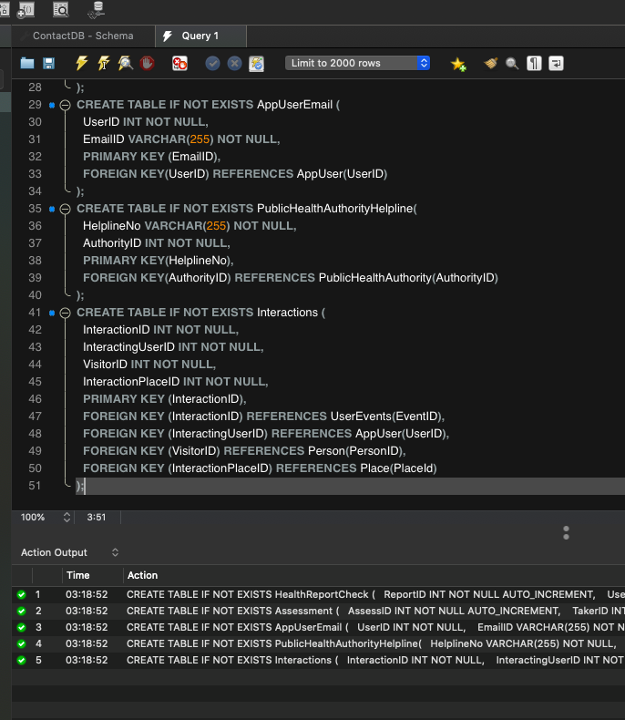 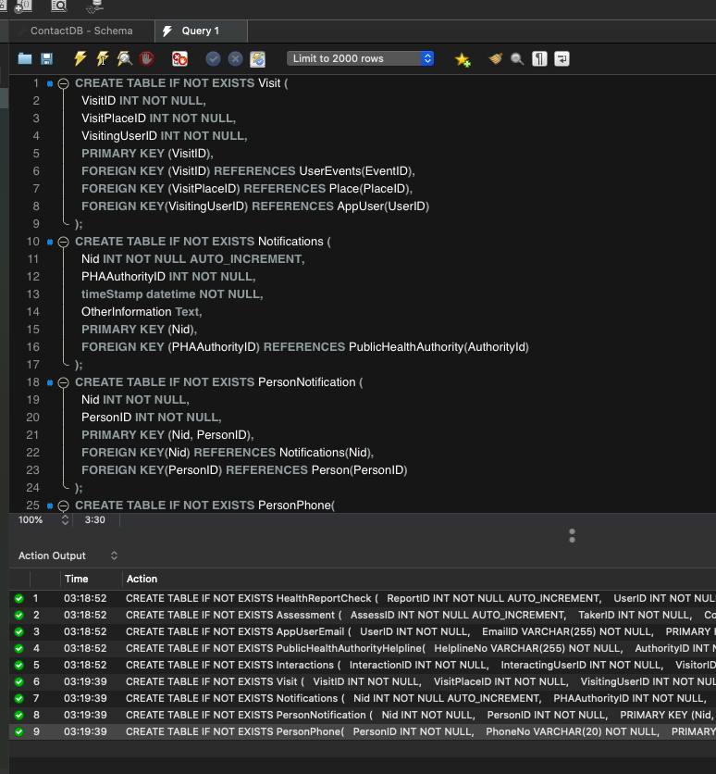 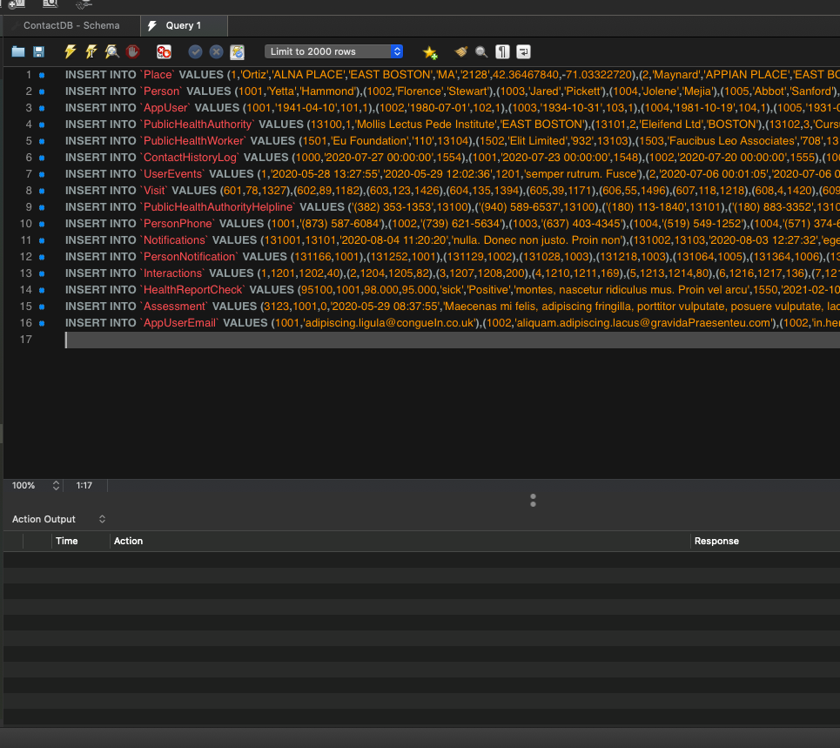 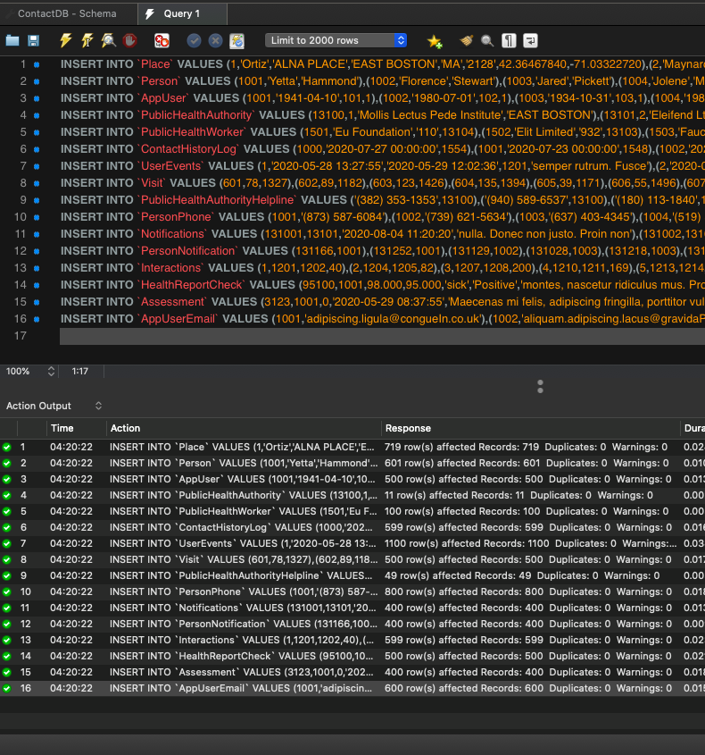

**10. Query Generation, Scripts & Outputs**

**QUERY - 1 - A SIMPLE JOIN QUERY**

Joining Tables: AppUser, Person, AppUserEmail

Goal : To find all the details of a user who tested positive in COVID-19 Drug Test

*SQL:* SELECT * FROM AppUser INNER JOIN Person ON AppUser.UserID=Person.PersonID INNER JOIN AppUserEmail on AppUser.UserID=AppUserEmail.UserID INNER JOIN Place on AppUser.AddressID=Place.placeid INNER JOIN HealthReportCheck on AppUser.UserId=HealthReportCheck.UserID WHERE HealthReportCheck.TestResult=‘positive’;

Response: 153 row(s) returned

*RESULT SCREENSHOTS*:

* Divided into two parts

PART 1

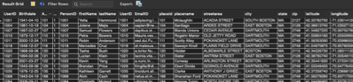

PART 2

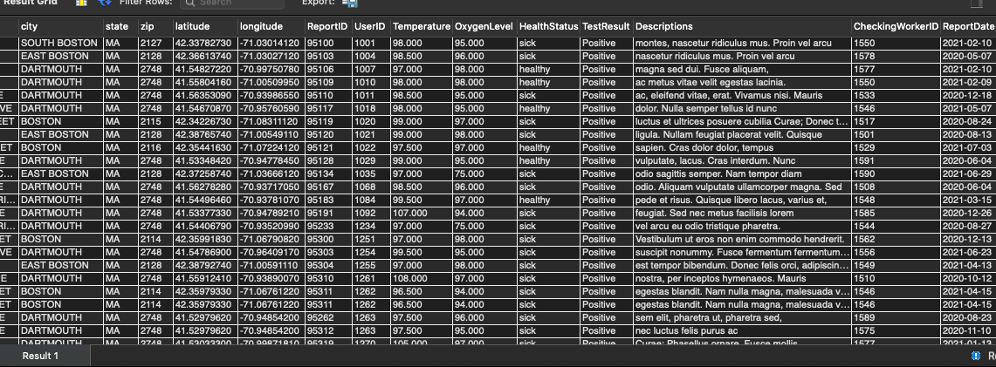

*R-Notebook Execution*

library(RMySQL)  
library(DBI)  
library(RColorBrewer)  
conn = dbConnect(MySQL(), userName="root", password="atcbtra123", dbname="ContactTracingDB", host="localhost",port = 3306)

val1 <- dbFetch(dbSendQuery(conn,"SELECT * FROM AppUser  
INNER JOIN Person ON AppUser.UserID=Person.PersonID  
INNER JOIN AppUserEmail on AppUser.UserID=AppUserEmail.UserID  
INNER JOIN Place on AppUser.AddressID=Place.placeid  
INNER JOIN HealthReportCheck on AppUser.UserId=HealthReportCheck.UserID  
WHERE HealthReportCheck.TestResult='positive';"))

## Warning in .local(conn, statement, ...): Decimal MySQL column 15 imported as  
## numeric

## Warning in .local(conn, statement, ...): Decimal MySQL column 16 imported as  
## numeric

## Warning in .local(conn, statement, ...): Decimal MySQL column 19 imported as  
## numeric

## Warning in .local(conn, statement, ...): Decimal MySQL column 20 imported as  
## numeric

val1

## UserID Birthdate AddressID RecoveredFromCovid PersonID firstName  
## 1 1001 1941-04-10 101 1 1001 Yetta  
## 2 1004 1981-10-19 104 1 1004 Jolene  
## 3 1005 1931-04-06 105 0 1005 Abbot  
## 4 1007 1997-02-27 107 1 1007 Samuel  
## 5 1008 1962-11-24 108 0 1008 Kyra  
## 6 1010 1973-12-17 110 1 1010 Petra  
## 7 1011 2000-12-24 111 1 1011 Robin  
## 8 1012 1953-08-19 112 0 1012 Malcolm  
## 9 1012 1953-08-19 112 0 1012 Malcolm  
## 10 1018 1946-12-07 118 1 1018 Mercedes  
## 11 1020 1968-09-06 120 1 1020 Tasha  
## 12 1021 1994-02-28 121 1 1021 Lucian  
## 13 1022 2001-03-27 122 1 1022 Kevin  
## 14 1027 1937-11-18 127 0 1027 Plato  
## 15 1029 1943-09-06 129 1 1029 Brendan  
## 16 1033 1998-02-02 133 0 1033 Roanna  
## 17 1035 1976-12-25 135 1 1035 Kathleen  
## 18 1037 2000-08-14 137 0 1037 Hollee  
## 19 1043 1986-03-27 143 0 1043 Baker  
## 20 1054 2018-07-22 154 0 1054 April  
## 21 1057 1938-09-24 157 0 1057 Blaze  
## 22 1068 1943-04-19 168 1 1068 Alvin  
## 23 1084 2006-09-11 184 1 1084 Elizabeth  
## 24 1092 1981-08-20 192 1 1092 Elton  
## 25 1234 2002-11-21 334 1 1234 Alexis  
## 26 1260 1999-05-30 360 0 1260 Aileen  
## 27 1263 1929-08-25 363 1 1263 Xandra  
## 28 1276 2001-04-02 376 1 1276 Patrick  
## 29 1251 1942-01-24 351 1 1251 Marny  
## 30 1254 1941-10-09 354 1 1254 Eve  
## 31 1255 1994-04-21 355 1 1255 Desiree  
## 32 1260 1999-05-30 360 0 1260 Aileen  
## 33 1261 1992-06-17 361 1 1261 Damian  
## 34 1262 1930-08-10 362 1 1262 Giacomo  
## 35 1262 1930-08-10 362 1 1262 Giacomo  
## 36 1263 1929-08-25 363 1 1263 Xandra  
## 37 1264 1987-01-02 364 0 1264 Alisa  
## 38 1268 1966-01-22 368 0 1268 Laurel  
## 39 1268 1966-01-22 368 0 1268 Laurel  
## 40 1270 1999-07-07 370 1 1270 Naomi  
## 41 1271 2011-02-28 371 1 1271 Aquila  
## 42 1271 2011-02-28 371 1 1271 Aquila  
## 43 1272 1933-01-11 372 1 1272 Erich  
## 44 1273 1962-09-27 373 1 1273 Adara  
## 45 1277 1948-12-17 377 0 1277 Hyatt  
## 46 1278 2004-03-10 378 0 1278 Meredith  
## 47 1283 1976-04-05 383 1 1283 Penelope  
## 48 1286 2004-10-08 386 1 1286 Clark  
## 49 1286 2004-10-08 386 1 1286 Clark  
## 50 1289 1964-03-25 389 1 1289 Wendy  
## 51 1291 1955-08-02 391 0 1291 Magee  
## 52 1292 1947-05-26 392 1 1292 Chaney  
## 53 1295 1964-02-22 395 1 1295 Inez  
## 54 1296 1970-10-17 396 0 1296 Charity  
## 55 1300 2008-10-21 400 0 1300 Maxine  
## 56 1302 1983-05-22 402 0 1302 Vance  
## 57 1306 1973-05-30 406 0 1306 Daniel  
## 58 1308 1994-06-21 408 1 1308 Eagan  
## 59 1310 2014-11-22 410 0 1310 Dai  
## 60 1314 2006-03-13 414 1 1314 Slade  
## 61 1315 1946-03-06 415 0 1315 Nayda  
## 62 1316 1931-01-29 416 0 1316 Seth  
## 63 1318 1931-03-20 418 0 1318 Haviva  
## 64 1320 1969-01-22 420 0 1320 Cara  
## 65 1321 1951-03-28 421 0 1321 Blake  
## 66 1322 1953-08-29 422 0 1322 Deacon  
## 67 1328 1951-02-15 428 0 1328 Thor  
## 68 1329 1956-06-17 429 1 1329 Wanda  
## 69 1330 2009-06-18 430 0 1330 Debra  
## 70 1335 1949-05-20 435 0 1335 Samuel  
## 71 1335 1949-05-20 435 0 1335 Samuel  
## 72 1336 1983-11-21 436 0 1336 Isadora  
## 73 1337 2014-11-30 437 1 1337 Lareina  
## 74 1338 1957-12-28 438 1 1338 Linus  
## 75 1339 1965-08-17 439 1 1339 Bryar  
## 76 1346 1970-09-15 446 0 1346 Lysandra  
## 77 1348 2000-08-31 448 1 1348 Vielka  
## 78 1354 2004-06-24 454 1 1354 Griffith  
## 79 1354 2004-06-24 454 1 1354 Griffith  
## 80 1387 1938-08-01 487 0 1387 Yetta  
## 81 1396 1960-08-28 496 0 1396 Judith  
## 82 1398 1973-02-27 498 1 1398 Simon  
## 83 1398 1973-02-27 498 1 1398 Simon  
## 84 1399 1955-08-04 499 1 1399 Alexis  
## 85 1400 2020-06-20 500 0 1400 Belle  
## 86 1401 1997-07-30 501 1 1401 Jonah  
## 87 1404 2010-04-27 504 0 1404 Ulysses  
## 88 1404 2010-04-27 504 0 1404 Ulysses  
## 89 1406 2020-10-30 506 0 1406 Nash  
## 90 1406 2020-10-30 506 0 1406 Nash  
## 91 1414 1929-09-08 514 0 1414 Jocelyn  
## 92 1417 2006-10-17 517 0 1417 Kellie  
## 93 1428 1986-11-24 528 0 1428 Jesse  
## 94 1430 1932-09-16 530 0 1430 Raphael  
## 95 1432 2001-04-11 532 1 1432 Eliana  
## 96 1433 2013-09-14 533 1 1433 Cathleen  
## 97 1434 1985-09-18 534 0 1434 Evangeline  
## 98 1435 1973-10-19 535 1 1435 Shafira  
## 99 1439 2010-10-19 539 1 1439 Jonas  
## 100 1441 1943-04-09 541 1 1441 Lacota  
## 101 1443 1949-01-17 543 1 1443 Adrienne  
## 102 1445 1971-07-29 545 1 1445 Cailin  
## 103 1446 1943-06-12 546 1 1446 Regan  
## 104 1446 1943-06-12 546 1 1446 Regan  
## 105 1447 1969-03-02 547 0 1447 Iris  
## 106 1400 2020-06-20 500 0 1400 Belle  
## 107 1401 1997-07-30 501 1 1401 Jonah  
## 108 1402 1933-07-19 502 1 1402 Harrison  
## 109 1403 2001-06-28 503 0 1403 Teegan  
## 110 1403 2001-06-28 503 0 1403 Teegan  
## 111 1408 1999-02-14 508 1 1408 Dana  
## 112 1411 2020-12-29 511 1 1411 Ross  
## 113 1414 1929-09-08 514 0 1414 Jocelyn  
## 114 1415 1936-03-16 515 1 1415 Daquan  
## 115 1423 1938-06-13 523 0 1423 Charissa  
## 116 1424 1950-01-01 524 1 1424 Xerxes  
## 117 1424 1950-01-01 524 1 1424 Xerxes  
## 118 1428 1986-11-24 528 0 1428 Jesse  
## 119 1429 2016-11-08 529 1 1429 Harding  
## 120 1432 2001-04-11 532 1 1432 Eliana  
## 121 1433 2013-09-14 533 1 1433 Cathleen  
## 122 1434 1985-09-18 534 0 1434 Evangeline  
## 123 1441 1943-04-09 541 1 1441 Lacota  
## 124 1448 1938-10-04 548 0 1448 Jillian  
## 125 1453 1957-07-08 553 1 1453 Yeo  
## 126 1456 2000-03-25 556 0 1456 Derek  
## 127 1456 2000-03-25 556 0 1456 Derek  
## 128 1457 1956-12-18 557 0 1457 Autumn  
## 129 1458 1953-09-22 558 0 1458 Iris  
## 130 1460 1956-08-27 560 1 1460 Nero  
## 131 1463 1970-03-08 563 1 1463 Phyllis  
## 132 1463 1970-03-08 563 1 1463 Phyllis  
## 133 1467 2017-01-19 567 1 1467 Chaim  
## 134 1467 2017-01-19 567 1 1467 Chaim  
## 135 1468 2002-06-02 568 0 1468 Deanna  
## 136 1469 1935-07-31 569 1 1469 Tanya  
## 137 1469 1935-07-31 569 1 1469 Tanya  
## 138 1471 1980-02-16 571 0 1471 Alexandra  
## 139 1473 1991-10-13 573 0 1473 Xanthus  
## 140 1473 1991-10-13 573 0 1473 Xanthus  
## 141 1475 1979-08-09 575 1 1475 Quamar  
## 142 1476 1985-03-02 576 0 1476 Brittany  
## 143 1479 1973-05-10 579 1 1479 Kamal  
## 144 1479 1973-05-10 579 1 1479 Kamal  
## 145 1482 2012-06-20 582 0 1482 Randall  
## 146 1485 2010-03-16 585 0 1485 Barry  
## 147 1489 2004-12-31 589 0 1489 Bertha  
## 148 1490 1960-06-26 590 0 1490 Marsden  
## 149 1490 1960-06-26 590 0 1490 Marsden  
## 150 1491 1954-07-04 591 0 1491 Zoe  
## 151 1496 1965-08-01 596 1 1496 Mikayla  
## 152 1497 1930-05-21 597 0 1497 Ishmael  
## 153 1499 1933-09-24 599 0 1499 Wayne  
## lastName UserID EmailID placeid  
## 1 Hammond 1001 adipiscing.ligula@congueIn.co.uk 101  
## 2 Mejia 1004 sapien@nequetellus.org 104  
## 3 Sanford 1005 aliquet@ligulaelit.org 105  
## 4 Flowers 1007 dapibus.id@tellusSuspendisse.ca 107  
## 5 Dickerson 1008 ligula@scelerisquedui.org 108  
## 6 Bowers 1010 Mauris.vestibulum@placeratvelitQuisque.co.uk 110  
## 7 Anderson 1011 sed.dui.Fusce@malesuadavel.co.uk 111  
## 8 Simon 1012 imperdiet@lectusCumsociis.net 112  
## 9 Simon 1012 ultrices.mauris@suscipitestac.co.uk 112  
## 10 Cruz 1018 et.malesuada.fames@urna.co.uk 118  
## 11 Bush 1020 a.tortor.Nunc@aliquetmetusurna.com 120  
## 12 Klein 1021 lacinia.vitae.sodales@necmauris.net 121  
## 13 Yang 1022 a.nunc.In@tristique.net 122  
## 14 Brooks 1027 Donec@Curae.com 127  
## 15 Price 1029 fringilla@dictumeleifend.co.uk 129  
## 16 Russell 1033 dui.quis.accumsan@in.co.uk 133  
## 17 Garrett 1035 tincidunt.aliquam@Aeneaneget.net 135  
## 18 Shields 1037 convallis.ante@etipsum.com 137  
## 19 Mcdonald 1043 rhoncus.Nullam.velit@duinec.ca 143  
## 20 Watts 1054 et.magnis.dis@Donecnonjusto.com 154  
## 21 Christian 1057 urna.Ut@euerat.com 157  
## 22 Cash 1068 netus.et.malesuada@ametdiameu.org 168  
## 23 Mcleod 1084 ultricies.ligula@ametconsectetuer.co.uk 184  
## 24 Bond 1092 libero@DonectinciduntDonec.ca 192  
## 25 Mcguire 1234 justo@convallisest.net 334  
## 26 Dean 1260 lorem.vehicula@pharetrafelis.ca 360  
## 27 Kane 1263 velit.Quisque.varius@metusAliquamerat.org 363  
## 28 Best 1276 nibh@vulputateullamcorper.edu 376  
## 29 Middleton 1251 fringilla.porttitor.vulputate@dapibusrutrum.edu 351  
## 30 Valentine 1254 molestie.sodales@idmollisnec.edu 354  
## 31 Farley 1255 nunc.nulla@turpisnec.ca 355  
## 32 Dean 1260 lorem.vehicula@pharetrafelis.ca 360  
## 33 Green 1261 non@quisarcuvel.ca 361  
## 34 Tyler 1262 non.ante.bibendum@ligulatortor.edu 362  
## 35 Tyler 1262 nonummy.ultricies.ornare@dictumeu.co.uk 362  
## 36 Kane 1263 velit.Quisque.varius@metusAliquamerat.org 363  
## 37 Nixon 1264 rhoncus@elit.ca 364  
## 38 Joyner 1268 dolor.dapibus.gravida@telluseu.com 368  
## 39 Joyner 1268 mauris.Morbi.non@nuncac.ca 368  
## 40 Ayers 1270 luctus.vulputate.nisi@sempereratin.com 370  
## 41 Shaw 1271 dictum@afacilisisnon.com 371  
## 42 Shaw 1271 ipsum@parturientmontes.net 371  
## 43 Sampson 1272 nunc@placeratorcilacus.net 372  
## 44 Bernard 1273 arcu.Aliquam@lectusrutrumurna.edu 373  
## 45 Riggs 1277 mauris.Integer@tortornibh.org 377  
## 46 Stokes 1278 lectus.quis.massa@diam.org 378  
## 47 Burt 1283 dictum.sapien.Aenean@Vivamus.co.uk 383  
## 48 Ewing 1286 aliquet.lobortis.nisi@mattisCraseget.com 386  
## 49 Ewing 1286 Suspendisse@ornareegestasligula.com 386  
## 50 Best 1289 eleifend@Proinsed.edu 389  
## 51 Stewart 1291 Proin.vel@amet.ca 391  
## 52 Bird 1292 nec.urna.suscipit@Integerinmagna.co.uk 392  
## 53 Mullen 1295 pharetra.Nam.ac@amet.ca 395  
## 54 Wheeler 1296 malesuada.augue.ut@purus.edu 396  
## 55 Knox 1300 libero.at.auctor@imperdietullamcorperDuis.org 400  
## 56 Aguirre 1302 fringilla@nunc.edu 402  
## 57 Witt 1306 arcu.Curabitur@vitae.ca 406  
## 58 Downs 1308 porttitor.scelerisque.neque@et.ca 408  
## 59 Moses 1310 molestie.Sed.id@montes.net 410  
## 60 Hubbard 1314 Vestibulum.ut.eros@sodales.net 414  
## 61 Foley 1315 orci@Pellentesquehabitant.edu 415  
## 62 Todd 1316 sem@odiosagittissemper.com 416  
## 63 Pickett 1318 Suspendisse.non.leo@dapibusligulaAliquam.net 418  
## 64 Patel 1320 tempor.augue@magnaDuisdignissim.edu 420  
## 65 Eaton 1321 varius.Nam.porttitor@pulvinararcuet.org 421  
## 66 Howe 1322 ultricies@inconsectetuer.org 422  
## 67 Howell 1328 leo.Morbi@feugiatplacerat.com 428  
## 68 Jenkins 1329 risus@nibhvulputate.ca 429  
## 69 Zimmerman 1330 tristique.neque@non.org 430  
## 70 Roach 1335 in.felis.Nulla@sed.co.uk 435  
## 71 Roach 1335 luctus.lobortis@risus.edu 435  
## 72 Frederick 1336 urna@loremloremluctus.com 436  
## 73 Wilkinson 1337 mattis.semper.dui@montesnasceturridiculus.com 437  
## 74 Riddle 1338 facilisis.vitae@dolor.edu 438  
## 75 Harper 1339 cursus@facilisisloremtristique.net 439  
## 76 Hernandez 1346 tellus.Suspendisse@Etiamgravidamolestie.ca 446  
## 77 Sims 1348 torquent.per.conubia@Vestibulumut.com 448  
## 78 Austin 1354 dictum.eleifend@fames.net 454  
## 79 Austin 1354 In.condimentum@nasceturridiculusmus.com 454  
## 80 Odom 1387 sed@adipiscing.org 487  
## 81 Berger 1396 aliquet.odio@sitametdapibus.co.uk 496  
## 82 Sellers 1398 Nunc@convallisconvallisdolor.edu 498  
## 83 Sellers 1398 Praesent@turpisAliquam.ca 498  
## 84 Mccoy 1399 velit.in@amet.com 499  
## 85 Atkinson 1400 nunc.interdum@vitaenibhDonec.ca 500  
## 86 Olson 1401 egestas@urna.com 501  
## 87 Maldonado 1404 diam@adipiscingfringillaporttitor.co.uk 504  
## 88 Maldonado 1404 non@nonenim.com 504  
## 89 Moss 1406 enim@tellusNunclectus.co.uk 506  
## 90 Moss 1406 vitae.velit@semmagna.edu 506  
## 91 Spence 1414 Vivamus.rhoncus@dui.edu 514  
## 92 Shepherd 1417 dui.augue.eu@sedest.com 517  
## 93 Ruiz 1428 porttitor.scelerisque.neque@id.net 528  
## 94 Wallace 1430 arcu.Vestibulum.ut@lobortisaugue.co.uk 530  
## 95 Mckee 1432 vestibulum.nec.euismod@Maurisquisturpis.net 532  
## 96 Beasley 1433 eleifend.non@sempererat.co.uk 533  
## 97 Franks 1434 at.velit.Cras@euismodindolor.com 534  
## 98 Johnson 1435 eu@lorem.org 535  
## 99 Campbell 1439 vel@nonnisiAenean.org 539  
## 100 Hodge 1441 ante.bibendum.ullamcorper@facilisisvitae.net 541  
## 101 Bird 1443 vulputate.nisi@natoquepenatibuset.org 543  
## 102 Contreras 1445 vitae.orci.Phasellus@nectempus.co.uk 545  
## 103 Soto 1446 blandit.enim@vellectusCum.ca 546  
## 104 Soto 1446 magna.a.neque@posuerecubiliaCurae.net 546  
## 105 Malone 1447 nisl.Maecenas.malesuada@sem.org 547  
## 106 Atkinson 1400 nunc.interdum@vitaenibhDonec.ca 500  
## 107 Olson 1401 egestas@urna.com 501  
## 108 Whitaker 1402 et@ridiculusmus.ca 502  
## 109 Cochran 1403 Sed@Duissit.co.uk 503  
## 110 Cochran 1403 sit@lorem.co.uk 503  
## 111 Parrish 1408 at@vitaevelit.edu 508  
## 112 Mueller 1411 mauris@velitegestaslacinia.com 511  
## 113 Spence 1414 Vivamus.rhoncus@dui.edu 514  
## 114 Jefferson 1415 cursus.diam.at@ullamcorperDuiscursus.com 515  
## 115 Strickland 1423 vitae.posuere.at@Uttincidunt.ca 523  
## 116 Holden 1424 diam.luctus@Vivamusnonlorem.ca 524  
## 117 Holden 1424 turpis.Aliquam@lectusasollicitudin.co.uk 524  
## 118 Ruiz 1428 porttitor.scelerisque.neque@id.net 528  
## 119 Palmer 1429 tortor.at@Aeneansed.net 529  
## 120 Mckee 1432 vestibulum.nec.euismod@Maurisquisturpis.net 532  
## 121 Beasley 1433 eleifend.non@sempererat.co.uk 533  
## 122 Franks 1434 at.velit.Cras@euismodindolor.com 534  
## 123 Hodge 1441 ante.bibendum.ullamcorper@facilisisvitae.net 541  
## 124 Rogers 1448 metus.Aenean.sed@liberoat.edu 548  
## 125 William 1453 lectus.convallis.est@turpis.ca 553  
## 126 Fletcher 1456 erat.eget@utmi.edu 556  
## 127 Fletcher 1456 Sed.nulla@aliquet.co.uk 556  
## 128 Marquez 1457 dictum@ametconsectetuer.com 557  
## 129 Willis 1458 convallis.in@parturientmontes.org 558  
## 130 Hunter 1460 molestie.tortor.nibh@porttitor.net 560  
## 131 Sharp 1463 massa.non.ante@lorem.co.uk 563  
## 132 Sharp 1463 Pellentesque.ut.ipsum@enimgravidasit.ca 563  
## 133 Montoya 1467 Duis.volutpat@congueInscelerisque.org 567  
## 134 Montoya 1467 libero.dui.nec@aclibero.edu 567  
## 135 Lane 1468 lectus.rutrum.urna@metusVivamus.co.uk 568  
## 136 Stuart 1469 sit.amet@a.ca 569  
## 137 Stuart 1469 tellus.Aenean.egestas@egestasnunc.net 569  
## 138 Hodge 1471 ac.mattis@vitaerisusDuis.ca 571  
## 139 Horton 1473 in.felis@placerataugue.co.uk 573  
## 140 Horton 1473 porttitor@turpisvitaepurus.com 573  
## 141 Oneill 1475 enim@Class.co.uk 575  
## 142 Thornton 1476 eros.nec.tellus@ligulaelit.com 576  
## 143 Walter 1479 eget.laoreet.posuere@aliquet.net 579  
## 144 Walter 1479 nunc.sed@at.edu 579  
## 145 Colon 1482 adipiscing.elit@tempus.net 582  
## 146 Lamb 1485 quis.diam@Suspendissecommodotincidunt.co.uk 585  
## 147 Parsons 1489 facilisis.Suspendisse@tellusSuspendisse.ca 589  
## 148 Bell 1490 bibendum.fermentum.metus@lectusNullam.ca 590  
## 149 Bell 1490 quis.arcu@dolortempus.edu 590  
## 150 Daniel 1491 Sed.id@fringillami.co.uk 591  
## 151 Lynch 1496 vulputate.risus.a@maurissapien.org 596  
## 152 Byrd 1497 in.lobortis@amet.org 597  
## 153 Burks 1499 condimentum.eget.volutpat@loremDonecelementum.edu 599  
## placename streetarea city state zip  
## 1 Mclaughlin ACADIA STREET SOUTH BOSTON MA 2127  
## 2 Santiago ARDEE STREET EAST BOSTON MA 2128  
## 3 Abdul Common ACORN WAY DARTMOUTH MA 2748  
## 4 Blanda Unions CEDAR AVENUE DARTMOUTH MA 2748  
## 5 Caden Circles EAGLE DRIVE DARTMOUTH MA 2748  
## 6 Rogahn Manor OLD JETTY ROAD DARTMOUTH MA 2748  
## 7 Scotty Alley POKANOKET LANE DARTMOUTH MA 2748  
## 8 Holden ACORN STREET BOSTON MA 2108  
## 9 Holden ACORN STREET BOSTON MA 2108  
## 10 Sawayn Knoll PLAINS FIELD DRIVE DARTMOUTH MA 2748  
## 11 Holder ALBEMARLE STREET BOSTON MA 2115  
## 12 Slater ANTRIM STREET EAST BOSTON MA 2128  
## 13 Conway ARLINGTON STREET BOSTON MA 2116  
## 14 Bednar Fords BITTERSWEET LANE DARTMOUTH MA 2790  
## 15 Ebert Divide GOSNOLD AVENUE DARTMOUTH MA 2748  
## 16 Shaina Mount POKANOKET LANE DARTMOUTH MA 2748  
## 17 Clarke ANTHONY J GRIECO TERRACE EAST BOSTON MA 2128  
## 18 Harvey BOWDOIN STREET BOSTON MA 2114  
## 19 Kertzmann Camp MATTAREST LANE DARTMOUTH MA 2748  
## 20 Kylee Locks MEADOW SHORES ROAD DARTMOUTH MA 2748  
## 21 Cruz ACADIA STREET SOUTH BOSTON MA 2127  
## 22 Shanahan Ford POKANOKET LANE DARTMOUTH MA 2748  
## 23 Nienow Turnpike NORTH SHORE DRIVE DARTMOUTH MA 2748  
## 24 Effertz Ford GOSNOLD AVENUE DARTMOUTH MA 2748  
## 25 Pfannerstill Meadows NORTH SHORE DRIVE DARTMOUTH MA 2748  
## 26 Lind Estates NAUSHON AVENUE DARTMOUTH MA 2748  
## 27 Lynch Street NAUSHON AVENUE DARTMOUTH MA 2748  
## 28 Brennan ATLANTIC AVENUE BOSTON MA 2110  
## 29 Montgomery ANDERSON STREET BOSTON MA 2114  
## 30 Schmitt Coves PLAINS FIELD DRIVE DARTMOUTH MA 2748  
## 31 Vinson ASHLEY STREET EAST BOSTON MA 2128  
## 32 Lind Estates NAUSHON AVENUE DARTMOUTH MA 2748  
## 33 Moshe Extension NONQUITT AVENUE DARTMOUTH MA 2748  
## 34 Nicholson ANDERSON STREET BOSTON MA 2114  
## 35 Nicholson ANDERSON STREET BOSTON MA 2114  
## 36 Lynch Street NAUSHON AVENUE DARTMOUTH MA 2748  
## 37 Mosciski Gardens NONQUITT AVENUE DARTMOUTH MA 2748  
## 38 Snider BRADDOCK PARK BOSTON MA 2116  
## 39 Snider BRADDOCK PARK BOSTON MA 2116  
## 40 Hermiston Road JORDAN ROAD DARTMOUTH MA 2748  
## 41 Mueller Pass NONQUITT AVENUE DARTMOUTH MA 2748  
## 42 Mueller Pass NONQUITT AVENUE DARTMOUTH MA 2748  
## 43 Morar Common NONQUITT AVENUE DARTMOUTH MA 2748  
## 44 Norberto Glen NORTH SHORE DRIVE DARTMOUTH MA 2748  
## 45 Abbott Island JORDAN ROAD DARTMOUTH MA 2748  
## 46 Macie Path NAUSHON AVENUE DARTMOUTH MA 2748  
## 47 Mike Mountain NONQUITT AVENUE DARTMOUTH MA 2748  
## 48 Moen Meadows NONQUITT AVENUE DARTMOUTH MA 2748  
## 49 Moen Meadows NONQUITT AVENUE DARTMOUTH MA 2748  
## 50 Jakob Freeway LITTLE RIVER ROAD DARTMOUTH MA 2748  
## 51 Osinski Greens NORTH SHORE DRIVE DARTMOUTH MA 2748  
## 52 Schroeder Centers PLAINS FIELD DRIVE DARTMOUTH MA 2748  
## 53 Madisen Row NAUSHON AVENUE DARTMOUTH MA 2748  
## 54 Mozell Way NONQUITT AVENUE DARTMOUTH MA 2748  
## 55 Michele Points NONQUITT AVENUE DARTMOUTH MA 2748  
## 56 Tate ANDERSON STREET BOSTON MA 2114  
## 57 Mozelle Courts NONQUITT AVENUE DARTMOUTH MA 2748  
## 58 Fadel Mall HETTY GREEN DRIVE DARTMOUTH MA 2748  
## 59 Moses Inlet NONQUITT AVENUE DARTMOUTH MA 2748  
## 60 Luna Highway NAUSHON AVENUE DARTMOUTH MA 2748  
## 61 Monahan Street NONQUITT AVENUE DARTMOUTH MA 2748  
## 62 London Bypass NAUSHON AVENUE DARTMOUTH MA 2748  
## 63 Hendrix ASHLEY STREET EAST BOSTON MA 2128  
## 64 Russel Unions PARDON HILL ROAD DARTMOUTH MA 2748  
## 65 Flatley Lights HETTY GREEN DRIVE DARTMOUTH MA 2790  
## 66 Madie Ville NAUSHON AVENUE DARTMOUTH MA 2748  
## 67 Lowery A STREET SOUTH BOSTON MA 2127  
## 68 Eusebio Street HETTY GREEN DRIVE DARTMOUTH MA 2748  
## 69 Littel Ranch NAUSHON AVENUE DARTMOUTH MA 2748  
## 70 Madalyn Road NAUSHON AVENUE DARTMOUTH MA 2748  
## 71 Madalyn Road NAUSHON AVENUE DARTMOUTH MA 2748  
## 72 Merl Plaza NONQUITT AVENUE DARTMOUTH MA 2748  
## 73 Pennington BENNINGTON STREET EAST BOSTON MA 2128  
## 74 Ernesto Ville HETTY GREEN DRIVE DARTMOUTH MA 2790  
## 75 Luz Fall NAUSHON AVENUE DARTMOUTH MA 2748  
## 76 Melendez ATLANTIC AVENUE BOSTON MA 2109  
## 77 Mclaughlin A STREET SOUTH BOSTON MA 2127  
## 78 Dibbert Mountain GAFFNEY ROAD DARTMOUTH MA 2748  
## 79 Dibbert Mountain GAFFNEY ROAD DARTMOUTH MA 2748  
## 80 D'Amore Shoal GAFFNEY ROAD DARTMOUTH MA 2748  
## 81 Ullrich Cliffs ROCK O'DUNDEE ROAD DARTMOUTH MA 2748  
## 82 Arjun Turnpike BARNEY'S JOY ROAD DARTMOUTH MA 2748  
## 83 Arjun Turnpike BARNEY'S JOY ROAD DARTMOUTH MA 2748  
## 84 Cummings Square GAFFNEY ROAD DARTMOUTH MA 2748  
## 85 Adams Forest ALLENS NECK ROAD DARTMOUTH MA 2748  
## 86 D'Amore Circles GAFFNEY ROAD DARTMOUTH MA 2748  
## 87 Dagmar Club GAFFNEY ROAD DARTMOUTH MA 2748  
## 88 Dagmar Club GAFFNEY ROAD DARTMOUTH MA 2748  
## 89 Wilkins ADDISON STREET EAST BOSTON MA 2128  
## 90 Wilkins ADDISON STREET EAST BOSTON MA 2128  
## 91 Gwen Vista HORSENECK ROAD DARTMOUTH MA 2748  
## 92 Crystel Spur GAFFNEY ROAD DARTMOUTH MA 2748  
## 93 Katelyn Overpass LITTLE RIVER ROAD DARTMOUTH MA 2748  
## 94 Hahn Villages HORSENECK ROAD DARTMOUTH MA 2748  
## 95 Angus Square BARNEY'S JOY ROAD DARTMOUTH MA 2748  
## 96 Jackson Flats LITTLE RIVER ROAD DARTMOUTH MA 2748  
## 97 Katheryn Gardens LITTLE RIVER ROAD DARTMOUTH MA 2748  
## 98 Jaron Grove LITTLE RIVER ROAD DARTMOUTH MA 2748  
## 99 Therese Bypass ROCK O'DUNDEE ROAD DARTMOUTH MA 2748  
## 100 Davis Port GAFFNEY ROAD DARTMOUTH MA 2748  
## 101 Thaddeus Ramp ROCK O'DUNDEE ROAD DARTMOUTH MA 2748  
## 102 Hilpert Points JORDAN ROAD DARTMOUTH MA 2748  
## 103 Hoeger Springs JORDAN ROAD DARTMOUTH MA 2748  
## 104 Hoeger Springs JORDAN ROAD DARTMOUTH MA 2748  
## 105 Delores Island GAFFNEY ROAD DARTMOUTH MA 2748  
## 106 Adams Forest ALLENS NECK ROAD DARTMOUTH MA 2748  
## 107 D'Amore Circles GAFFNEY ROAD DARTMOUTH MA 2748  
## 108 Raynor Branch OCEAN AVENUE DARTMOUTH MA 2748  
## 109 Farmer ADDISON STREET EAST BOSTON MA 2128  
## 110 Farmer ADDISON STREET EAST BOSTON MA 2128  
## 111 Heidenreich Prairie JORDAN ROAD DARTMOUTH MA 2748  
## 112 Ryan ARLINGTON STREET BOSTON MA 2116  
## 113 Gwen Vista HORSENECK ROAD DARTMOUTH MA 2748  
## 114 Scott ADDISON STREET EAST BOSTON MA 2128  
## 115 Gardner ARLINGTON STREET BOSTON MA 2116  
## 116 Rosales ATHENS STREET SOUTH BOSTON MA 2127  
## 117 Rosales ATHENS STREET SOUTH BOSTON MA 2127  
## 118 Katelyn Overpass LITTLE RIVER ROAD DARTMOUTH MA 2748  
## 119 Albert ATHENS STREET SOUTH BOSTON MA 2127  
## 120 Angus Square BARNEY'S JOY ROAD DARTMOUTH MA 2748  
## 121 Jackson Flats LITTLE RIVER ROAD DARTMOUTH MA 2748  
## 122 Katheryn Gardens LITTLE RIVER ROAD DARTMOUTH MA 2748  
## 123 Davis Port GAFFNEY ROAD DARTMOUTH MA 2748  
## 124 Gulgowski Shores HORSENECK ROAD DARTMOUTH MA 2748  
## 125 Pacheco BEACON STREET BOSTON MA 2116  
## 126 Wallace BAY STATE ROAD BOSTON MA 2215  
## 127 Wallace BAY STATE ROAD BOSTON MA 2215  
## 128 Daugherty Mission GAFFNEY ROAD DARTMOUTH MA 2790  
## 129 Bonner BAY STATE ROAD BOSTON MA 2215  
## 130 Hahn Wells HORSENECK ROAD DARTMOUTH MA 2748  
## 131 Morin BAY STATE ROAD BOSTON MA 2215  
## 132 Morin BAY STATE ROAD BOSTON MA 2215  
## 133 Cunningham BAY STATE ROAD BOSTON MA 2215  
## 134 Cunningham BAY STATE ROAD BOSTON MA 2215  
## 135 Kailyn Streets LITTLE RIVER ROAD DARTMOUTH MA 2748  
## 136 Jermey Drive LITTLE RIVER ROAD DARTMOUTH MA 2748  
## 137 Jermey Drive LITTLE RIVER ROAD DARTMOUTH MA 2748  
## 138 Hendrix BOYLSTON STREET BOSTON MA 2116  
## 139 Brooks ALBANY STREET BOSTON MA 2118  
## 140 Brooks ALBANY STREET BOSTON MA 2118  
## 141 Deven Mall GAFFNEY ROAD DARTMOUTH MA 2748  
## 142 Richards A STREET SOUTH BOSTON MA 2210  
## 143 Tina Corners ROCK O'DUNDEE ROAD DARTMOUTH MA 2748  
## 144 Tina Corners ROCK O'DUNDEE ROAD DARTMOUTH MA 2748  
## 145 Tristian Spurs ROCK O'DUNDEE ROAD DARTMOUTH MA 2748  
## 146 Hilda Hill JORDAN ROAD DARTMOUTH MA 2748  
## 147 Hettinger Run JORDAN ROAD DARTMOUTH MA 2748  
## 148 Hickle Vista JORDAN ROAD DARTMOUTH MA 2748  
## 149 Hickle Vista JORDAN ROAD DARTMOUTH MA 2748  
## 150 Hilll Drives JORDAN ROAD DARTMOUTH MA 2748  
## 151 Armstrong Summit BARNEY'S JOY ROAD DARTMOUTH MA 2748  
## 152 Lynn ATHENS STREET SOUTH BOSTON MA 2127  
## 153 Justice ATHENS STREET SOUTH BOSTON MA 2127  
## latitude longitude ReportID UserID Temperature OxygenLevel HealthStatus  
## 1 42.33783 -71.03014 95100 1001 98.0 95 sick  
## 2 42.36614 -71.03027 95103 1004 98.5 96 sick  
## 3 41.55993 -70.98651 95104 1005 98.0 98 healthy  
## 4 41.54827 -70.99751 95106 1007 97.0 98 healthy  
## 5 41.54494 -70.94545 95107 1008 98.0 94 sick  
## 6 41.55804 -71.00510 95109 1010 98.0 98 healthy  
## 7 41.56353 -70.93987 95110 1011 98.5 95 sick  
## 8 42.35751 -71.06910 95111 1012 99.5 95 healthy  
## 9 42.35751 -71.06910 95111 1012 99.5 95 healthy  
## 10 41.54671 -70.95761 95117 1018 98.0 95 healthy  
## 11 42.34227 -71.08311 95119 1020 99.0 97 sick  
## 12 42.38766 -71.00549 95120 1021 99.0 98 sick  
## 13 42.35442 -71.07224 95121 1022 97.5 97 healthy  
## 14 41.55385 -70.95275 95126 1027 98.5 95 sick  
## 15 41.53348 -70.94778 95128 1029 99.0 95 healthy  
## 16 41.56335 -70.93901 95132 1033 96.5 84 healthy  
## 17 42.37259 -71.03666 95134 1035 97.0 75 sick  
## 18 42.36040 -71.06210 95136 1037 98.0 97 healthy  
## 19 41.54783 -70.93632 95142 1043 98.0 97 healthy  
## 20 41.53695 -70.94954 95153 1054 99.0 96 sick  
## 21 42.33788 -71.02983 95156 1057 98.0 96 healthy  
## 22 41.56278 -70.93717 95167 1068 98.5 96 sick  
## 23 41.54496 -70.93781 95183 1084 99.5 97 healthy  
## 24 41.53377 -70.94789 95191 1092 107.0 94 sick  
## 25 41.54407 -70.93521 95233 1234 97.0 75 sick  
## 26 41.53039 -70.94818 95259 1260 96.5 97 sick  
## 27 41.52980 -70.94854 95262 1263 97.5 96 sick  
## 28 42.36311 -71.05134 95275 1276 97.5 95 sick  
## 29 42.35992 -71.06791 95300 1251 97.0 98 sick  
## 30 41.54787 -70.96409 95303 1254 99.5 95 sick  
## 31 42.38793 -71.00591 95304 1255 97.0 98 sick  
## 32 41.53039 -70.94818 95309 1260 97.0 98 sick  
## 33 41.55912 -70.93890 95310 1261 108.0 97 sick  
## 34 42.35979 -71.06761 95311 1262 96.5 94 sick  
## 35 42.35979 -71.06761 95311 1262 96.5 94 sick  
## 36 41.52980 -70.94854 95312 1263 97.5 95 sick  
## 37 41.55902 -70.94009 95313 1264 106.5 97 sick  
## 38 42.34478 -71.07900 95317 1268 100.5 98 sick  
## 39 42.34478 -71.07900 95317 1268 100.5 98 sick  
## 40 41.53033 -70.99872 95319 1270 105.0 97 sick  
## 41 41.55878 -70.93945 95320 1271 97.0 98 sick  
## 42 41.55878 -70.93945 95320 1271 97.0 98 sick  
## 43 41.55859 -70.93992 95321 1272 96.5 94 sick  
## 44 41.54410 -70.93302 95322 1273 101.5 97 sick  
## 45 41.52978 -70.99783 95326 1277 98.0 95 sick  
## 46 41.53064 -70.94818 95327 1278 96.5 98 sick  
## 47 41.55690 -70.93862 95332 1283 98.0 94 sick  
## 48 41.55723 -70.93841 95335 1286 105.0 96 sick  
## 49 41.55723 -70.93841 95335 1286 105.0 96 sick  
## 50 41.53921 -70.95557 95338 1289 108.0 75 sick  
## 51 41.54322 -70.93409 95340 1291 98.5 95 sick  
## 52 41.54661 -70.96524 95341 1292 98.0 95 sick  
## 53 41.53091 -70.94825 95344 1295 100.0 94 sick  
## 54 41.55720 -70.93778 95345 1296 96.5 66 sick  
## 55 41.55652 -70.93817 95349 1300 98.0 96 sick  
## 56 42.35943 -71.06788 95351 1302 97.0 84 sick  
## 57 41.55672 -70.93767 95355 1306 96.5 95 sick  
## 58 41.54325 -70.93685 95357 1308 99.0 96 sick  
## 59 41.55653 -70.93749 95359 1310 99.5 94 sick  
## 60 41.53170 -70.94832 95363 1314 98.5 94 sick  
## 61 41.55610 -70.93719 95364 1315 106.0 75 sick  
## 62 41.53058 -70.94860 95365 1316 102.5 95 sick  
## 63 42.38849 -71.00721 95367 1318 98.0 95 sick  
## 64 41.55982 -70.98294 95369 1320 98.5 97 sick  
## 65 41.54220 -70.93412 95370 1321 98.0 96 sick  
## 66 41.53085 -70.94866 95371 1322 105.0 95 sick  
## 67 42.34217 -71.05541 95377 1328 103.0 97 sick  
## 68 41.54201 -70.93349 95378 1329 101.5 66 sick  
## 69 41.53112 -70.94873 95379 1330 98.5 97 sick  
## 70 41.53141 -70.94877 95384 1335 98.5 84 sick  
## 71 41.53141 -70.94877 95384 1335 98.5 84 sick  
## 72 41.55852 -70.93662 95385 1336 97.5 98 sick  
## 73 42.37599 -71.03639 95386 1337 97.0 97 sick  
## 74 41.54162 -70.93254 95387 1338 99.0 96 sick  
## 75 41.53283 -70.94865 95388 1339 99.0 95 sick  
## 76 42.36258 -71.05119 95395 1346 99.5 94 sick  
## 77 42.34245 -71.05507 95397 1348 99.5 97 sick  
## 78 41.55113 -70.99462 95403 1354 97.5 98 sick  
## 79 41.55113 -70.99462 95403 1354 97.5 98 sick  
## 80 41.55307 -70.99491 95436 1387 98.5 94 sick  
## 81 41.56157 -70.96368 95445 1396 98.0 66 sick  
## 82 41.52595 -70.99133 95447 1398 98.5 66 sick  
## 83 41.52595 -70.99133 95447 1398 98.5 66 sick  
## 84 41.55279 -70.99723 95448 1399 100.0 94 sick  
## 85 41.53297 -71.01167 95449 1400 98.5 98 sick  
## 86 41.55246 -70.99845 95450 1401 108.0 96 sick  
## 87 41.55355 -71.00004 95453 1404 104.5 84 sick  
## 88 41.55355 -71.00004 95453 1404 104.5 84 sick  
## 89 42.38536 -71.01672 95455 1406 100.5 96 sick  
## 90 42.38536 -71.01672 95455 1406 100.5 96 sick  
## 91 41.56369 -71.00667 95463 1414 101.5 94 sick  
## 92 41.55438 -70.99369 95466 1417 104.0 96 sick  
## 93 41.53842 -70.96316 95477 1428 99.0 98 sick  
## 94 41.56220 -71.00441 95479 1430 97.0 98 sick  
## 95 41.52757 -70.99277 95481 1432 97.0 94 sick  
## 96 41.53669 -70.96220 95482 1433 98.5 97 sick  
## 97 41.53786 -70.96400 95483 1434 97.5 94 sick  
## 98 41.53513 -70.96088 95484 1435 97.5 98 sick  
## 99 41.55926 -70.96511 95488 1439 98.0 94 sick  
## 100 41.55719 -70.99277 95490 1441 99.0 97 sick  
## 101 41.55903 -70.96608 95492 1443 104.0 84 sick  
## 102 41.52453 -70.99495 95494 1445 96.5 95 sick  
## 103 41.52262 -70.99831 95495 1446 98.0 97 sick  
## 104 41.52262 -70.99831 95495 1446 98.0 97 sick  
## 105 41.55760 -70.99345 95496 1447 99.5 94 sick  
## 106 41.53297 -71.01167 95500 1400 98.5 94 sick  
## 107 41.55246 -70.99845 95501 1401 106.5 94 sick  
## 108 41.53478 -70.95081 95502 1402 97.0 97 sick  
## 109 42.38543 -71.01708 95503 1403 96.5 97 sick  
## 110 42.38543 -71.01708 95503 1403 96.5 97 sick  
## 111 41.52635 -71.00012 95508 1408 98.5 75 sick  
## 112 42.34890 -71.06974 95511 1411 97.5 96 sick  
## 113 41.56369 -71.00667 95514 1414 97.5 95 sick  
## 114 42.38528 -71.01644 95515 1415 97.5 75 sick  
## 115 42.34861 -71.06959 95523 1423 106.0 98 sick  
## 116 42.34089 -71.05275 95524 1424 100.5 94 sick  
## 117 42.34089 -71.05275 95524 1424 100.5 94 sick  
## 118 41.53842 -70.96316 95528 1428 107.5 94 sick  
## 119 42.34076 -71.05253 95529 1429 96.5 98 sick  
## 120 41.52757 -70.99277 95532 1432 96.5 94 sick  
## 121 41.53669 -70.96220 95533 1433 98.0 66 healthy  
## 122 41.53786 -70.96400 95534 1434 99.5 96 sick  
## 123 41.55719 -70.99277 95541 1441 99.0 97 sick  
## 124 41.56072 -71.00856 95548 1448 105.5 94 sick  
## 125 42.35428 -71.07773 95553 1453 99.5 95 sick  
## 126 42.35074 -71.10243 95556 1456 97.5 95 sick  
## 127 42.35074 -71.10243 95556 1456 97.5 95 sick  
## 128 41.55823 -70.99445 95557 1457 99.0 94 sick  
## 129 42.35034 -71.10255 95558 1458 97.0 96 sick  
## 130 41.55994 -71.00938 95560 1460 99.5 97 sick  
## 131 42.35037 -71.10280 95563 1463 97.5 95 healthy  
## 132 42.35037 -71.10280 95563 1463 97.5 95 healthy  
## 133 42.35077 -71.10284 95567 1467 97.0 66 sick  
## 134 42.35077 -71.10284 95567 1467 97.0 66 sick  
## 135 41.53636 -70.96724 95568 1468 103.5 75 sick  
## 136 41.53625 -70.96755 95569 1469 97.5 95 sick  
## 137 41.53625 -70.96755 95569 1469 97.5 95 sick  
## 138 42.35207 -71.06832 95571 1471 99.0 95 sick  
## 139 42.34531 -71.06183 95573 1473 96.5 95 sick  
## 140 42.34531 -71.06183 95573 1473 96.5 95 sick  
## 141 41.55845 -70.99715 95575 1475 97.5 98 sick  
## 142 42.34671 -71.05165 95576 1476 99.5 96 sick  
## 143 41.56236 -70.97138 95579 1479 107.5 97 sick  
## 144 41.56236 -70.97138 95579 1479 107.5 97 sick  
## 145 41.56311 -70.97161 95582 1482 103.0 95 sick  
## 146 41.52112 -70.99134 95585 1485 98.5 84 sick  
## 147 41.51941 -70.99708 95589 1489 99.0 94 sick  
## 148 41.51959 -70.99181 95590 1490 99.5 97 sick  
## 149 41.51959 -70.99181 95590 1490 99.5 97 sick  
## 150 41.51788 -70.99434 95591 1491 107.0 98 sick  
## 151 41.53975 -70.98590 95596 1496 98.0 97 sick  
## 152 42.33772 -71.04779 95597 1497 100.5 95 sick  
## 153 42.33766 -71.04807 95599 1499 99.5 95 sick  
## TestResult Descriptions  
## 1 Positive montes, nascetur ridiculus mus. Proin vel arcu  
## 2 Positive nascetur ridiculus mus. Proin vel arcu  
## 3 Positive vehicula. Pellentesque tincidunt tempus risus. Donec egestas.  
## 4 Positive magna sed dui. Fusce aliquam,  
## 5 Positive dignissim. Maecenas ornare egestas ligula. Nullam feugiat  
## 6 Positive ac metus vitae velit egestas lacinia.  
## 7 Positive ac, eleifend vitae, erat. Vivamus nisi. Mauris  
## 8 Positive nec ligula consectetuer rhoncus. Nullam velit  
## 9 Positive nec ligula consectetuer rhoncus. Nullam velit  
## 10 Positive dolor. Nulla semper tellus id nunc  
## 11 Positive luctus et ultrices posuere cubilia Curae; Donec tincidunt.  
## 12 Positive ligula. Nullam feugiat placerat velit. Quisque  
## 13 Positive sapien. Cras dolor dolor, tempus  
## 14 Positive urna suscipit nonummy. Fusce fermentum fermentum  
## 15 Positive vulputate, lacus. Cras interdum. Nunc  
## 16 Positive in faucibus orci luctus et  
## 17 Positive odio sagittis semper. Nam tempor diam  
## 18 Positive ornare placerat, orci lacus vestibulum lorem, sit  
## 19 Positive Aliquam rutrum lorem ac risus. Morbi metus.  
## 20 Positive ligula eu enim. Etiam imperdiet dictum magna.  
## 21 Positive cursus. Nunc mauris elit, dictum eu, eleifend nec,  
## 22 Positive odio. Aliquam vulputate ullamcorper magna. Sed  
## 23 Positive pede et risus. Quisque libero lacus, varius et,  
## 24 Positive feugiat. Sed nec metus facilisis lorem  
## 25 Positive vel arcu eu odio tristique pharetra.  
## 26 Positive In scelerisque scelerisque dui. Suspendisse ac  
## 27 Positive sem elit, pharetra ut, pharetra sed,  
## 28 Positive non lorem vitae odio sagittis semper.  
## 29 Positive Vestibulum ut eros non enim commodo hendrerit.  
## 30 Positive suscipit nonummy. Fusce fermentum fermentum arcu.  
## 31 Positive est tempor bibendum. Donec felis orci, adipiscing non,  
## 32 Positive dignissim lacus. Aliquam rutrum lorem  
## 33 Positive nostra, per inceptos hymenaeos. Mauris  
## 34 Positive egestas blandit. Nam nulla magna, malesuada vel, convallis  
## 35 Positive egestas blandit. Nam nulla magna, malesuada vel, convallis  
## 36 Positive nec luctus felis purus ac  
## 37 Positive enim nec tempus scelerisque, lorem ipsum sodales purus,  
## 38 Positive Duis sit amet diam eu dolor egestas  
## 39 Positive Duis sit amet diam eu dolor egestas  
## 40 Positive Curae; Phasellus ornare. Fusce mollis.  
## 41 Positive erat, eget tincidunt dui augue eu tellus.  
## 42 Positive erat, eget tincidunt dui augue eu tellus.  
## 43 Positive euismod ac, fermentum vel, mauris. Integer sem  
## 44 Positive sodales elit erat vitae risus. Duis  
## 45 Positive lacus, varius et, euismod et, commodo  
## 46 Positive blandit congue. In scelerisque scelerisque dui. Suspendisse  
## 47 Positive tellus lorem eu metus. In lorem. Donec elementum,  
## 48 Positive Donec tincidunt. Donec vitae erat  
## 49 Positive Donec tincidunt. Donec vitae erat  
## 50 Positive sagittis augue, eu tempor erat neque  
## 51 Positive erat. Vivamus nisi. Mauris nulla. Integer  
## 52 Positive risus odio, auctor vitae, aliquet nec, imperdiet  
## 53 Positive cursus. Integer mollis. Integer tincidunt aliquam arcu. Aliquam  
## 54 Positive quis, pede. Praesent eu dui. Cum sociis  
## 55 Positive Mauris eu turpis. Nulla aliquet. Proin  
## 56 Positive nec, malesuada ut, sem. Nulla interdum. Curabitur dictum.  
## 57 Positive Quisque nonummy ipsum non arcu. Vivamus sit  
## 58 Positive mauris, rhoncus id, mollis nec, cursus a, enim.  
## 59 Positive Cum sociis natoque penatibus et magnis  
## 60 Positive Proin mi. Aliquam gravida mauris ut mi.  
## 61 Positive dapibus rutrum, justo. Praesent luctus.  
## 62 Positive malesuada vel, venenatis vel, faucibus id,  
## 63 Positive lacus. Cras interdum. Nunc sollicitudin commodo  
## 64 Positive eget ipsum. Suspendisse sagittis. Nullam vitae diam. Proin  
## 65 Positive sapien. Aenean massa. Integer vitae nibh.  
## 66 Positive vitae semper egestas, urna justo  
## 67 Positive facilisi. Sed neque. Sed eget lacus. Mauris  
## 68 Positive Curabitur sed tortor. Integer aliquam adipiscing lacus.  
## 69 Positive ultricies adipiscing, enim mi tempor  
## 70 Positive condimentum. Donec at arcu. Vestibulum ante  
## 71 Positive condimentum. Donec at arcu. Vestibulum ante  
## 72 Positive sapien imperdiet ornare. In faucibus. Morbi vehicula.  
## 73 Positive orci sem eget massa. Suspendisse  
## 74 Positive pulvinar arcu et pede. Nunc sed orci  
## 75 Positive sapien. Aenean massa. Integer vitae nibh. Donec  
## 76 Positive Sed nec metus facilisis lorem tristique aliquet. Phasellus  
## 77 Positive magna. Praesent interdum ligula eu enim.  
## 78 Positive Maecenas iaculis aliquet diam. Sed diam lorem,  
## 79 Positive Maecenas iaculis aliquet diam. Sed diam lorem,  
## 80 Positive tellus, imperdiet non, vestibulum nec, euismod in, dolor.  
## 81 Positive sed consequat auctor, nunc nulla vulputate dui, nec  
## 82 Positive nulla. Cras eu tellus eu augue  
## 83 Positive nulla. Cras eu tellus eu augue  
## 84 Positive enim. Nunc ut erat. Sed nunc est, mollis  
## 85 Positive tempor diam dictum sapien. Aenean massa.  
## 86 Positive eget laoreet posuere, enim nisl elementum purus, accumsan  
## 87 Positive sem, consequat nec, mollis vitae, posuere at, velit.  
## 88 Positive sem, consequat nec, mollis vitae, posuere at, velit.  
## 89 Positive vel, venenatis vel, faucibus id, libero. Donec  
## 90 Positive vel, venenatis vel, faucibus id, libero. Donec  
## 91 Positive tortor at risus. Nunc ac  
## 92 Positive sociis natoque penatibus et magnis dis  
## 93 Positive ut eros non enim commodo hendrerit. Donec porttitor  
## 94 Positive ornare egestas ligula. Nullam feugiat placerat velit.  
## 95 Positive Fusce feugiat. Lorem ipsum dolor sit  
## 96 Positive amet, dapibus id, blandit at, nisi. Cum  
## 97 Positive ac tellus. Suspendisse sed dolor.  
## 98 Positive Curabitur ut odio vel est tempor bibendum. Donec  
## 99 Positive facilisis eget, ipsum. Donec sollicitudin adipiscing ligula.  
## 100 Positive sodales at, velit. Pellentesque ultricies  
## 101 Positive est. Mauris eu turpis. Nulla aliquet. Proin  
## 102 Positive commodo tincidunt nibh. Phasellus nulla. Integer  
## 103 Positive Mauris molestie pharetra nibh. Aliquam ornare, libero  
## 104 Positive Mauris molestie pharetra nibh. Aliquam ornare, libero  
## 105 Positive tincidunt tempus risus. Donec egestas. Duis ac arcu.  
## 106 Positive Donec dignissim magna a tortor.  
## 107 Positive In lorem. Donec elementum, lorem ut  
## 108 Positive consectetuer adipiscing elit. Aliquam auctor, velit eget  
## 109 Positive ultricies ligula. Nullam enim. Sed  
## 110 Positive ultricies ligula. Nullam enim. Sed  
## 111 Positive Cras eget nisi dictum augue malesuada malesuada. Integer  
## 112 Positive sociis natoque penatibus et magnis  
## 113 Positive vel turpis. Aliquam adipiscing lobortis risus. In  
## 114 Positive enim. Etiam imperdiet dictum magna. Ut tincidunt orci  
## 115 Positive scelerisque sed, sapien. Nunc pulvinar  
## 116 Positive justo sit amet nulla. Donec non  
## 117 Positive justo sit amet nulla. Donec non  
## 118 Positive Integer sem elit, pharetra ut, pharetra sed,  
## 119 Positive sed orci lobortis augue scelerisque mollis. Phasellus libero  
## 120 Positive morbi tristique senectus et netus  
## 121 Positive senectus et netus et malesuada  
## 122 Positive lectus pede, ultrices a, auctor non, feugiat nec,  
## 123 Positive parturient montes, nascetur ridiculus mus. Proin vel nisl.  
## 124 Positive congue. In scelerisque scelerisque dui. Suspendisse  
## 125 Positive lorem, vehicula et, rutrum eu, ultrices sit amet,  
## 126 Positive cursus. Nunc mauris elit, dictum eu, eleifend nec,  
## 127 Positive cursus. Nunc mauris elit, dictum eu, eleifend nec,  
## 128 Positive molestie arcu. Sed eu nibh  
## 129 Positive Nam tempor diam dictum sapien.  
## 130 Positive mauris elit, dictum eu, eleifend nec, malesuada ut,  
## 131 Positive Donec luctus aliquet odio. Etiam  
## 132 Positive Donec luctus aliquet odio. Etiam  
## 133 Positive mollis. Duis sit amet diam  
## 134 Positive mollis. Duis sit amet diam  
## 135 Positive non quam. Pellentesque habitant morbi tristique senectus  
## 136 Positive Cras eget nisi dictum augue malesuada  
## 137 Positive Cras eget nisi dictum augue malesuada  
## 138 Positive consectetuer euismod est arcu ac orci. Ut semper  
## 139 Positive posuere, enim nisl elementum purus,  
## 140 Positive posuere, enim nisl elementum purus,  
## 141 Positive dignissim magna a tortor. Nunc commodo auctor velit.  
## 142 Positive Aliquam erat volutpat. Nulla dignissim. Maecenas  
## 143 Positive congue turpis. In condimentum. Donec at arcu. Vestibulum  
## 144 Positive congue turpis. In condimentum. Donec at arcu. Vestibulum  
## 145 Positive massa. Suspendisse eleifend. Cras sed  
## 146 Positive arcu imperdiet ullamcorper. Duis at  
## 147 Positive eu, euismod ac, fermentum vel, mauris.  
## 148 Positive fringilla mi lacinia mattis. Integer eu lacus. Quisque  
## 149 Positive fringilla mi lacinia mattis. Integer eu lacus. Quisque  
## 150 Positive cursus in, hendrerit consectetuer, cursus et, magna. Praesent  
## 151 Positive mi tempor lorem, eget mollis lectus  
## 152 Positive dapibus gravida. Aliquam tincidunt, nunc  
## 153 Positive nunc sed libero. Proin sed turpis nec mauris  
## CheckingWorkerID ReportDate  
## 1 1550 2021-02-10  
## 2 1578 2020-05-07  
## 3 1524 2021-04-23  
## 4 1577 2021-02-10  
## 5 1545 2021-01-03  
## 6 1550 2021-02-09  
## 7 1533 2020-12-18  
## 8 1580 2021-04-06  
## 9 1580 2021-04-06  
## 10 1546 2021-05-07  
## 11 1517 2020-08-24  
## 12 1501 2020-08-13  
## 13 1529 2021-07-03  
## 14 1546 2021-05-13  
## 15 1591 2020-06-04  
## 16 1535 2021-06-06  
## 17 1590 2021-06-29  
## 18 1575 2020-09-13  
## 19 1573 2020-09-20  
## 20 1519 2021-04-12  
## 21 1523 2020-04-06  
## 22 1508 2020-06-04  
## 23 1548 2021-03-15  
## 24 1585 2020-12-26  
## 25 1544 2020-08-27  
## 26 1559 2020-07-06  
## 27 1589 2020-08-23  
## 28 1510 2020-07-13  
## 29 1562 2020-12-13  
## 30 1556 2021-06-23  
## 31 1549 2021-04-13  
## 32 1591 2021-07-24  
## 33 1510 2020-10-12  
## 34 1546 2021-04-15  
## 35 1546 2021-04-15  
## 36 1575 2020-11-10  
## 37 1590 2021-06-14  
## 38 1568 2021-01-23  
## 39 1568 2021-01-23  
## 40 1577 2021-01-13  
## 41 1586 2020-07-08  
## 42 1586 2020-07-08  
## 43 1585 2021-07-04  
## 44 1513 2021-02-24  
## 45 1591 2021-07-19  
## 46 1531 2021-05-18  
## 47 1558 2021-03-04  
## 48 1574 2020-12-28  
## 49 1574 2020-12-28  
## 50 1558 2020-10-17  
## 51 1505 2020-05-04  
## 52 1583 2020-07-02  
## 53 1512 2021-02-20  
## 54 1504 2021-06-01  
## 55 1526 2020-11-10  
## 56 1561 2021-05-16  
## 57 1541 2021-04-03  
## 58 1508 2021-02-21  
## 59 1518 2020-04-26  
## 60 1582 2021-04-07  
## 61 1562 2021-03-20  
## 62 1550 2021-05-14  
## 63 1551 2020-09-24  
## 64 1519 2020-05-08  
## 65 1514 2021-02-22  
## 66 1543 2021-01-15  
## 67 1528 2020-09-14  
## 68 1545 2021-05-04  
## 69 1592 2020-11-15  
## 70 1515 2020-11-11  
## 71 1515 2020-11-11  
## 72 1516 2020-07-22  
## 73 1523 2020-06-11  
## 74 1571 2021-06-03  
## 75 1549 2020-05-12  
## 76 1503 2020-05-18  
## 77 1503 2021-06-03  
## 78 1559 2020-11-24  
## 79 1559 2020-11-24  
## 80 1561 2021-06-10  
## 81 1573 2021-04-12  
## 82 1508 2020-07-29  
## 83 1508 2020-07-29  
## 84 1568 2020-10-14  
## 85 1560 2021-05-10  
## 86 1537 2021-06-18  
## 87 1563 2021-06-24  
## 88 1563 2021-06-24  
## 89 1526 2020-12-20  
## 90 1526 2020-12-20  
## 91 1501 2021-02-01  
## 92 1553 2021-04-23  
## 93 1598 2020-10-18  
## 94 1600 2020-06-12  
## 95 1548 2021-04-07  
## 96 1597 2021-04-20  
## 97 1583 2021-06-11  
## 98 1564 2020-12-03  
## 99 1544 2021-05-04  
## 100 1576 2021-06-25  
## 101 1587 2021-02-28  
## 102 1523 2021-05-17  
## 103 1522 2021-06-30  
## 104 1522 2021-06-30  
## 105 1516 2021-03-12  
## 106 1581 2021-01-10  
## 107 1504 2021-06-17  
## 108 1542 2021-01-22  
## 109 1535 2021-01-28  
## 110 1535 2021-01-28  
## 111 1535 2020-06-29  
## 112 1534 2021-02-15  
## 113 1559 2021-05-12  
## 114 1562 2020-04-19  
## 115 1549 2021-03-30  
## 116 1526 2021-05-30  
## 117 1526 2021-05-30  
## 118 1561 2021-06-09  
## 119 1566 2021-03-24  
## 120 1569 2020-10-05  
## 121 1567 2021-06-20  
## 122 1525 2020-07-25  
## 123 1576 2020-07-21  
## 124 1507 2021-06-02  
## 125 1505 2021-05-28  
## 126 1565 2020-06-28  
## 127 1565 2020-06-28  
## 128 1532 2021-03-16  
## 129 1541 2021-07-22  
## 130 1547 2021-07-05  
## 131 1594 2021-05-22  
## 132 1594 2021-05-22  
## 133 1547 2021-06-20  
## 134 1547 2021-06-20  
## 135 1563 2020-04-08  
## 136 1591 2020-04-28  
## 137 1591 2020-04-28  
## 138 1571 2020-07-10  
## 139 1588 2021-07-22  
## 140 1588 2021-07-22  
## 141 1531 2020-12-27  
## 142 1588 2020-08-31  
## 143 1501 2020-11-28  
## 144 1501 2020-11-28  
## 145 1501 2020-10-13  
## 146 1561 2021-01-31  
## 147 1567 2021-04-12  
## 148 1504 2021-03-23  
## 149 1504 2021-03-23  
## 150 1589 2021-03-26  
## 151 1510 2020-06-10  
## 152 1534 2020-08-17  
## 153 1531 2021-02-05

**QUERY *2** - A Subquery to count total number of possible cases of direct person to person transmission in Massachusetts state.

*SQL:* SELECT count(*) as “Total probable cases of Direct Transmission via person to person interactions in Massachusetts” FROM ( SELECT i.InteractingUserID FROM Interactions i INNER JOIN UserEvents on i.InteractionID=UserEvents.EventID INNER JOIN HealthReportCheck r1 on i.InteractingUserID=r1.UserID INNER JOIN HealthReportCheck r2 on i.VisitorID=r2.UserID INNER JOIN Place on i.InteractionPlaceID=place.placeid WHERE r1.TestResult=‘POSITIVE’ and r2.TestResult in (‘NEGATIVE’,‘UNCLEAR’) AND r1.ReportDate<r2.ReportDate AND Place.State in (‘MA’) ) as derived;

1 row(s) returned

*RESULT SCREENSHOTS*:

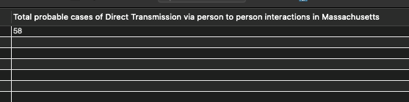

*R-Notebook Execution*

val2 <- dbFetch(dbSendQuery(conn,"SELECT count(*) as TotalProbableCasesViaPersonToPersonMassachusetts  
FROM  
 (SELECT i.InteractingUserID FROM Interactions i  
INNER JOIN UserEvents on i.InteractionID=UserEvents.EventID  
INNER JOIN HealthReportCheck r1 on i.InteractingUserID=r1.UserID  
INNER JOIN HealthReportCheck r2 on i.VisitorID=r2.UserID  
INNER JOIN Place on i.InteractionPlaceID=place.placeid  
WHERE r1.TestResult='POSITIVE' and r2.TestResult in ('NEGATIVE','UNCLEAR')  
AND r1.ReportDate<r2.ReportDate  
AND Place.State in ('MA')  
) as derived;" ))  
  
val2

## TotalProbableCasesViaPersonToPersonMassachusetts  
## 1 58

**QUERY 3** - A QUERY with a HAVING CLAUSE to return the details of visits made by people who tested positive, within 20 days(before and after) of getting the test reports. Where the visit lasted longer than 4 hours.

*SQL:*

SELECT a.UserID, p.firstName, s.PhoneNo, u.EventStartTime as “Time of Visit”,TIMEDIFF(u.EventEndTime,u.EventStartTime)as DurationOfVisit, m.placename,m.streetarea, m.city, m.longitude, m.latitude FROM visit v INNER JOIN AppUser a on v.VisitingUserID=a.UserID INNER JOIN Person p on a.userid=p.PersonID INNER JOIN PersonPhone s on p.PersonID=s.PersonID INNER JOIN Place m on v.VisitPlaceID=m.placeid INNER JOIN UserEvents u on v.VisitID=u.EventID INNER JOIN HealthReportCheck h on a.UserID=h.UserID WHERE h.TestResult=‘POSITIVE’ AND datediff(h.ReportDate, u.EventStartTime)<20 AND datediff(h.ReportDate, u.EventStartTime)>-20 HAVING DurationOfVisit>‘04:00:00’ ORDER by DurationOfVisit

9 row(s) returned

*RESULT SCREENSHOTS*:

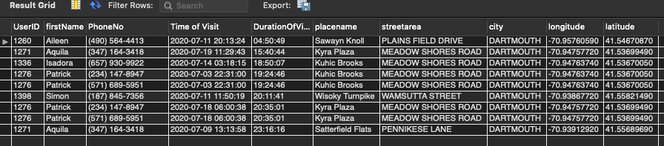

*R-Notebook Execution*

val3 <- dbFetch(dbSendQuery(conn,"SELECT a.UserID, p.firstName, s.PhoneNo, u.EventStartTime as TimeOFVisit,TIMEDIFF(u.EventEndTime,u.EventStartTime)as DurationOfVisit, m.placename,m.streetarea, m.city, m.longitude, m.latitude FROM visit v  
INNER JOIN AppUser a on v.VisitingUserID=a.UserID  
INNER JOIN Person p on a.userid=p.PersonID  
INNER JOIN PersonPhone s on p.PersonID=s.PersonID  
INNER JOIN Place m on v.VisitPlaceID=m.placeid  
INNER JOIN UserEvents u on v.VisitID=u.EventID  
INNER JOIN HealthReportCheck h on a.UserID=h.UserID  
WHERE h.TestResult='POSITIVE'  
AND datediff(h.ReportDate, u.EventStartTime)<20   
AND datediff(h.ReportDate, u.EventStartTime)>-20  
HAVING DurationOfVisit>'04:00:00'  
ORDER by DurationOfVisit"))

## Warning in .local(conn, statement, ...): Decimal MySQL column 8 imported as  
## numeric

## Warning in .local(conn, statement, ...): Decimal MySQL column 9 imported as  
## numeric

val3

## UserID firstName PhoneNo TimeOFVisit DurationOfVisit  
## 1 1260 Aileen (490) 564-4413 2020-07-11 20:13:24 04:50:49  
## 2 1271 Aquila (347) 164-3418 2020-07-19 11:29:43 15:40:44  
## 3 1336 Isadora (657) 930-9922 2020-07-14 03:18:15 18:50:07  
## 4 1276 Patrick (234) 147-8947 2020-07-03 22:31:00 19:24:46  
## 5 1276 Patrick (571) 689-5951 2020-07-03 22:31:00 19:24:46  
## 6 1398 Simon (187) 845-7356 2020-07-11 11:50:19 20:11:41  
## 7 1276 Patrick (234) 147-8947 2020-07-18 06:00:38 20:35:01  
## 8 1276 Patrick (571) 689-5951 2020-07-18 06:00:38 20:35:01  
## 9 1271 Aquila (347) 164-3418 2020-07-09 13:13:58 23:16:16  
## placename streetarea city longitude latitude  
## 1 Sawayn Knoll PLAINS FIELD DRIVE DARTMOUTH -70.95761 41.54671  
## 2 Kyra Plaza MEADOW SHORES ROAD DARTMOUTH -70.94758 41.53699  
## 3 Kuhic Brooks MEADOW SHORES ROAD DARTMOUTH -70.94764 41.53670  
## 4 Kuhic Brooks MEADOW SHORES ROAD DARTMOUTH -70.94764 41.53670  
## 5 Kuhic Brooks MEADOW SHORES ROAD DARTMOUTH -70.94764 41.53670  
## 6 Wisoky Turnpike WAMSUTTA STREET DARTMOUTH -70.93868 41.55821  
## 7 Kyra Plaza MEADOW SHORES ROAD DARTMOUTH -70.94758 41.53699  
## 8 Kyra Plaza MEADOW SHORES ROAD DARTMOUTH -70.94758 41.53699  
## 9 Satterfield Flats PENNIKESE LANE DARTMOUTH -70.93913 41.55690

**QUERY 4 - A COMPLEX QUERY** - A depth-2 search query to find out all interactions of persons, who came out positive/unclear in the covid-19 test, after their interacting with some person in the past.

Example Case:

* John Doe meets Sabrina Chan, and Jian Yang.
* John Doe was found positive, so Sabrina Chan and Jian Yang take covid tests.
* Jian tests positive, while Sabrina tests negative, so we need to trace Jian’s interactions now.

*SQL:* select o.FirstName as “Guy1 who found out he got exposed”, p.FirstName as “Guy2 who had met guy1”, s.PhoneNo as “Phone number of Guy2”, u.eventstarttime as “Interaction Start Details” , u.eventendtime as “Interaction End Details” from interactions a, person p, personphone s,userevents u, person o WHERE a.InteractionID=u.eventid AND p.personid = a.visitorid AND s.PersonID=p.PersonId AND a.Interactinguserid=o.personid

AND a.interactinguserid IN ( SELECT i.VisitorID FROM Interactions i INNER JOIN UserEvents on i.InteractionID=UserEvents.EventID INNER JOIN HealthReportCheck r1 on i.InteractingUserID=r1.UserID INNER JOIN HealthReportCheck r2 on i.VisitorID=r2.UserID WHERE r1.TestResult=‘POSITIVE’ and r2.TestResult in (‘UNCLEAR’,‘POSITIVE’) AND r1.ReportDate< r2.ReportDate )

AND a.Interactinguserid NOT IN ( SELECT i.interactinguserid FROM Interactions i INNER JOIN UserEvents on i.InteractionID=UserEvents.EventID INNER JOIN HealthReportCheck r1 on i.InteractingUserID=r1.UserID INNER JOIN HealthReportCheck r2 on i.VisitorID=r2.UserID WHERE r1.TestResult=‘POSITIVE’ and r2.TestResult in (‘UNCLEAR’,‘POSITIVE’) AND r1.ReportDate< r2.ReportDate )

37 row(s) returned

*RESULT SCREENSHOTS*

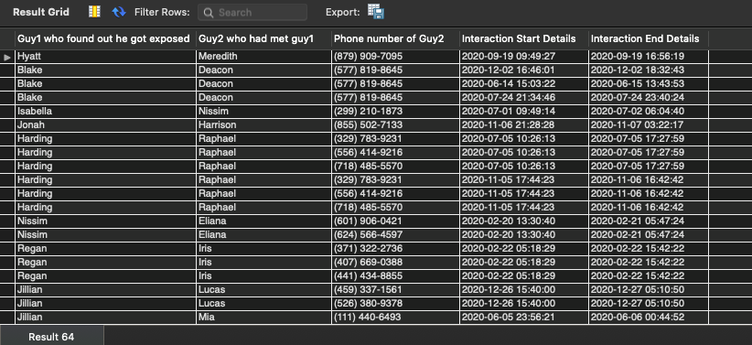

Results

Note: We don’t use the distinct keyword because we want to find out all interactions, even if there were more than one!

We can go till depth 5 with MySQL in a medium sized database, after depth-5 mysqld crashes within 30 minutes of wait.

*R-Notebook Execution*

val4 <- dbFetch(dbSendQuery(conn,"select o.FirstName as Guy1_who_found_out_he_got_exposed, p.FirstName as Guy2_who_had_met_guy1, s.PhoneNo as Phone_number_of_Guy2, u.eventstarttime as Interaction_Start_Details , u.eventendtime as Interaction_End_Details from interactions a, person p, personphone s,userevents u, person o  
WHERE a.InteractionID=u.eventid  
AND p.personid = a.visitorid  
AND s.PersonID=p.PersonId  
AND a.Interactinguserid=o.personid  
  
AND a.interactinguserid IN (  
SELECT i.VisitorID FROM Interactions i  
INNER JOIN UserEvents on i.InteractionID=UserEvents.EventID  
INNER JOIN HealthReportCheck r1 on i.InteractingUserID=r1.UserID  
INNER JOIN HealthReportCheck r2 on i.VisitorID=r2.UserID  
WHERE r1.TestResult='POSITIVE' and r2.TestResult in ('UNCLEAR','POSITIVE')  
AND r1.ReportDate< r2.ReportDate  
)  
  
AND a.Interactinguserid NOT IN (  
SELECT i.interactinguserid FROM Interactions i  
INNER JOIN UserEvents on i.InteractionID=UserEvents.EventID  
INNER JOIN HealthReportCheck r1 on i.InteractingUserID=r1.UserID  
INNER JOIN HealthReportCheck r2 on i.VisitorID=r2.UserID  
WHERE r1.TestResult='POSITIVE' and r2.TestResult in ('UNCLEAR','POSITIVE')  
AND r1.ReportDate< r2.ReportDate  
) "))  
  
val4

## Guy1_who_found_out_he_got_exposed Guy2_who_had_met_guy1 Phone_number_of_Guy2  
## 1 Hyatt Meredith (879) 909-7095  
## 2 Blake Deacon (577) 819-8645  
## 3 Blake Deacon (577) 819-8645  
## 4 Blake Deacon (577) 819-8645  
## 5 Isabella Nissim (299) 210-1873  
## 6 Jonah Harrison (855) 502-7133  
## 7 Harding Raphael (329) 783-9231  
## 8 Harding Raphael (556) 414-9216  
## 9 Harding Raphael (718) 485-5570  
## 10 Harding Raphael (329) 783-9231  
## 11 Harding Raphael (556) 414-9216  
## 12 Harding Raphael (718) 485-5570  
## 13 Nissim Eliana (601) 906-0421  
## 14 Nissim Eliana (624) 566-4597  
## 15 Regan Iris (371) 322-2736  
## 16 Regan Iris (407) 669-0388  
## 17 Regan Iris (441) 434-8855  
## 18 Jillian Lucas (459) 337-1561  
## 19 Jillian Lucas (526) 380-9378  
## 20 Jillian Mia (111) 440-6493  
## 21 Jillian Mia (411) 680-7101  
## 22 Jillian Mia (638) 297-5657  
## 23 Ulysses Courtney (475) 783-9150  
## 24 Xerxes Leilani (259) 483-8832  
## 25 Shafira Katell (363) 101-8143  
## 26 Shafira Katell (797) 450-6084  
## 27 Shafira Katell (363) 101-8143  
## 28 Shafira Katell (797) 450-6084  
## 29 Shafira Fredericka (245) 631-6854  
## 30 Shafira Katell (363) 101-8143  
## 31 Shafira Katell (797) 450-6084  
## 32 Iris Blake (925) 907-6582  
## 33 Dacey Alexandra (181) 501-5690  
## 34 Dacey Alexandra (181) 501-5690  
## 35 Zoe Colby (329) 852-7871  
## 36 Tashya Wayne (641) 587-1772  
## 37 Tashya Wayne (641) 587-1772  
## Interaction_Start_Details Interaction_End_Details  
## 1 2020-09-19 09:49:27 2020-09-19 16:56:19  
## 2 2020-12-02 16:46:01 2020-12-02 18:32:43  
## 3 2020-06-14 15:03:22 2020-06-15 13:43:53  
## 4 2020-07-24 21:34:46 2020-07-24 23:40:24  
## 5 2020-07-01 09:49:14 2020-07-02 06:04:40  
## 6 2020-11-06 21:28:28 2020-11-07 03:22:17  
## 7 2020-07-05 10:26:13 2020-07-05 17:27:59  
## 8 2020-07-05 10:26:13 2020-07-05 17:27:59  
## 9 2020-07-05 10:26:13 2020-07-05 17:27:59  
## 10 2020-11-05 17:44:23 2020-11-06 16:42:42  
## 11 2020-11-05 17:44:23 2020-11-06 16:42:42  
## 12 2020-11-05 17:44:23 2020-11-06 16:42:42  
## 13 2020-02-20 13:30:40 2020-02-21 05:47:24  
## 14 2020-02-20 13:30:40 2020-02-21 05:47:24  
## 15 2020-02-22 05:18:29 2020-02-22 15:42:22  
## 16 2020-02-22 05:18:29 2020-02-22 15:42:22  
## 17 2020-02-22 05:18:29 2020-02-22 15:42:22  
## 18 2020-12-26 15:40:00 2020-12-27 05:10:50  
## 19 2020-12-26 15:40:00 2020-12-27 05:10:50  
## 20 2020-06-05 23:56:21 2020-06-06 00:44:52  
## 21 2020-06-05 23:56:21 2020-06-06 00:44:52  
## 22 2020-06-05 23:56:21 2020-06-06 00:44:52  
## 23 2020-11-24 03:20:33 2020-11-24 10:32:17  
## 24 2020-03-16 05:26:22 2020-03-16 12:53:25  
## 25 2020-11-23 11:26:12 2020-11-23 19:12:51  
## 26 2020-11-23 11:26:12 2020-11-23 19:12:51  
## 27 2020-08-29 13:37:45 2020-08-29 15:40:25  
## 28 2020-08-29 13:37:45 2020-08-29 15:40:25  
## 29 2020-04-09 08:14:49 2020-04-10 00:27:31  
## 30 2020-01-05 13:53:23 2020-01-06 00:40:26  
## 31 2020-01-05 13:53:23 2020-01-06 00:40:26  
## 32 2020-04-04 15:16:41 2020-04-04 23:30:01  
## 33 2020-02-16 04:35:03 2020-02-16 20:04:04  
## 34 2020-09-21 12:39:58 2020-09-22 02:20:06  
## 35 2020-08-18 23:13:41 2020-08-19 03:14:37  
## 36 2020-01-31 23:21:49 2020-02-01 07:47:41  
## 37 2020-03-01 22:01:35 2020-03-02 17:01:29

**QUERY 5 - A Query of Choice**

Details of interactions of persons who tested COVID positive(Depth 1 -> Guy 0 meets Guy 1)

*SQL:*

SELECT i.interactingUserId as UniqueID, guy1.firstName as “Meeting Person 1”, r1.TestResult as “First Guy’s Covid Report” ,i.VisitorID as UniqueID,guy2.firstName as “Meeting Person 2”, r2.TestResult as “Second Guy’s Covid Report”, UserEvents.EventStartTime as “DateTime of Meeting”, UserEvents.Description as “Details of Meeting” FROM Interactions i INNER JOIN UserEvents on i.InteractionID=UserEvents.EventID INNER JOIN Person guy1 on i.InteractingUserID=guy1.PersonID INNER JOIN Person guy2 on i.VisitorID=guy2.PersonID INNER JOIN HealthReportCheck r1 on i.InteractingUserID=r1.UserID INNER JOIN HealthReportCheck r2 on i.VisitorID=r2.UserID WHERE r1.TestResult=‘POSITIVE’ 228 row(s) returned

RESULTS SCREENSHOTS:

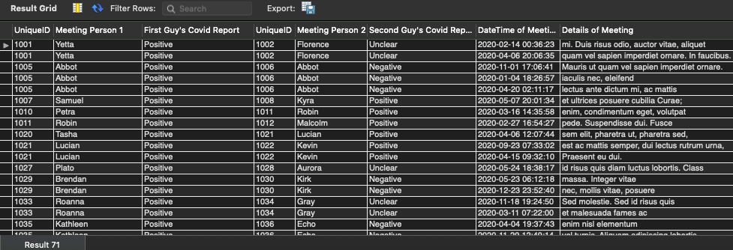

Results

*R-Notebook Execution*

val5 <- dbFetch(dbSendQuery(conn,"SELECT i.interactingUserId as UniqueID,  
guy1.firstName as Meeting_Person_1, r1.TestResult as First_Guys_Covid_Report,  
i.VisitorID as UniqueID, guy2.firstName as Meeting_Person_2,   
r2.TestResult as Second_Guys_CovidReport,   
UserEvents.EventStartTime as DateTime_of_Meeting, UserEvents.Description as Details_of_Meeting  
 FROM Interactions i  
INNER JOIN UserEvents on i.InteractionID=UserEvents.EventID  
INNER JOIN Person guy1 on i.InteractingUserID=guy1.PersonID  
INNER JOIN Person guy2 on i.VisitorID=guy2.PersonID  
INNER JOIN HealthReportCheck r1 on i.InteractingUserID=r1.UserID  
INNER JOIN HealthReportCheck r2 on i.VisitorID=r2.UserID  
WHERE r1.TestResult='POSITIVE'"))  
  
val5

## UniqueID Meeting_Person_1 First_Guys_Covid_Report UniqueID Meeting_Person_2  
## 1 1001 Yetta Positive 1002 Florence  
## 2 1001 Yetta Positive 1002 Florence  
## 3 1005 Abbot Positive 1006 Abbot  
## 4 1005 Abbot Positive 1006 Abbot  
## 5 1005 Abbot Positive 1006 Abbot  
## 6 1007 Samuel Positive 1008 Kyra  
## 7 1010 Petra Positive 1011 Robin  
## 8 1011 Robin Positive 1012 Malcolm  
## 9 1020 Tasha Positive 1021 Lucian  
## 10 1021 Lucian Positive 1022 Kevin  
## 11 1021 Lucian Positive 1022 Kevin  
## 12 1027 Plato Positive 1028 Aurora  
## 13 1029 Brendan Positive 1030 Kirk  
## 14 1029 Brendan Positive 1030 Kirk  
## 15 1033 Roanna Positive 1034 Gray  
## 16 1033 Roanna Positive 1034 Gray  
## 17 1035 Kathleen Positive 1036 Echo  
## 18 1035 Kathleen Positive 1036 Echo  
## 19 1037 Hollee Positive 1038 Hope  
## 20 1037 Hollee Positive 1038 Hope  
## 21 1043 Baker Positive 1044 Carson  
## 22 1057 Blaze Positive 1058 Igor  
## 23 1057 Blaze Positive 1058 Igor  
## 24 1234 Alexis Positive 1235 Octavius  
## 25 1260 Aileen Positive 1261 Damian  
## 26 1260 Aileen Positive 1261 Damian  
## 27 1276 Patrick Positive 1277 Hyatt  
## 28 1276 Patrick Positive 1277 Hyatt  
## 29 1255 Desiree Positive 1256 Eagan  
## 30 1255 Desiree Positive 1256 Eagan  
## 31 1255 Desiree Positive 1256 Eagan  
## 32 1255 Desiree Positive 1256 Eagan  
## 33 1260 Aileen Positive 1261 Damian  
## 34 1260 Aileen Positive 1261 Damian  
## 35 1261 Damian Positive 1262 Giacomo  
## 36 1261 Damian Positive 1262 Giacomo  
## 37 1261 Damian Positive 1262 Giacomo  
## 38 1261 Damian Positive 1262 Giacomo  
## 39 1264 Alisa Positive 1265 Michael  
## 40 1264 Alisa Positive 1265 Michael  
## 41 1270 Naomi Positive 1271 Aquila  
## 42 1270 Naomi Positive 1271 Aquila  
## 43 1270 Naomi Positive 1271 Aquila  
## 44 1270 Naomi Positive 1271 Aquila  
## 45 1273 Adara Positive 1274 Malik  
## 46 1273 Adara Positive 1274 Malik  
## 47 1273 Adara Positive 1274 Malik  
## 48 1273 Adara Positive 1274 Malik  
## 49 1277 Hyatt Positive 1278 Meredith  
## 50 1277 Hyatt Positive 1278 Meredith  
## 51 1289 Wendy Positive 1290 Xander  
## 52 1289 Wendy Positive 1290 Xander  
## 53 1291 Magee Positive 1292 Chaney  
## 54 1291 Magee Positive 1292 Chaney  
## 55 1295 Inez Positive 1296 Charity  
## 56 1295 Inez Positive 1296 Charity  
## 57 1300 Maxine Positive 1301 Candace  
## 58 1300 Maxine Positive 1301 Candace  
## 59 1306 Daniel Positive 1307 Lesley  
## 60 1310 Dai Positive 1311 Malachi  
## 61 1315 Nayda Positive 1316 Seth  
## 62 1315 Nayda Positive 1316 Seth  
## 63 1315 Nayda Positive 1316 Seth  
## 64 1318 Haviva Positive 1319 Myra  
## 65 1320 Cara Positive 1321 Blake  
## 66 1321 Blake Positive 1322 Deacon  
## 67 1321 Blake Positive 1322 Deacon  
## 68 1321 Blake Positive 1322 Deacon  
## 69 1329 Wanda Positive 1330 Debra  
## 70 1329 Wanda Positive 1330 Debra  
## 71 1330 Debra Positive 1331 Alice  
## 72 1330 Debra Positive 1331 Alice  
## 73 1335 Samuel Positive 1336 Isadora  
## 74 1335 Samuel Positive 1336 Isadora  
## 75 1336 Isadora Positive 1337 Lareina  
## 76 1337 Lareina Positive 1338 Linus  
## 77 1337 Lareina Positive 1338 Linus  
## 78 1339 Bryar Positive 1340 Isabella  
## 79 1339 Bryar Positive 1340 Isabella  
## 80 1348 Vielka Positive 1349 Colette  
## 81 1354 Griffith Positive 1355 Christopher  
## 82 1387 Yetta Positive 1388 Igor  
## 83 1387 Yetta Positive 1388 Igor  
## 84 1396 Judith Positive 1397 Kato  
## 85 1399 Alexis Positive 1400 Belle  
## 86 1399 Alexis Positive 1400 Belle  
## 87 1399 Alexis Positive 1400 Belle  
## 88 1399 Alexis Positive 1400 Belle  
## 89 1400 Belle Positive 1401 Jonah  
## 90 1400 Belle Positive 1401 Jonah  
## 91 1400 Belle Positive 1401 Jonah  
## 92 1400 Belle Positive 1401 Jonah  
## 93 1401 Jonah Positive 1402 Harrison  
## 94 1401 Jonah Positive 1402 Harrison  
## 95 1404 Ulysses Positive 1405 Courtney  
## 96 1404 Ulysses Positive 1405 Courtney  
## 97 1406 Nash Positive 1407 Katelyn  
## 98 1406 Nash Positive 1407 Katelyn  
## 99 1414 Jocelyn Positive 1415 Daquan  
## 100 1414 Jocelyn Positive 1415 Daquan  
## 101 1414 Jocelyn Positive 1415 Daquan  
## 102 1414 Jocelyn Positive 1415 Daquan  
## 103 1417 Kellie Positive 1418 Kiayada  
## 104 1417 Kellie Positive 1418 Kiayada  
## 105 1417 Kellie Positive 1418 Kiayada  
## 106 1417 Kellie Positive 1418 Kiayada  
## 107 1428 Jesse Positive 1429 Harding  
## 108 1428 Jesse Positive 1429 Harding  
## 109 1430 Raphael Positive 1431 Nissim  
## 110 1430 Raphael Positive 1431 Nissim  
## 111 1430 Raphael Positive 1431 Nissim  
## 112 1430 Raphael Positive 1431 Nissim  
## 113 1432 Eliana Positive 1433 Cathleen  
## 114 1432 Eliana Positive 1433 Cathleen  
## 115 1432 Eliana Positive 1433 Cathleen  
## 116 1432 Eliana Positive 1433 Cathleen  
## 117 1433 Cathleen Positive 1434 Evangeline  
## 118 1433 Cathleen Positive 1434 Evangeline  
## 119 1434 Evangeline Positive 1435 Shafira  
## 120 1434 Evangeline Positive 1435 Shafira  
## 121 1435 Shafira Positive 1436 Katell  
## 122 1435 Shafira Positive 1436 Katell  
## 123 1435 Shafira Positive 1436 Katell  
## 124 1435 Shafira Positive 1436 Katell  
## 125 1435 Shafira Positive 1436 Katell  
## 126 1435 Shafira Positive 1436 Katell  
## 127 1439 Jonas Positive 1440 Brenna  
## 128 1439 Jonas Positive 1440 Brenna  
## 129 1441 Lacota Positive 1442 Raymond  
## 130 1441 Lacota Positive 1442 Raymond  
## 131 1441 Lacota Positive 1442 Raymond  
## 132 1441 Lacota Positive 1442 Raymond  
## 133 1443 Adrienne Positive 1444 Odysseus  
## 134 1443 Adrienne Positive 1444 Odysseus  
## 135 1445 Cailin Positive 1446 Regan  
## 136 1445 Cailin Positive 1446 Regan  
## 137 1445 Cailin Positive 1446 Regan  
## 138 1445 Cailin Positive 1446 Regan  
## 139 1446 Regan Positive 1447 Iris  
## 140 1446 Regan Positive 1447 Iris  
## 141 1447 Iris Positive 1448 Jillian  
## 142 1447 Iris Positive 1448 Jillian  
## 143 1447 Iris Positive 1448 Jillian  
## 144 1447 Iris Positive 1448 Jillian  
## 145 1400 Belle Positive 1401 Jonah  
## 146 1400 Belle Positive 1401 Jonah  
## 147 1400 Belle Positive 1401 Jonah  
## 148 1400 Belle Positive 1401 Jonah  
## 149 1401 Jonah Positive 1402 Harrison  
## 150 1401 Jonah Positive 1402 Harrison  
## 151 1402 Harrison Positive 1403 Teegan  
## 152 1402 Harrison Positive 1403 Teegan  
## 153 1402 Harrison Positive 1403 Teegan  
## 154 1402 Harrison Positive 1403 Teegan  
## 155 1403 Teegan Positive 1404 Ulysses  
## 156 1403 Teegan Positive 1404 Ulysses  
## 157 1408 Dana Positive 1409 Lael  
## 158 1408 Dana Positive 1409 Lael  
## 159 1408 Dana Positive 1409 Lael  
## 160 1408 Dana Positive 1409 Lael  
## 161 1411 Ross Positive 1412 Scott  
## 162 1411 Ross Positive 1412 Scott  
## 163 1411 Ross Positive 1412 Scott  
## 164 1411 Ross Positive 1412 Scott  
## 165 1414 Jocelyn Positive 1415 Daquan  
## 166 1414 Jocelyn Positive 1415 Daquan  
## 167 1414 Jocelyn Positive 1415 Daquan  
## 168 1414 Jocelyn Positive 1415 Daquan  
## 169 1415 Daquan Positive 1416 Hedy  
## 170 1415 Daquan Positive 1416 Hedy  
## 171 1415 Daquan Positive 1416 Hedy  
## 172 1415 Daquan Positive 1416 Hedy  
## 173 1423 Charissa Positive 1424 Xerxes  
## 174 1423 Charissa Positive 1424 Xerxes  
## 175 1423 Charissa Positive 1424 Xerxes  
## 176 1423 Charissa Positive 1424 Xerxes  
## 177 1424 Xerxes Positive 1425 Leilani  
## 178 1424 Xerxes Positive 1425 Leilani  
## 179 1428 Jesse Positive 1429 Harding  
## 180 1428 Jesse Positive 1429 Harding  
## 181 1429 Harding Positive 1430 Raphael  
## 182 1429 Harding Positive 1430 Raphael  
## 183 1429 Harding Positive 1430 Raphael  
## 184 1429 Harding Positive 1430 Raphael  
## 185 1432 Eliana Positive 1433 Cathleen  
## 186 1432 Eliana Positive 1433 Cathleen  
## 187 1432 Eliana Positive 1433 Cathleen  
## 188 1432 Eliana Positive 1433 Cathleen  
## 189 1433 Cathleen Positive 1434 Evangeline  
## 190 1433 Cathleen Positive 1434 Evangeline  
## 191 1434 Evangeline Positive 1435 Shafira  
## 192 1434 Evangeline Positive 1435 Shafira  
## 193 1441 Lacota Positive 1442 Raymond  
## 194 1441 Lacota Positive 1442 Raymond  
## 195 1441 Lacota Positive 1442 Raymond  
## 196 1441 Lacota Positive 1442 Raymond  
## 197 1448 Jillian Positive 1449 Lucas  
## 198 1448 Jillian Positive 1449 Lucas  
## 199 1453 Yeo Positive 1454 Oren  
## 200 1453 Yeo Positive 1454 Oren  
## 201 1456 Derek Positive 1457 Autumn  
## 202 1456 Derek Positive 1457 Autumn  
## 203 1457 Autumn Positive 1458 Iris  
## 204 1458 Iris Positive 1459 Blake  
## 205 1460 Nero Positive 1461 Harding  
## 206 1460 Nero Positive 1461 Harding  
## 207 1463 Phyllis Positive 1464 Demetrius  
## 208 1467 Chaim Positive 1468 Deanna  
## 209 1468 Deanna Positive 1469 Tanya  
## 210 1468 Deanna Positive 1469 Tanya  
## 211 1469 Tanya Positive 1470 Dacey  
## 212 1471 Alexandra Positive 1472 Winifred  
## 213 1471 Alexandra Positive 1472 Winifred  
## 214 1473 Xanthus Positive 1474 Gannon  
## 215 1475 Quamar Positive 1476 Brittany  
## 216 1475 Quamar Positive 1476 Brittany  
## 217 1476 Brittany Positive 1477 Garrett  
## 218 1479 Kamal Positive 1480 Noel  
## 219 1482 Randall Positive 1483 Adena  
## 220 1485 Barry Positive 1486 Erin  
## 221 1485 Barry Positive 1486 Erin  
## 222 1489 Bertha Positive 1490 Marsden  
## 223 1489 Bertha Positive 1490 Marsden  
## 224 1490 Marsden Positive 1491 Zoe  
## 225 1490 Marsden Positive 1491 Zoe  
## 226 1491 Zoe Positive 1492 Colby  
## 227 1496 Mikayla Positive 1497 Ishmael  
## 228 1497 Ishmael Positive 1498 Tashya  
## Second_Guys_CovidReport DateTime_of_Meeting  
## 1 Unclear 2020-02-14 00:36:23  
## 2 Unclear 2020-04-06 20:06:35  
## 3 Negative 2020-11-01 17:06:41  
## 4 Negative 2020-01-04 18:26:57  
## 5 Negative 2020-04-20 02:11:17  
## 6 Positive 2020-05-07 20:01:34  
## 7 Positive 2020-03-16 14:35:58  
## 8 Positive 2020-02-27 16:54:27  
## 9 Positive 2020-04-06 12:07:44  
## 10 Positive 2020-09-23 07:33:02  
## 11 Positive 2020-04-15 09:32:10  
## 12 Unclear 2020-05-24 18:38:17  
## 13 Negative 2020-05-23 06:12:18  
## 14 Negative 2020-12-23 23:52:40  
## 15 Unclear 2020-11-18 19:24:50  
## 16 Unclear 2020-03-11 07:22:00  
## 17 Negative 2020-04-04 19:37:43  
## 18 Negative 2020-11-29 12:49:14  
## 19 Negative 2020-01-30 20:36:51  
## 20 Negative 2020-01-31 12:19:56  
## 21 Negative 2020-02-17 20:20:07  
## 22 Negative 2020-12-24 15:51:24  
## 23 Negative 2020-06-26 20:09:01  
## 24 Negative 2020-03-25 23:58:49  
## 25 Negative 2020-09-27 03:37:25  
## 26 Positive 2020-09-27 03:37:25  
## 27 Unclear 2020-12-31 23:16:28  
## 28 Positive 2020-12-31 23:16:28  
## 29 Negative 2020-10-11 08:35:09  
## 30 Negative 2020-10-11 08:35:09  
## 31 Negative 2020-06-16 06:26:50  
## 32 Negative 2020-06-16 06:26:50  
## 33 Negative 2020-09-27 03:37:25  
## 34 Positive 2020-09-27 03:37:25  
## 35 Unclear 2020-04-22 05:26:11  
## 36 Positive 2020-04-22 05:26:11  
## 37 Unclear 2020-01-17 02:15:55  
## 38 Positive 2020-01-17 02:15:55  
## 39 Negative 2020-08-30 11:05:37  
## 40 Unclear 2020-08-30 11:05:37  
## 41 Negative 2020-11-30 09:53:08  
## 42 Positive 2020-11-30 09:53:08  
## 43 Negative 2020-08-26 16:55:45  
## 44 Positive 2020-08-26 16:55:45  
## 45 Negative 2020-02-15 15:25:29  
## 46 Unclear 2020-02-15 15:25:29  
## 47 Negative 2020-08-02 06:01:47  
## 48 Unclear 2020-08-02 06:01:47  
## 49 Negative 2020-09-19 09:49:27  
## 50 Positive 2020-09-19 09:49:27  
## 51 Negative 2020-03-16 05:06:21  
## 52 Negative 2020-03-16 05:06:21  
## 53 Negative 2020-03-25 23:24:56  
## 54 Positive 2020-03-25 23:24:56  
## 55 Negative 2020-10-04 00:10:03  
## 56 Positive 2020-10-04 00:10:03  
## 57 Negative 2020-01-19 14:48:27  
## 58 Negative 2020-05-15 17:44:35  
## 59 Negative 2020-07-13 22:59:50  
## 60 Negative 2020-12-09 05:44:25  
## 61 Positive 2020-05-17 16:58:49  
## 62 Positive 2020-06-29 01:52:13  
## 63 Positive 2020-07-04 02:57:55  
## 64 Negative 2020-09-26 16:22:37  
## 65 Positive 2020-02-17 08:08:22  
## 66 Positive 2020-12-02 16:46:01  
## 67 Positive 2020-06-14 15:03:22  
## 68 Positive 2020-07-24 21:34:46  
## 69 Positive 2020-12-03 04:05:56  
## 70 Positive 2020-03-23 17:56:48  
## 71 Negative 2020-08-11 19:50:24  
## 72 Negative 2020-10-06 04:26:21  
## 73 Positive 2020-03-02 12:59:37  
## 74 Positive 2020-08-08 18:57:34  
## 75 Positive 2020-02-04 16:45:00  
## 76 Positive 2020-12-12 12:39:06  
## 77 Positive 2020-01-25 12:41:12  
## 78 Unclear 2020-10-29 13:22:43  
## 79 Unclear 2020-04-25 16:36:02  
## 80 Negative 2020-01-19 12:59:09  
## 81 Negative 2020-07-31 22:53:13  
## 82 Negative 2020-05-07 08:58:51  
## 83 Negative 2020-08-03 13:29:55  
## 84 Unclear 2020-07-14 17:44:23  
## 85 Positive 2020-07-26 01:46:46  
## 86 Positive 2020-07-26 01:46:46  
## 87 Positive 2020-11-27 10:48:03  
## 88 Positive 2020-11-27 10:48:03  
## 89 Positive 2020-11-13 02:00:29  
## 90 Positive 2020-11-13 02:00:29  
## 91 Positive 2020-01-19 03:47:17  
## 92 Positive 2020-01-19 03:47:17  
## 93 Unclear 2020-11-06 21:28:28  
## 94 Positive 2020-11-06 21:28:28  
## 95 Negative 2020-11-24 03:20:33  
## 96 Negative 2020-11-24 03:20:33  
## 97 Negative 2020-10-12 03:58:30  
## 98 Negative 2020-10-12 03:58:30  
## 99 Negative 2020-02-22 02:54:05  
## 100 Positive 2020-02-22 02:54:05  
## 101 Negative 2020-02-04 10:15:39  
## 102 Positive 2020-02-04 10:15:39  
## 103 Unclear 2020-04-27 18:18:28  
## 104 Negative 2020-04-27 18:18:28  
## 105 Unclear 2020-12-28 03:03:41  
## 106 Negative 2020-12-28 03:03:41  
## 107 Negative 2020-09-02 07:23:08  
## 108 Positive 2020-09-02 07:23:08  
## 109 Negative 2020-03-19 00:22:18  
## 110 Unclear 2020-03-19 00:22:18  
## 111 Negative 2020-01-05 17:32:01  
## 112 Unclear 2020-01-05 17:32:01  
## 113 Positive 2020-08-28 17:22:53  
## 114 Positive 2020-08-28 17:22:53  
## 115 Positive 2020-11-15 14:01:52  
## 116 Positive 2020-11-15 14:01:52  
## 117 Positive 2020-06-20 15:07:18  
## 118 Positive 2020-06-20 15:07:18  
## 119 Positive 2020-09-09 20:26:35  
## 120 Negative 2020-09-09 20:26:35  
## 121 Negative 2020-11-23 11:26:12  
## 122 Negative 2020-11-23 11:26:12  
## 123 Negative 2020-08-29 13:37:45  
## 124 Negative 2020-08-29 13:37:45  
## 125 Negative 2020-01-05 13:53:23  
## 126 Negative 2020-01-05 13:53:23  
## 127 Negative 2020-11-04 12:53:00  
## 128 Negative 2020-11-04 12:53:00  
## 129 Negative 2020-05-02 11:24:06  
## 130 Negative 2020-05-02 11:24:06  
## 131 Negative 2020-09-30 23:54:19  
## 132 Negative 2020-09-30 23:54:19  
## 133 Negative 2020-12-10 05:50:41  
## 134 Negative 2020-12-10 05:50:41  
## 135 Positive 2020-05-06 17:03:24  
## 136 Unclear 2020-05-06 17:03:24  
## 137 Positive 2020-07-05 18:36:58  
## 138 Unclear 2020-07-05 18:36:58  
## 139 Positive 2020-02-22 05:18:29  
## 140 Unclear 2020-02-22 05:18:29  
## 141 Unclear 2020-02-14 23:14:17  
## 142 Positive 2020-02-14 23:14:17  
## 143 Unclear 2020-12-18 03:23:03  
## 144 Positive 2020-12-18 03:23:03  
## 145 Positive 2020-11-13 02:00:29  
## 146 Positive 2020-11-13 02:00:29  
## 147 Positive 2020-01-19 03:47:17  
## 148 Positive 2020-01-19 03:47:17  
## 149 Unclear 2020-11-06 21:28:28  
## 150 Positive 2020-11-06 21:28:28  
## 151 Negative 2020-04-09 06:23:47  
## 152 Positive 2020-04-09 06:23:47  
## 153 Negative 2020-07-21 20:44:50  
## 154 Positive 2020-07-21 20:44:50  
## 155 Positive 2020-05-19 02:21:42  
## 156 Unclear 2020-05-19 02:21:42  
## 157 Negative 2020-01-14 11:28:18  
## 158 Negative 2020-01-14 11:28:18  
## 159 Negative 2020-01-04 22:16:19  
## 160 Negative 2020-01-04 22:16:19  
## 161 Negative 2020-12-08 10:14:55  
## 162 Negative 2020-12-08 10:14:55  
## 163 Negative 2020-06-20 20:11:58  
## 164 Negative 2020-06-20 20:11:58  
## 165 Negative 2020-02-22 02:54:05  
## 166 Positive 2020-02-22 02:54:05  
## 167 Negative 2020-02-04 10:15:39  
## 168 Positive 2020-02-04 10:15:39  
## 169 Negative 2020-04-17 03:39:20  
## 170 Negative 2020-04-17 03:39:20  
## 171 Negative 2020-09-02 08:49:11  
## 172 Negative 2020-09-02 08:49:11  
## 173 Unclear 2020-09-18 20:46:04  
## 174 Positive 2020-09-18 20:46:04  
## 175 Unclear 2020-12-24 00:54:36  
## 176 Positive 2020-12-24 00:54:36  
## 177 Negative 2020-03-16 05:26:22  
## 178 Negative 2020-03-16 05:26:22  
## 179 Negative 2020-09-02 07:23:08  
## 180 Positive 2020-09-02 07:23:08  
## 181 Positive 2020-07-05 10:26:13  
## 182 Negative 2020-07-05 10:26:13  
## 183 Positive 2020-11-05 17:44:23  
## 184 Negative 2020-11-05 17:44:23  
## 185 Positive 2020-08-28 17:22:53  
## 186 Positive 2020-08-28 17:22:53  
## 187 Positive 2020-11-15 14:01:52  
## 188 Positive 2020-11-15 14:01:52  
## 189 Positive 2020-06-20 15:07:18  
## 190 Positive 2020-06-20 15:07:18  
## 191 Positive 2020-09-09 20:26:35  
## 192 Negative 2020-09-09 20:26:35  
## 193 Negative 2020-05-02 11:24:06  
## 194 Negative 2020-05-02 11:24:06  
## 195 Negative 2020-09-30 23:54:19  
## 196 Negative 2020-09-30 23:54:19  
## 197 Unclear 2020-12-26 15:40:00  
## 198 Negative 2020-12-26 15:40:00  
## 199 Negative 2020-04-02 17:44:26  
## 200 Negative 2020-01-16 15:58:25  
## 201 Positive 2020-01-25 19:23:34  
## 202 Positive 2020-05-11 12:20:09  
## 203 Positive 2020-06-02 16:48:09  
## 204 Negative 2020-04-04 15:16:41  
## 205 Unclear 2020-07-11 16:55:20  
## 206 Unclear 2020-06-22 12:03:31  
## 207 Unclear 2020-05-21 05:34:24  
## 208 Positive 2020-06-21 23:35:39  
## 209 Positive 2020-05-06 01:43:04  
## 210 Positive 2020-05-30 03:01:33  
## 211 Unclear 2020-09-24 07:45:07  
## 212 Negative 2020-08-11 07:18:29  
## 213 Negative 2020-08-07 15:14:12  
## 214 Negative 2020-05-21 02:17:35  
## 215 Positive 2020-05-06 00:38:16  
## 216 Positive 2020-05-11 02:26:58  
## 217 Negative 2020-04-28 12:04:31  
## 218 Unclear 2020-06-02 03:58:52  
## 219 Negative 2020-12-25 01:06:52  
## 220 Negative 2020-05-07 20:24:47  
## 221 Negative 2020-07-17 21:52:24  
## 222 Positive 2020-09-23 22:47:59  
## 223 Positive 2020-10-13 23:02:03  
## 224 Positive 2020-02-20 23:56:48  
## 225 Positive 2020-08-10 05:06:46  
## 226 Unclear 2020-08-18 23:13:41  
## 227 Positive 2020-12-13 19:30:39  
## 228 Unclear 2020-06-17 22:05:29  
## Details_of_Meeting  
## 1 mi. Duis risus odio, auctor vitae, aliquet  
## 2 quam vel sapien imperdiet ornare. In faucibus.  
## 3 Mauris ut quam vel sapien imperdiet ornare.  
## 4 iaculis nec, eleifend  
## 5 lectus ante dictum mi, ac mattis  
## 6 et ultrices posuere cubilia Curae;  
## 7 enim, condimentum eget, volutpat  
## 8 pede. Suspendisse dui. Fusce  
## 9 sem elit, pharetra ut, pharetra sed,  
## 10 est ac mattis semper, dui lectus rutrum urna,  
## 11 Praesent eu dui.  
## 12 id risus quis diam luctus lobortis. Class  
## 13 massa. Integer vitae  
## 14 nec, mollis vitae, posuere  
## 15 Sed molestie. Sed id risus quis  
## 16 et malesuada fames ac  
## 17 enim nisl elementum  
## 18 vel turpis. Aliquam adipiscing lobortis  
## 19 erat, in consectetuer ipsum nunc id  
## 20 Sed nulla ante, iaculis nec,  
## 21 varius. Nam porttitor scelerisque  
## 22 eget, venenatis a,  
## 23 risus. Morbi metus. Vivamus euismod urna. Nullam lobortis  
## 24 per conubia nostra,  
## 25 libero lacus, varius et, euismod et, commodo at,  
## 26 libero lacus, varius et, euismod et, commodo at,  
## 27 Duis elementum, dui quis accumsan convallis,  
## 28 Duis elementum, dui quis accumsan convallis,  
## 29 amet metus. Aliquam erat volutpat.  
## 30 amet metus. Aliquam erat volutpat.  
## 31 arcu imperdiet ullamcorper. Duis at  
## 32 arcu imperdiet ullamcorper. Duis at  
## 33 libero lacus, varius et, euismod et, commodo at,  
## 34 libero lacus, varius et, euismod et, commodo at,  
## 35 Mauris eu turpis. Nulla aliquet. Proin velit. Sed  
## 36 Mauris eu turpis. Nulla aliquet. Proin velit. Sed  
## 37 vel pede blandit congue. In  
## 38 vel pede blandit congue. In  
## 39 Class aptent taciti sociosqu ad litora torquent per  
## 40 Class aptent taciti sociosqu ad litora torquent per  
## 41 in molestie tortor  
## 42 in molestie tortor  
## 43 vulputate, lacus. Cras interdum.  
## 44 vulputate, lacus. Cras interdum.  
## 45 Duis a mi fringilla  
## 46 Duis a mi fringilla  
## 47 lorem. Donec elementum,  
## 48 lorem. Donec elementum,  
## 49 Lorem ipsum dolor sit amet, consectetuer  
## 50 Lorem ipsum dolor sit amet, consectetuer  
## 51 Donec fringilla. Donec  
## 52 Donec fringilla. Donec  
## 53 lacus. Nulla tincidunt, neque vitae semper egestas, urna  
## 54 lacus. Nulla tincidunt, neque vitae semper egestas, urna  
## 55 a, scelerisque sed, sapien. Nunc pulvinar arcu  
## 56 a, scelerisque sed, sapien. Nunc pulvinar arcu  
## 57 In nec orci.  
## 58 natoque penatibus et magnis dis parturient montes,  
## 59 risus. In mi pede, nonummy ut, molestie  
## 60 lorem semper auctor. Mauris vel turpis. Aliquam adipiscing  
## 61 vulputate, nisi sem semper erat, in  
## 62 ornare placerat, orci lacus vestibulum lorem, sit amet  
## 63 nec metus facilisis lorem tristique aliquet. Phasellus fermentum  
## 64 velit. Aliquam nisl. Nulla eu  
## 65 ornare tortor at risus. Nunc ac  
## 66 ullamcorper eu, euismod ac, fermentum  
## 67 Mauris eu turpis.  
## 68 feugiat placerat velit. Quisque varius. Nam porttitor  
## 69 penatibus et magnis  
## 70 Sed eget lacus. Mauris  
## 71 Donec tempor, est  
## 72 interdum. Sed auctor odio a purus. Duis elementum,  
## 73 ornare lectus justo eu arcu. Morbi  
## 74 ac turpis egestas. Aliquam  
## 75 et, rutrum non, hendrerit id,  
## 76 eu, odio. Phasellus at augue id  
## 77 consequat purus. Maecenas libero est, congue a, aliquet  
## 78 vitae velit egestas lacinia.  
## 79 libero mauris, aliquam  
## 80 Proin mi. Aliquam gravida mauris ut mi.  
## 81 laoreet, libero et tristique pellentesque, tellus  
## 82 feugiat non, lobortis  
## 83 vestibulum lorem, sit  
## 84 metus vitae velit egestas lacinia. Sed  
## 85 mi felis, adipiscing fringilla, porttitor  
## 86 mi felis, adipiscing fringilla, porttitor  
## 87 adipiscing elit. Etiam  
## 88 adipiscing elit. Etiam  
## 89 amet diam eu  
## 90 amet diam eu  
## 91 eget mollis lectus pede et risus. Quisque  
## 92 eget mollis lectus pede et risus. Quisque  
## 93 eu sem. Pellentesque ut ipsum ac mi eleifend  
## 94 eu sem. Pellentesque ut ipsum ac mi eleifend  
## 95 non, hendrerit id,  
## 96 non, hendrerit id,  
## 97 orci luctus et  
## 98 orci luctus et  
## 99 cursus. Integer mollis. Integer tincidunt aliquam  
## 100 cursus. Integer mollis. Integer tincidunt aliquam  
## 101 dui lectus rutrum  
## 102 dui lectus rutrum  
## 103 montes, nascetur ridiculus  
## 104 montes, nascetur ridiculus  
## 105 molestie orci tincidunt adipiscing. Mauris molestie pharetra  
## 106 molestie orci tincidunt adipiscing. Mauris molestie pharetra  
## 107 felis. Donec tempor, est ac mattis semper,  
## 108 felis. Donec tempor, est ac mattis semper,  
## 109 nec, diam. Duis mi enim, condimentum eget, volutpat  
## 110 nec, diam. Duis mi enim, condimentum eget, volutpat  
## 111 Ut tincidunt orci quis lectus. Nullam suscipit, est  
## 112 Ut tincidunt orci quis lectus. Nullam suscipit, est  
## 113 Quisque fringilla euismod enim. Etiam gravida molestie arcu.  
## 114 Quisque fringilla euismod enim. Etiam gravida molestie arcu.  
## 115 pretium neque. Morbi quis urna. Nunc  
## 116 pretium neque. Morbi quis urna. Nunc  
## 117 at sem molestie  
## 118 at sem molestie  
## 119 ac orci. Ut semper  
## 120 ac orci. Ut semper  
## 121 molestie in, tempus eu,  
## 122 molestie in, tempus eu,  
## 123 eu tellus. Phasellus elit  
## 124 eu tellus. Phasellus elit  
## 125 vulputate, posuere vulputate, lacus. Cras interdum. Nunc sollicitudin  
## 126 vulputate, posuere vulputate, lacus. Cras interdum. Nunc sollicitudin  
## 127 sit amet, consectetuer adipiscing elit. Etiam laoreet, libero  
## 128 sit amet, consectetuer adipiscing elit. Etiam laoreet, libero  
## 129 placerat. Cras dictum ultricies ligula.  
## 130 placerat. Cras dictum ultricies ligula.  
## 131 sapien molestie orci tincidunt  
## 132 sapien molestie orci tincidunt  
## 133 lacus. Cras interdum. Nunc sollicitudin commodo ipsum. Suspendisse  
## 134 lacus. Cras interdum. Nunc sollicitudin commodo ipsum. Suspendisse  
## 135 nec, imperdiet nec, leo. Morbi neque  
## 136 nec, imperdiet nec, leo. Morbi neque  
## 137 tellus. Aenean egestas  
## 138 tellus. Aenean egestas  
## 139 blandit congue. In scelerisque scelerisque  
## 140 blandit congue. In scelerisque scelerisque  
## 141 a nunc. In at pede.  
## 142 a nunc. In at pede.  
## 143 eu, placerat eget,  
## 144 eu, placerat eget,  
## 145 amet diam eu  
## 146 amet diam eu  
## 147 eget mollis lectus pede et risus. Quisque  
## 148 eget mollis lectus pede et risus. Quisque  
## 149 eu sem. Pellentesque ut ipsum ac mi eleifend  
## 150 eu sem. Pellentesque ut ipsum ac mi eleifend  
## 151 non arcu. Vivamus sit amet risus. Donec  
## 152 non arcu. Vivamus sit amet risus. Donec  
## 153 neque sed sem egestas  
## 154 neque sed sem egestas  
## 155 dictum augue malesuada malesuada. Integer  
## 156 dictum augue malesuada malesuada. Integer  
## 157 Donec fringilla. Donec feugiat metus sit amet ante.  
## 158 Donec fringilla. Donec feugiat metus sit amet ante.  
## 159 sodales elit erat  
## 160 sodales elit erat  
## 161 lectus quis massa. Mauris  
## 162 lectus quis massa. Mauris  
## 163 turpis. In condimentum. Donec at arcu. Vestibulum  
## 164 turpis. In condimentum. Donec at arcu. Vestibulum  
## 165 cursus. Integer mollis. Integer tincidunt aliquam  
## 166 cursus. Integer mollis. Integer tincidunt aliquam  
## 167 dui lectus rutrum  
## 168 dui lectus rutrum  
## 169 cursus purus. Nullam scelerisque  
## 170 cursus purus. Nullam scelerisque  
## 171 aliquet lobortis, nisi nibh lacinia orci, consectetuer  
## 172 aliquet lobortis, nisi nibh lacinia orci, consectetuer  
## 173 senectus et netus  
## 174 senectus et netus  
## 175 non lorem vitae odio sagittis semper. Nam tempor  
## 176 non lorem vitae odio sagittis semper. Nam tempor  
## 177 vehicula aliquet libero. Integer in  
## 178 vehicula aliquet libero. Integer in  
## 179 felis. Donec tempor, est ac mattis semper,  
## 180 felis. Donec tempor, est ac mattis semper,  
## 181 metus. In lorem. Donec elementum,  
## 182 metus. In lorem. Donec elementum,  
## 183 id enim. Curabitur massa. Vestibulum  
## 184 id enim. Curabitur massa. Vestibulum  
## 185 Quisque fringilla euismod enim. Etiam gravida molestie arcu.  
## 186 Quisque fringilla euismod enim. Etiam gravida molestie arcu.  
## 187 pretium neque. Morbi quis urna. Nunc  
## 188 pretium neque. Morbi quis urna. Nunc  
## 189 at sem molestie  
## 190 at sem molestie  
## 191 ac orci. Ut semper  
## 192 ac orci. Ut semper  
## 193 placerat. Cras dictum ultricies ligula.  
## 194 placerat. Cras dictum ultricies ligula.  
## 195 sapien molestie orci tincidunt  
## 196 sapien molestie orci tincidunt  
## 197 vel, vulputate eu, odio. Phasellus at  
## 198 vel, vulputate eu, odio. Phasellus at  
## 199 pharetra ut, pharetra sed, hendrerit a, arcu.  
## 200 elementum at, egestas a, scelerisque  
## 201 at, velit. Cras lorem lorem, luctus  
## 202 erat vel pede blandit congue.  
## 203 Phasellus nulla. Integer vulputate,  
## 204 erat vel pede blandit congue. In scelerisque  
## 205 In faucibus. Morbi vehicula. Pellentesque tincidunt tempus  
## 206 risus. Donec nibh  
## 207 placerat velit. Quisque varius. Nam porttitor scelerisque neque.  
## 208 Suspendisse non leo. Vivamus nibh dolor, nonummy ac,  
## 209 in sodales elit erat vitae risus.  
## 210 ultrices. Vivamus rhoncus. Donec  
## 211 posuere at, velit. Cras lorem lorem, luctus ut,  
## 212 libero. Donec consectetuer mauris id  
## 213 parturient montes, nascetur ridiculus mus. Proin vel  
## 214 eget, volutpat ornare, facilisis  
## 215 amet, consectetuer adipiscing elit. Aliquam  
## 216 sagittis semper. Nam tempor diam dictum sapien. Aenean  
## 217 ipsum porta elit, a  
## 218 interdum. Nunc sollicitudin commodo ipsum. Suspendisse non leo.  
## 219 Phasellus at augue id ante dictum  
## 220 Pellentesque habitant morbi tristique senectus  
## 221 quam vel sapien imperdiet ornare.  
## 222 mollis vitae, posuere at, velit. Cras lorem lorem,  
## 223 placerat. Cras dictum ultricies  
## 224 libero nec ligula consectetuer rhoncus. Nullam  
## 225 amet ante. Vivamus non lorem vitae odio sagittis  
## 226 sem egestas blandit.  
## 227 et ultrices posuere cubilia  
## 228 ac arcu. Nunc mauris. Morbi non sapien

**QUERY 6 - EXTRA QUERY**

A QUERY with HAVING clause to count the no of people per city above 60 years in age, who took the Covid-19 Assessment survey, and suspected an infection, Only listing cities with more than 10 distinct suspects.

*SQL:*

SELECT distinct Place.city, count(distinct Assessment.TakerID) as “Total Covid Suspects around Boston region, with age greater than 50” FROM Place INNER JOIN AppUser on Place.placeid=AppUser.addressid INNER JOIN Assessment on AppUser.UserID=Assessment.TakerID WHERE Assessment.CovidSuspected=1 AND AppUser.Birthdate<‘1960-01-01’ Group By Place.City HAVING count(distinct Assessment.TakerID)>10;

*RESULT SCREENSHOTS*:

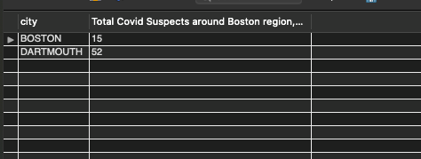

*R-Notebook Execution*

val6 <- dbFetch(dbSendQuery(conn,"SELECT distinct Place.city,   
count(distinct Assessment.TakerID) as TotalCovidSuspectsInBostonregionAgeGreaterThan50   
FROM Place  
INNER JOIN AppUser on Place.placeid=AppUser.addressid  
INNER JOIN Assessment on AppUser.UserID=Assessment.TakerID  
WHERE Assessment.CovidSuspected=1 AND AppUser.Birthdate<'1960-01-01'  
Group By Place.City HAVING count(distinct Assessment.TakerID)>10;"))  
  
val6

## city TotalCovidSuspectsInBostonregionAgeGreaterThan50  
## 1 BOSTON 15  
## 2 DARTMOUTH 52

**QUERY 7 - EXTRA QUERY** Exposure events and places and Massachusetts. This query backtracks the visit log of a COVID-19 positive persons and returns exact places where they visited and spent some time.

SELECT m.placename,streetarea, m.city,u.EventStartTime as ExposureStart, u.EventEndTime as ExposureEnd FROM visit v INNER JOIN AppUser a on v.VisitingUserID=a.UserID INNER JOIN Person p on a.userid=p.PersonID INNER JOIN PersonPhone s on p.PersonID=s.PersonID INNER JOIN Place m on v.VisitPlaceID=m.placeid INNER JOIN UserEvents u on v.VisitID=u.EventID INNER JOIN HealthReportCheck h on a.UserID=h.UserID WHERE h.TestResult=‘POSITIVE’ AND M.state=‘MA’ AND datediff(h.ReportDate, u.EventStartTime)<20 AND datediff(h.ReportDate, u.EventStartTime)>-20

10 row(s) returned

*RESULT SCREENSHOTS*:

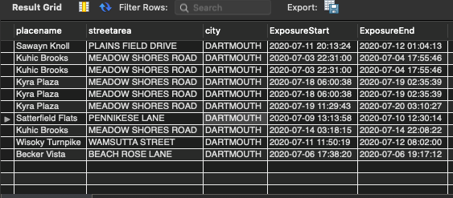

*R-Notebook Execution*

val7 <- dbFetch(dbSendQuery(conn,"SELECT m.placename,streetarea, m.city,u.EventStartTime as ExposureStart, u.EventEndTime as ExposureEnd FROM visit v  
INNER JOIN AppUser a on v.VisitingUserID=a.UserID  
INNER JOIN Person p on a.userid=p.PersonID  
INNER JOIN PersonPhone s on p.PersonID=s.PersonID  
INNER JOIN Place m on v.VisitPlaceID=m.placeid  
INNER JOIN UserEvents u on v.VisitID=u.EventID  
INNER JOIN HealthReportCheck h on a.UserID=h.UserID  
WHERE h.TestResult='POSITIVE'  
AND m.state='MA'  
AND datediff(h.ReportDate, u.EventStartTime)<20   
AND datediff(h.ReportDate, u.EventStartTime)>-20  
"))  
  
val7

## placename streetarea city ExposureStart  
## 1 Sawayn Knoll PLAINS FIELD DRIVE DARTMOUTH 2020-07-11 20:13:24  
## 2 Kuhic Brooks MEADOW SHORES ROAD DARTMOUTH 2020-07-03 22:31:00  
## 3 Kuhic Brooks MEADOW SHORES ROAD DARTMOUTH 2020-07-03 22:31:00  
## 4 Kyra Plaza MEADOW SHORES ROAD DARTMOUTH 2020-07-18 06:00:38  
## 5 Kyra Plaza MEADOW SHORES ROAD DARTMOUTH 2020-07-18 06:00:38  
## 6 Kyra Plaza MEADOW SHORES ROAD DARTMOUTH 2020-07-19 11:29:43  
## 7 Satterfield Flats PENNIKESE LANE DARTMOUTH 2020-07-09 13:13:58  
## 8 Kuhic Brooks MEADOW SHORES ROAD DARTMOUTH 2020-07-14 03:18:15  
## 9 Wisoky Turnpike WAMSUTTA STREET DARTMOUTH 2020-07-11 11:50:19  
## 10 Becker Vista BEACH ROSE LANE DARTMOUTH 2020-07-06 17:38:20  
## ExposureEnd  
## 1 2020-07-12 01:04:13  
## 2 2020-07-04 17:55:46  
## 3 2020-07-04 17:55:46  
## 4 2020-07-19 02:35:39  
## 5 2020-07-19 02:35:39  
## 6 2020-07-20 03:10:27  
## 7 2020-07-10 12:30:14  
## 8 2020-07-14 22:08:22  
## 9 2020-07-12 08:02:00  
## 10 2020-07-06 19:17:12

**11. Plotting MySQL-Integrated Graphs in R**

library(RMySQL)  
library(DBI)  
library(RColorBrewer)  
conn = dbConnect(MySQL(), userName="root", password="atcbtra123", dbname="ContactTracingDB", host="localhost",port = 3306)

## UserId TestResult HealthStatus  
## 1 1001 Positive sick  
## 2 1002 Unclear healthy  
## 3 1003 Unclear sick  
## 4 1004 Positive sick  
## 5 1005 Positive healthy  
## 6 1006 Negative healthy  
## 7 1007 Positive healthy  
## 8 1008 Positive sick  
## 9 1009 Unclear healthy  
## 10 1010 Positive healthy  
## 11 1011 Positive sick  
## 12 1012 Positive healthy  
## 13 1013 Negative healthy  
## 14 1014 Negative healthy  
## 15 1015 Negative healthy  
## 16 1016 Negative healthy  
## 17 1017 Unclear sick  
## 18 1018 Positive healthy  
## 19 1019 Negative healthy  
## 20 1020 Positive sick  
## 21 1021 Positive sick  
## 22 1022 Positive healthy  
## 23 1023 Negative healthy  
## 24 1024 Unclear sick  
## 25 1025 Negative healthy  
## 26 1026 Unclear healthy  
## 27 1027 Positive sick  
## 28 1028 Unclear healthy  
## 29 1029 Positive healthy  
## 30 1030 Negative healthy  
## 31 1031 Unclear sick  
## 32 1032 Unclear healthy  
## 33 1033 Positive healthy  
## 34 1034 Unclear sick  
## 35 1035 Positive sick  
## 36 1036 Negative sick  
## 37 1037 Positive healthy  
## 38 1038 Negative healthy  
## 39 1039 Negative healthy  
## 40 1040 Negative sick  
## 41 1041 Unclear sick  
## 42 1042 Negative sick  
## 43 1043 Positive healthy  
## 44 1044 Negative healthy  
## 45 1045 Negative healthy  
## 46 1046 Negative sick  
## 47 1047 Negative sick  
## 48 1048 Negative healthy  
## 49 1049 Unclear sick  
## 50 1050 Negative healthy  
## 51 1051 Negative healthy  
## 52 1052 Unclear sick  
## 53 1053 Unclear healthy  
## 54 1054 Positive sick  
## 55 1055 Negative sick  
## 56 1056 Negative sick  
## 57 1057 Positive healthy  
## 58 1058 Negative healthy  
## 59 1059 Negative healthy  
## 60 1060 Unclear sick  
## 61 1061 Unclear sick  
## 62 1062 Negative healthy  
## 63 1063 Negative healthy  
## 64 1064 Negative healthy  
## 65 1065 Negative healthy  
## 66 1066 Unclear healthy  
## 67 1067 Negative healthy  
## 68 1068 Positive sick  
## 69 1069 Unclear sick  
## 70 1070 Negative sick  
## 71 1071 Negative healthy  
## 72 1072 Negative sick  
## 73 1073 Unclear healthy  
## 74 1074 Unclear sick  
## 75 1075 Unclear healthy  
## 76 1076 Negative healthy  
## 77 1077 Unclear healthy  
## 78 1078 Negative sick  
## 79 1079 Unclear sick  
## 80 1080 Negative healthy  
## 81 1081 Unclear sick  
## 82 1082 Unclear sick  
## 83 1083 Negative healthy  
## 84 1084 Positive healthy  
## 85 1085 Negative sick  
## 86 1086 Negative healthy  
## 87 1087 Unclear sick  
## 88 1088 Negative healthy  
## 89 1089 Unclear healthy  
## 90 1090 Unclear healthy  
## 91 1091 Negative sick  
## 92 1092 Positive sick  
## 93 1093 Negative healthy  
## 94 1094 Negative sick  
## 95 1095 Negative sick  
## 96 1096 Unclear healthy  
## 97 1097 Unclear sick  
## 98 1098 Unclear sick  
## 99 1099 Unclear healthy  
## 100 1100 Negative sick  
## 101 1201 Unclear sick  
## 102 1202 Unclear sick  
## 103 1203 Negative healthy  
## 104 1204 Negative sick  
## 105 1205 Negative sick  
## 106 1206 Unclear healthy  
## 107 1207 Negative sick  
## 108 1208 Negative sick  
## 109 1209 Negative sick  
## 110 1210 Negative sick  
## 111 1211 Negative healthy  
## 112 1212 Negative healthy  
## 113 1213 Negative healthy  
## 114 1214 Negative sick  
## 115 1215 Negative sick  
## 116 1216 Negative healthy  
## 117 1217 Negative healthy  
## 118 1218 Negative healthy  
## 119 1219 Negative sick  
## 120 1220 Negative healthy  
## 121 1221 Unclear sick  
## 122 1222 Negative healthy  
## 123 1223 Unclear sick  
## 124 1224 Negative sick  
## 125 1225 Negative sick  
## 126 1226 Negative healthy  
## 127 1227 Negative healthy  
## 128 1228 Negative sick  
## 129 1229 Negative healthy  
## 130 1230 Negative healthy  
## 131 1231 Negative sick  
## 132 1232 Unclear sick  
## 133 1233 Negative healthy  
## 134 1234 Positive sick  
## 135 1235 Negative sick  
## 136 1236 Negative healthy  
## 137 1237 Negative healthy  
## 138 1238 Negative healthy  
## 139 1239 Unclear sick  
## 140 1240 Negative sick  
## 141 1241 Negative healthy  
## 142 1242 Negative healthy  
## 143 1243 Unclear sick  
## 144 1244 Negative healthy  
## 145 1245 Negative healthy  
## 146 1246 Negative sick  
## 147 1247 Negative healthy  
## 148 1248 Negative healthy  
## 149 1249 Negative healthy  
## 150 1250 Negative healthy  
## 151 1251 Negative healthy  
## 152 1252 Unclear sick  
## 153 1253 Negative healthy  
## 154 1254 Unclear sick  
## 155 1255 Negative sick  
## 156 1256 Negative healthy  
## 157 1257 Negative healthy  
## 158 1258 Negative healthy  
## 159 1259 Negative sick  
## 160 1260 Positive sick  
## 161 1261 Negative sick  
## 162 1262 Unclear sick  
## 163 1263 Positive sick  
## 164 1264 Unclear sick  
## 165 1265 Negative healthy  
## 166 1266 Negative sick  
## 167 1267 Negative healthy  
## 168 1268 Negative healthy  
## 169 1269 Negative healthy  
## 170 1270 Negative sick  
## 171 1271 Negative healthy  
## 172 1272 Negative healthy  
## 173 1273 Negative healthy  
## 174 1274 Negative sick  
## 175 1275 Negative sick  
## 176 1276 Positive sick  
## 177 1277 Unclear sick  
## 178 1278 Negative healthy  
## 179 1279 Unclear sick  
## 180 1280 Unclear sick  
## 181 1281 Negative healthy  
## 182 1282 Negative sick  
## 183 1283 Negative healthy  
## 184 1284 Negative sick  
## 185 1285 Negative healthy  
## 186 1286 Negative sick  
## 187 1287 Negative healthy  
## 188 1288 Negative sick  
## 189 1289 Unclear sick  
## 190 1290 Negative healthy  
## 191 1291 Unclear sick  
## 192 1292 Negative healthy  
## 193 1293 Negative healthy  
## 194 1294 Negative healthy  
## 195 1295 Negative sick  
## 196 1296 Negative healthy  
## 197 1297 Negative healthy  
## 198 1298 Unclear sick  
## 199 1299 Negative healthy  
## 200 1300 Negative healthy  
## 201 1251 Positive sick  
## 202 1252 Negative healthy  
## 203 1253 Negative healthy  
## 204 1254 Positive sick  
## 205 1255 Positive sick  
## 206 1256 Negative healthy  
## 207 1257 Unclear sick  
## 208 1258 Negative healthy  
## 209 1259 Negative healthy  
## 210 1260 Positive sick  
## 211 1261 Positive sick  
## 212 1262 Positive sick  
## 213 1263 Positive sick  
## 214 1264 Positive sick  
## 215 1265 Unclear sick  
## 216 1266 Negative healthy  
## 217 1267 Unclear sick  
## 218 1268 Positive sick  
## 219 1269 Negative healthy  
## 220 1270 Positive sick  
## 221 1271 Positive sick  
## 222 1272 Positive sick  
## 223 1273 Positive sick  
## 224 1274 Unclear sick  
## 225 1275 Unclear sick  
## 226 1276 Unclear sick  
## 227 1277 Positive sick  
## 228 1278 Positive sick  
## 229 1279 Negative healthy  
## 230 1280 Negative healthy  
## 231 1281 Negative healthy  
## 232 1282 Negative healthy  
## 233 1283 Positive sick  
## 234 1284 Unclear sick  
## 235 1285 Negative healthy  
## 236 1286 Positive sick  
## 237 1287 Negative healthy  
## 238 1288 Unclear sick  
## 239 1289 Positive sick  
## 240 1290 Negative healthy  
## 241 1291 Positive sick  
## 242 1292 Positive sick  
## 243 1293 Negative healthy  
## 244 1294 Negative healthy  
## 245 1295 Positive sick  
## 246 1296 Positive sick  
## 247 1297 Negative healthy  
## 248 1298 Unclear sick  
## 249 1299 Negative healthy  
## 250 1300 Positive sick  
## 251 1301 Negative healthy  
## 252 1302 Positive sick  
## 253 1303 Unclear sick  
## 254 1304 Negative healthy  
## 255 1305 Negative healthy  
## 256 1306 Positive sick  
## 257 1307 Negative healthy  
## 258 1308 Positive sick  
## 259 1309 Negative healthy  
## 260 1310 Positive sick  
## 261 1311 Negative healthy  
## 262 1312 Negative healthy  
## 263 1313 Negative healthy  
## 264 1314 Positive sick  
## 265 1315 Positive sick  
## 266 1316 Positive sick  
## 267 1317 Negative healthy  
## 268 1318 Positive sick  
## 269 1319 Negative healthy  
## 270 1320 Positive sick  
## 271 1321 Positive sick  
## 272 1322 Positive sick  
## 273 1323 Unclear sick  
## 274 1324 Unclear sick  
## 275 1325 Negative healthy  
## 276 1326 Negative healthy  
## 277 1327 Unclear sick  
## 278 1328 Positive sick  
## 279 1329 Positive sick  
## 280 1330 Positive sick  
## 281 1331 Negative healthy  
## 282 1332 Negative healthy  
## 283 1333 Negative healthy  
## 284 1334 Negative healthy  
## 285 1335 Positive sick  
## 286 1336 Positive sick  
## 287 1337 Positive sick  
## 288 1338 Positive sick  
## 289 1339 Positive sick  
## 290 1340 Unclear sick  
## 291 1341 Negative healthy  
## 292 1342 Negative healthy  
## 293 1343 Negative healthy  
## 294 1344 Negative healthy  
## 295 1345 Unclear sick  
## 296 1346 Positive sick  
## 297 1347 Unclear sick  
## 298 1348 Positive sick  
## 299 1349 Negative healthy  
## 300 1350 Negative healthy  
## 301 1351 Unclear sick  
## 302 1352 Negative sick  
## 303 1353 Unclear sick  
## 304 1354 Positive sick  
## 305 1355 Negative healthy  
## 306 1356 Negative sick  
## 307 1357 Negative healthy  
## 308 1358 Negative healthy  
## 309 1359 Negative healthy  
## 310 1360 Negative healthy  
## 311 1361 Negative healthy  
## 312 1362 Negative healthy  
## 313 1363 Negative healthy  
## 314 1364 Negative healthy  
## 315 1365 Negative healthy  
## 316 1366 Unclear sick  
## 317 1367 Negative sick  
## 318 1368 Negative healthy  
## 319 1369 Negative healthy  
## 320 1370 Unclear sick  
## 321 1371 Negative healthy  
## 322 1372 Negative healthy  
## 323 1373 Negative sick  
## 324 1374 Negative healthy  
## 325 1375 Negative sick  
## 326 1376 Negative healthy  
## 327 1377 Unclear sick  
## 328 1378 Negative healthy  
## 329 1379 Negative healthy  
## 330 1380 Unclear sick  
## 331 1381 Negative healthy  
## 332 1382 Negative sick  
## 333 1383 Negative healthy  
## 334 1384 Negative healthy  
## 335 1385 Negative healthy  
## 336 1386 Negative healthy  
## 337 1387 Positive sick  
## 338 1388 Negative healthy  
## 339 1389 Unclear sick  
## 340 1390 Unclear sick  
## 341 1391 Unclear sick  
## 342 1392 Negative sick  
## 343 1393 Negative healthy  
## 344 1394 Negative healthy  
## 345 1395 Negative sick  
## 346 1396 Positive sick  
## 347 1397 Unclear sick  
## 348 1398 Positive sick  
## 349 1399 Positive sick  
## 350 1400 Positive sick  
## 351 1401 Positive sick  
## 352 1402 Unclear sick  
## 353 1403 Negative healthy  
## 354 1404 Positive sick  
## 355 1405 Negative healthy  
## 356 1406 Positive sick  
## 357 1407 Negative healthy  
## 358 1408 Negative healthy  
## 359 1409 Negative healthy  
## 360 1410 Unclear sick  
## 361 1411 Negative healthy  
## 362 1412 Negative healthy  
## 363 1413 Negative healthy  
## 364 1414 Positive sick  
## 365 1415 Negative healthy  
## 366 1416 Negative healthy  
## 367 1417 Positive sick  
## 368 1418 Unclear sick  
## 369 1419 Unclear sick  
## 370 1420 Negative healthy  
## 371 1421 Negative healthy  
## 372 1422 Negative healthy  
## 373 1423 Unclear sick  
## 374 1424 Unclear sick  
## 375 1425 Negative healthy  
## 376 1426 Unclear sick  
## 377 1427 Negative healthy  
## 378 1428 Positive sick  
## 379 1429 Negative healthy  
## 380 1430 Positive sick  
## 381 1431 Negative healthy  
## 382 1432 Positive sick  
## 383 1433 Positive sick  
## 384 1434 Positive sick  
## 385 1435 Positive sick  
## 386 1436 Negative healthy  
## 387 1437 Negative healthy  
## 388 1438 Unclear sick  
## 389 1439 Positive sick  
## 390 1440 Negative healthy  
## 391 1441 Positive sick  
## 392 1442 Negative healthy  
## 393 1443 Positive sick  
## 394 1444 Negative healthy  
## 395 1445 Positive sick  
## 396 1446 Positive sick  
## 397 1447 Positive sick  
## 398 1448 Unclear sick  
## 399 1449 Unclear sick  
## 400 1450 Negative healthy  
## 401 1400 Positive sick  
## 402 1401 Positive sick  
## 403 1402 Positive sick  
## 404 1403 Positive sick  
## 405 1404 Unclear sick  
## 406 1405 Negative healthy  
## 407 1406 Unclear sick  
## 408 1407 Negative healthy  
## 409 1408 Positive sick  
## 410 1409 Negative healthy  
## 411 1410 Negative healthy  
## 412 1411 Positive sick  
## 413 1412 Negative healthy  
## 414 1413 Negative healthy  
## 415 1414 Positive sick  
## 416 1415 Positive sick  
## 417 1416 Negative healthy  
## 418 1417 Unclear sick  
## 419 1418 Negative healthy  
## 420 1419 Unclear sick  
## 421 1420 Unclear sick  
## 422 1421 Unclear sick  
## 423 1422 Negative healthy  
## 424 1423 Positive sick  
## 425 1424 Positive sick  
## 426 1425 Negative healthy  
## 427 1426 Negative healthy  
## 428 1427 Unclear sick  
## 429 1428 Positive sick  
## 430 1429 Positive sick  
## 431 1430 Negative sick  
## 432 1431 Unclear sick  
## 433 1432 Positive sick  
## 434 1433 Positive healthy  
## 435 1434 Positive sick  
## 436 1435 Negative sick  
## 437 1436 Negative sick  
## 438 1437 Negative healthy  
## 439 1438 Unclear sick  
## 440 1439 Negative healthy  
## 441 1440 Negative sick  
## 442 1441 Positive sick  
## 443 1442 Negative sick  
## 444 1443 Negative healthy  
## 445 1444 Negative sick  
## 446 1445 Negative sick  
## 447 1446 Unclear sick  
## 448 1447 Unclear sick  
## 449 1448 Positive sick  
## 450 1449 Negative healthy  
## 451 1450 Negative healthy  
## 452 1451 Unclear sick  
## 453 1452 Negative healthy  
## 454 1453 Positive sick  
## 455 1454 Negative healthy  
## 456 1455 Negative healthy  
## 457 1456 Positive sick  
## 458 1457 Positive sick  
## 459 1458 Positive sick  
## 460 1459 Negative healthy  
## 461 1460 Positive sick  
## 462 1461 Unclear sick  
## 463 1462 Negative healthy  
## 464 1463 Positive healthy  
## 465 1464 Unclear sick  
## 466 1465 Negative healthy  
## 467 1466 Negative healthy  
## 468 1467 Positive sick  
## 469 1468 Positive sick  
## 470 1469 Positive sick  
## 471 1470 Unclear sick  
## 472 1471 Positive sick  
## 473 1472 Negative healthy  
## 474 1473 Positive sick  
## 475 1474 Negative healthy  
## 476 1475 Positive sick  
## 477 1476 Positive sick  
## 478 1477 Negative healthy  
## 479 1478 Unclear sick  
## 480 1479 Positive sick  
## 481 1480 Unclear sick  
## 482 1481 Negative healthy  
## 483 1482 Positive sick  
## 484 1483 Negative healthy  
## 485 1484 Unclear sick  
## 486 1485 Positive sick  
## 487 1486 Negative healthy  
## 488 1487 Negative healthy  
## 489 1488 Unclear healthy  
## 490 1489 Positive sick  
## 491 1490 Positive sick  
## 492 1491 Positive sick  
## 493 1492 Unclear sick  
## 494 1493 Unclear healthy  
## 495 1494 Negative healthy  
## 496 1495 Negative healthy  
## 497 1496 Positive sick  
## 498 1497 Positive sick  
## 499 1498 Unclear healthy  
## 500 1499 Positive sick  
## CASE \n WHEN TestResult ="Positive" THEN "The user is COVID-19 Positive."\n WHEN TestResult = "Unclear" AND HealthStatus = "Sick" THEN "The user may be COVID-19 Positive"\n WHEN TestResult = "Negative" AND HealthStatus = "Sick" THEN "The user is COV  
## 1 The user is COVID-19 Positive.  
## 2 Patient Status Unknown  
## 3 The user may be COVID-19 Positive  
## 4 The user is COVID-19 Positive.  
## 5 The user is COVID-19 Positive.  
## 6 The user is COVID-19 Free And Healthy  
## 7 The user is COVID-19 Positive.  
## 8 The user is COVID-19 Positive.  
## 9 Patient Status Unknown  
## 10 The user is COVID-19 Positive.  
## 11 The user is COVID-19 Positive.  
## 12 The user is COVID-19 Positive.  
## 13 The user is COVID-19 Free And Healthy  
## 14 The user is COVID-19 Free And Healthy  
## 15 The user is COVID-19 Free And Healthy  
## 16 The user is COVID-19 Free And Healthy  
## 17 The user may be COVID-19 Positive  
## 18 The user is COVID-19 Positive.  
## 19 The user is COVID-19 Free And Healthy  
## 20 The user is COVID-19 Positive.  
## 21 The user is COVID-19 Positive.  
## 22 The user is COVID-19 Positive.  
## 23 The user is COVID-19 Free And Healthy  
## 24 The user may be COVID-19 Positive  
## 25 The user is COVID-19 Free And Healthy  
## 26 Patient Status Unknown  
## 27 The user is COVID-19 Positive.  
## 28 Patient Status Unknown  
## 29 The user is COVID-19 Positive.  
## 30 The user is COVID-19 Free And Healthy  
## 31 The user may be COVID-19 Positive  
## 32 Patient Status Unknown  
## 33 The user is COVID-19 Positive.  
## 34 The user may be COVID-19 Positive  
## 35 The user is COVID-19 Positive.  
## 36 The user is COVID-19 Negative but suffers from some ailment  
## 37 The user is COVID-19 Positive.  
## 38 The user is COVID-19 Free And Healthy  
## 39 The user is COVID-19 Free And Healthy  
## 40 The user is COVID-19 Negative but suffers from some ailment  
## 41 The user may be COVID-19 Positive  
## 42 The user is COVID-19 Negative but suffers from some ailment  
## 43 The user is COVID-19 Positive.  
## 44 The user is COVID-19 Free And Healthy  
## 45 The user is COVID-19 Free And Healthy  
## 46 The user is COVID-19 Negative but suffers from some ailment  
## 47 The user is COVID-19 Negative but suffers from some ailment  
## 48 The user is COVID-19 Free And Healthy  
## 49 The user may be COVID-19 Positive  
## 50 The user is COVID-19 Free And Healthy  
## 51 The user is COVID-19 Free And Healthy  
## 52 The user may be COVID-19 Positive  
## 53 Patient Status Unknown  
## 54 The user is COVID-19 Positive.  
## 55 The user is COVID-19 Negative but suffers from some ailment  
## 56 The user is COVID-19 Negative but suffers from some ailment  
## 57 The user is COVID-19 Positive.  
## 58 The user is COVID-19 Free And Healthy  
## 59 The user is COVID-19 Free And Healthy  
## 60 The user may be COVID-19 Positive  
## 61 The user may be COVID-19 Positive  
## 62 The user is COVID-19 Free And Healthy  
## 63 The user is COVID-19 Free And Healthy  
## 64 The user is COVID-19 Free And Healthy  
## 65 The user is COVID-19 Free And Healthy  
## 66 Patient Status Unknown  
## 67 The user is COVID-19 Free And Healthy  
## 68 The user is COVID-19 Positive.  
## 69 The user may be COVID-19 Positive  
## 70 The user is COVID-19 Negative but suffers from some ailment  
## 71 The user is COVID-19 Free And Healthy  
## 72 The user is COVID-19 Negative but suffers from some ailment  
## 73 Patient Status Unknown  
## 74 The user may be COVID-19 Positive  
## 75 Patient Status Unknown  
## 76 The user is COVID-19 Free And Healthy  
## 77 Patient Status Unknown  
## 78 The user is COVID-19 Negative but suffers from some ailment  
## 79 The user may be COVID-19 Positive  
## 80 The user is COVID-19 Free And Healthy  
## 81 The user may be COVID-19 Positive  
## 82 The user may be COVID-19 Positive  
## 83 The user is COVID-19 Free And Healthy  
## 84 The user is COVID-19 Positive.  
## 85 The user is COVID-19 Negative but suffers from some ailment  
## 86 The user is COVID-19 Free And Healthy  
## 87 The user may be COVID-19 Positive  
## 88 The user is COVID-19 Free And Healthy  
## 89 Patient Status Unknown  
## 90 Patient Status Unknown  
## 91 The user is COVID-19 Negative but suffers from some ailment  
## 92 The user is COVID-19 Positive.  
## 93 The user is COVID-19 Free And Healthy  
## 94 The user is COVID-19 Negative but suffers from some ailment  
## 95 The user is COVID-19 Negative but suffers from some ailment  
## 96 Patient Status Unknown  
## 97 The user may be COVID-19 Positive  
## 98 The user may be COVID-19 Positive  
## 99 Patient Status Unknown  
## 100 The user is COVID-19 Negative but suffers from some ailment  
## 101 The user may be COVID-19 Positive  
## 102 The user may be COVID-19 Positive  
## 103 The user is COVID-19 Free And Healthy  
## 104 The user is COVID-19 Negative but suffers from some ailment  
## 105 The user is COVID-19 Negative but suffers from some ailment  
## 106 Patient Status Unknown  
## 107 The user is COVID-19 Negative but suffers from some ailment  
## 108 The user is COVID-19 Negative but suffers from some ailment  
## 109 The user is COVID-19 Negative but suffers from some ailment  
## 110 The user is COVID-19 Negative but suffers from some ailment  
## 111 The user is COVID-19 Free And Healthy  
## 112 The user is COVID-19 Free And Healthy  
## 113 The user is COVID-19 Free And Healthy  
## 114 The user is COVID-19 Negative but suffers from some ailment  
## 115 The user is COVID-19 Negative but suffers from some ailment  
## 116 The user is COVID-19 Free And Healthy  
## 117 The user is COVID-19 Free And Healthy  
## 118 The user is COVID-19 Free And Healthy  
## 119 The user is COVID-19 Negative but suffers from some ailment  
## 120 The user is COVID-19 Free And Healthy  
## 121 The user may be COVID-19 Positive  
## 122 The user is COVID-19 Free And Healthy  
## 123 The user may be COVID-19 Positive  
## 124 The user is COVID-19 Negative but suffers from some ailment  
## 125 The user is COVID-19 Negative but suffers from some ailment  
## 126 The user is COVID-19 Free And Healthy  
## 127 The user is COVID-19 Free And Healthy  
## 128 The user is COVID-19 Negative but suffers from some ailment  
## 129 The user is COVID-19 Free And Healthy  
## 130 The user is COVID-19 Free And Healthy  
## 131 The user is COVID-19 Negative but suffers from some ailment  
## 132 The user may be COVID-19 Positive  
## 133 The user is COVID-19 Free And Healthy  
## 134 The user is COVID-19 Positive.  
## 135 The user is COVID-19 Negative but suffers from some ailment  
## 136 The user is COVID-19 Free And Healthy  
## 137 The user is COVID-19 Free And Healthy  
## 138 The user is COVID-19 Free And Healthy  
## 139 The user may be COVID-19 Positive  
## 140 The user is COVID-19 Negative but suffers from some ailment  
## 141 The user is COVID-19 Free And Healthy  
## 142 The user is COVID-19 Free And Healthy  
## 143 The user may be COVID-19 Positive  
## 144 The user is COVID-19 Free And Healthy  
## 145 The user is COVID-19 Free And Healthy  
## 146 The user is COVID-19 Negative but suffers from some ailment  
## 147 The user is COVID-19 Free And Healthy  
## 148 The user is COVID-19 Free And Healthy  
## 149 The user is COVID-19 Free And Healthy  
## 150 The user is COVID-19 Free And Healthy  
## 151 The user is COVID-19 Free And Healthy  
## 152 The user may be COVID-19 Positive  
## 153 The user is COVID-19 Free And Healthy  
## 154 The user may be COVID-19 Positive  
## 155 The user is COVID-19 Negative but suffers from some ailment  
## 156 The user is COVID-19 Free And Healthy  
## 157 The user is COVID-19 Free And Healthy  
## 158 The user is COVID-19 Free And Healthy  
## 159 The user is COVID-19 Negative but suffers from some ailment  
## 160 The user is COVID-19 Positive.  
## 161 The user is COVID-19 Negative but suffers from some ailment  
## 162 The user may be COVID-19 Positive  
## 163 The user is COVID-19 Positive.  
## 164 The user may be COVID-19 Positive  
## 165 The user is COVID-19 Free And Healthy  
## 166 The user is COVID-19 Negative but suffers from some ailment  
## 167 The user is COVID-19 Free And Healthy  
## 168 The user is COVID-19 Free And Healthy  
## 169 The user is COVID-19 Free And Healthy  
## 170 The user is COVID-19 Negative but suffers from some ailment  
## 171 The user is COVID-19 Free And Healthy  
## 172 The user is COVID-19 Free And Healthy  
## 173 The user is COVID-19 Free And Healthy  
## 174 The user is COVID-19 Negative but suffers from some ailment  
## 175 The user is COVID-19 Negative but suffers from some ailment  
## 176 The user is COVID-19 Positive.  
## 177 The user may be COVID-19 Positive  
## 178 The user is COVID-19 Free And Healthy  
## 179 The user may be COVID-19 Positive  
## 180 The user may be COVID-19 Positive  
## 181 The user is COVID-19 Free And Healthy  
## 182 The user is COVID-19 Negative but suffers from some ailment  
## 183 The user is COVID-19 Free And Healthy  
## 184 The user is COVID-19 Negative but suffers from some ailment  
## 185 The user is COVID-19 Free And Healthy  
## 186 The user is COVID-19 Negative but suffers from some ailment  
## 187 The user is COVID-19 Free And Healthy  
## 188 The user is COVID-19 Negative but suffers from some ailment  
## 189 The user may be COVID-19 Positive  
## 190 The user is COVID-19 Free And Healthy  
## 191 The user may be COVID-19 Positive  
## 192 The user is COVID-19 Free And Healthy  
## 193 The user is COVID-19 Free And Healthy  
## 194 The user is COVID-19 Free And Healthy  
## 195 The user is COVID-19 Negative but suffers from some ailment  
## 196 The user is COVID-19 Free And Healthy  
## 197 The user is COVID-19 Free And Healthy  
## 198 The user may be COVID-19 Positive  
## 199 The user is COVID-19 Free And Healthy  
## 200 The user is COVID-19 Free And Healthy  
## 201 The user is COVID-19 Positive.  
## 202 The user is COVID-19 Free And Healthy  
## 203 The user is COVID-19 Free And Healthy  
## 204 The user is COVID-19 Positive.  
## 205 The user is COVID-19 Positive.  
## 206 The user is COVID-19 Free And Healthy  
## 207 The user may be COVID-19 Positive  
## 208 The user is COVID-19 Free And Healthy  
## 209 The user is COVID-19 Free And Healthy  
## 210 The user is COVID-19 Positive.  
## 211 The user is COVID-19 Positive.  
## 212 The user is COVID-19 Positive.  
## 213 The user is COVID-19 Positive.  
## 214 The user is COVID-19 Positive.  
## 215 The user may be COVID-19 Positive  
## 216 The user is COVID-19 Free And Healthy  
## 217 The user may be COVID-19 Positive  
## 218 The user is COVID-19 Positive.  
## 219 The user is COVID-19 Free And Healthy  
## 220 The user is COVID-19 Positive.  
## 221 The user is COVID-19 Positive.  
## 222 The user is COVID-19 Positive.  
## 223 The user is COVID-19 Positive.  
## 224 The user may be COVID-19 Positive  
## 225 The user may be COVID-19 Positive  
## 226 The user may be COVID-19 Positive  
## 227 The user is COVID-19 Positive.  
## 228 The user is COVID-19 Positive.  
## 229 The user is COVID-19 Free And Healthy  
## 230 The user is COVID-19 Free And Healthy  
## 231 The user is COVID-19 Free And Healthy  
## 232 The user is COVID-19 Free And Healthy  
## 233 The user is COVID-19 Positive.  
## 234 The user may be COVID-19 Positive  
## 235 The user is COVID-19 Free And Healthy  
## 236 The user is COVID-19 Positive.  
## 237 The user is COVID-19 Free And Healthy  
## 238 The user may be COVID-19 Positive  
## 239 The user is COVID-19 Positive.  
## 240 The user is COVID-19 Free And Healthy  
## 241 The user is COVID-19 Positive.  
## 242 The user is COVID-19 Positive.  
## 243 The user is COVID-19 Free And Healthy  
## 244 The user is COVID-19 Free And Healthy  
## 245 The user is COVID-19 Positive.  
## 246 The user is COVID-19 Positive.  
## 247 The user is COVID-19 Free And Healthy  
## 248 The user may be COVID-19 Positive  
## 249 The user is COVID-19 Free And Healthy  
## 250 The user is COVID-19 Positive.  
## 251 The user is COVID-19 Free And Healthy  
## 252 The user is COVID-19 Positive.  
## 253 The user may be COVID-19 Positive  
## 254 The user is COVID-19 Free And Healthy  
## 255 The user is COVID-19 Free And Healthy  
## 256 The user is COVID-19 Positive.  
## 257 The user is COVID-19 Free And Healthy  
## 258 The user is COVID-19 Positive.  
## 259 The user is COVID-19 Free And Healthy  
## 260 The user is COVID-19 Positive.  
## 261 The user is COVID-19 Free And Healthy  
## 262 The user is COVID-19 Free And Healthy  
## 263 The user is COVID-19 Free And Healthy  
## 264 The user is COVID-19 Positive.  
## 265 The user is COVID-19 Positive.  
## 266 The user is COVID-19 Positive.  
## 267 The user is COVID-19 Free And Healthy  
## 268 The user is COVID-19 Positive.  
## 269 The user is COVID-19 Free And Healthy  
## 270 The user is COVID-19 Positive.  
## 271 The user is COVID-19 Positive.  
## 272 The user is COVID-19 Positive.  
## 273 The user may be COVID-19 Positive  
## 274 The user may be COVID-19 Positive  
## 275 The user is COVID-19 Free And Healthy  
## 276 The user is COVID-19 Free And Healthy  
## 277 The user may be COVID-19 Positive  
## 278 The user is COVID-19 Positive.  
## 279 The user is COVID-19 Positive.  
## 280 The user is COVID-19 Positive.  
## 281 The user is COVID-19 Free And Healthy  
## 282 The user is COVID-19 Free And Healthy  
## 283 The user is COVID-19 Free And Healthy  
## 284 The user is COVID-19 Free And Healthy  
## 285 The user is COVID-19 Positive.  
## 286 The user is COVID-19 Positive.  
## 287 The user is COVID-19 Positive.  
## 288 The user is COVID-19 Positive.  
## 289 The user is COVID-19 Positive.  
## 290 The user may be COVID-19 Positive  
## 291 The user is COVID-19 Free And Healthy  
## 292 The user is COVID-19 Free And Healthy  
## 293 The user is COVID-19 Free And Healthy  
## 294 The user is COVID-19 Free And Healthy  
## 295 The user may be COVID-19 Positive  
## 296 The user is COVID-19 Positive.  
## 297 The user may be COVID-19 Positive  
## 298 The user is COVID-19 Positive.  
## 299 The user is COVID-19 Free And Healthy  
## 300 The user is COVID-19 Free And Healthy  
## 301 The user may be COVID-19 Positive  
## 302 The user is COVID-19 Negative but suffers from some ailment  
## 303 The user may be COVID-19 Positive  
## 304 The user is COVID-19 Positive.  
## 305 The user is COVID-19 Free And Healthy  
## 306 The user is COVID-19 Negative but suffers from some ailment  
## 307 The user is COVID-19 Free And Healthy  
## 308 The user is COVID-19 Free And Healthy  
## 309 The user is COVID-19 Free And Healthy  
## 310 The user is COVID-19 Free And Healthy  
## 311 The user is COVID-19 Free And Healthy  
## 312 The user is COVID-19 Free And Healthy  
## 313 The user is COVID-19 Free And Healthy  
## 314 The user is COVID-19 Free And Healthy  
## 315 The user is COVID-19 Free And Healthy  
## 316 The user may be COVID-19 Positive  
## 317 The user is COVID-19 Negative but suffers from some ailment  
## 318 The user is COVID-19 Free And Healthy  
## 319 The user is COVID-19 Free And Healthy  
## 320 The user may be COVID-19 Positive  
## 321 The user is COVID-19 Free And Healthy  
## 322 The user is COVID-19 Free And Healthy  
## 323 The user is COVID-19 Negative but suffers from some ailment  
## 324 The user is COVID-19 Free And Healthy  
## 325 The user is COVID-19 Negative but suffers from some ailment  
## 326 The user is COVID-19 Free And Healthy  
## 327 The user may be COVID-19 Positive  
## 328 The user is COVID-19 Free And Healthy  
## 329 The user is COVID-19 Free And Healthy  
## 330 The user may be COVID-19 Positive  
## 331 The user is COVID-19 Free And Healthy  
## 332 The user is COVID-19 Negative but suffers from some ailment  
## 333 The user is COVID-19 Free And Healthy  
## 334 The user is COVID-19 Free And Healthy  
## 335 The user is COVID-19 Free And Healthy  
## 336 The user is COVID-19 Free And Healthy  
## 337 The user is COVID-19 Positive.  
## 338 The user is COVID-19 Free And Healthy  
## 339 The user may be COVID-19 Positive  
## 340 The user may be COVID-19 Positive  
## 341 The user may be COVID-19 Positive  
## 342 The user is COVID-19 Negative but suffers from some ailment  
## 343 The user is COVID-19 Free And Healthy  
## 344 The user is COVID-19 Free And Healthy  
## 345 The user is COVID-19 Negative but suffers from some ailment  
## 346 The user is COVID-19 Positive.  
## 347 The user may be COVID-19 Positive  
## 348 The user is COVID-19 Positive.  
## 349 The user is COVID-19 Positive.  
## 350 The user is COVID-19 Positive.  
## 351 The user is COVID-19 Positive.  
## 352 The user may be COVID-19 Positive  
## 353 The user is COVID-19 Free And Healthy  
## 354 The user is COVID-19 Positive.  
## 355 The user is COVID-19 Free And Healthy  
## 356 The user is COVID-19 Positive.  
## 357 The user is COVID-19 Free And Healthy  
## 358 The user is COVID-19 Free And Healthy  
## 359 The user is COVID-19 Free And Healthy  
## 360 The user may be COVID-19 Positive  
## 361 The user is COVID-19 Free And Healthy  
## 362 The user is COVID-19 Free And Healthy  
## 363 The user is COVID-19 Free And Healthy  
## 364 The user is COVID-19 Positive.  
## 365 The user is COVID-19 Free And Healthy  
## 366 The user is COVID-19 Free And Healthy  
## 367 The user is COVID-19 Positive.  
## 368 The user may be COVID-19 Positive  
## 369 The user may be COVID-19 Positive  
## 370 The user is COVID-19 Free And Healthy  
## 371 The user is COVID-19 Free And Healthy  
## 372 The user is COVID-19 Free And Healthy  
## 373 The user may be COVID-19 Positive  
## 374 The user may be COVID-19 Positive  
## 375 The user is COVID-19 Free And Healthy  
## 376 The user may be COVID-19 Positive  
## 377 The user is COVID-19 Free And Healthy  
## 378 The user is COVID-19 Positive.  
## 379 The user is COVID-19 Free And Healthy  
## 380 The user is COVID-19 Positive.  
## 381 The user is COVID-19 Free And Healthy  
## 382 The user is COVID-19 Positive.  
## 383 The user is COVID-19 Positive.  
## 384 The user is COVID-19 Positive.  
## 385 The user is COVID-19 Positive.  
## 386 The user is COVID-19 Free And Healthy  
## 387 The user is COVID-19 Free And Healthy  
## 388 The user may be COVID-19 Positive  
## 389 The user is COVID-19 Positive.  
## 390 The user is COVID-19 Free And Healthy  
## 391 The user is COVID-19 Positive.  
## 392 The user is COVID-19 Free And Healthy  
## 393 The user is COVID-19 Positive.  
## 394 The user is COVID-19 Free And Healthy  
## 395 The user is COVID-19 Positive.  
## 396 The user is COVID-19 Positive.  
## 397 The user is COVID-19 Positive.  
## 398 The user may be COVID-19 Positive  
## 399 The user may be COVID-19 Positive  
## 400 The user is COVID-19 Free And Healthy  
## 401 The user is COVID-19 Positive.  
## 402 The user is COVID-19 Positive.  
## 403 The user is COVID-19 Positive.  
## 404 The user is COVID-19 Positive.  
## 405 The user may be COVID-19 Positive  
## 406 The user is COVID-19 Free And Healthy  
## 407 The user may be COVID-19 Positive  
## 408 The user is COVID-19 Free And Healthy  
## 409 The user is COVID-19 Positive.  
## 410 The user is COVID-19 Free And Healthy  
## 411 The user is COVID-19 Free And Healthy  
## 412 The user is COVID-19 Positive.  
## 413 The user is COVID-19 Free And Healthy  
## 414 The user is COVID-19 Free And Healthy  
## 415 The user is COVID-19 Positive.  
## 416 The user is COVID-19 Positive.  
## 417 The user is COVID-19 Free And Healthy  
## 418 The user may be COVID-19 Positive  
## 419 The user is COVID-19 Free And Healthy  
## 420 The user may be COVID-19 Positive  
## 421 The user may be COVID-19 Positive  
## 422 The user may be COVID-19 Positive  
## 423 The user is COVID-19 Free And Healthy  
## 424 The user is COVID-19 Positive.  
## 425 The user is COVID-19 Positive.  
## 426 The user is COVID-19 Free And Healthy  
## 427 The user is COVID-19 Free And Healthy  
## 428 The user may be COVID-19 Positive  
## 429 The user is COVID-19 Positive.  
## 430 The user is COVID-19 Positive.  
## 431 The user is COVID-19 Negative but suffers from some ailment  
## 432 The user may be COVID-19 Positive  
## 433 The user is COVID-19 Positive.  
## 434 The user is COVID-19 Positive.  
## 435 The user is COVID-19 Positive.  
## 436 The user is COVID-19 Negative but suffers from some ailment  
## 437 The user is COVID-19 Negative but suffers from some ailment  
## 438 The user is COVID-19 Free And Healthy  
## 439 The user may be COVID-19 Positive  
## 440 The user is COVID-19 Free And Healthy  
## 441 The user is COVID-19 Negative but suffers from some ailment  
## 442 The user is COVID-19 Positive.  
## 443 The user is COVID-19 Negative but suffers from some ailment  
## 444 The user is COVID-19 Free And Healthy  
## 445 The user is COVID-19 Negative but suffers from some ailment  
## 446 The user is COVID-19 Negative but suffers from some ailment  
## 447 The user may be COVID-19 Positive  
## 448 The user may be COVID-19 Positive  
## 449 The user is COVID-19 Positive.  
## 450 The user is COVID-19 Free And Healthy  
## 451 The user is COVID-19 Free And Healthy  
## 452 The user may be COVID-19 Positive  
## 453 The user is COVID-19 Free And Healthy  
## 454 The user is COVID-19 Positive.  
## 455 The user is COVID-19 Free And Healthy  
## 456 The user is COVID-19 Free And Healthy  
## 457 The user is COVID-19 Positive.  
## 458 The user is COVID-19 Positive.  
## 459 The user is COVID-19 Positive.  
## 460 The user is COVID-19 Free And Healthy  
## 461 The user is COVID-19 Positive.  
## 462 The user may be COVID-19 Positive  
## 463 The user is COVID-19 Free And Healthy  
## 464 The user is COVID-19 Positive.  
## 465 The user may be COVID-19 Positive  
## 466 The user is COVID-19 Free And Healthy  
## 467 The user is COVID-19 Free And Healthy  
## 468 The user is COVID-19 Positive.  
## 469 The user is COVID-19 Positive.  
## 470 The user is COVID-19 Positive.  
## 471 The user may be COVID-19 Positive  
## 472 The user is COVID-19 Positive.  
## 473 The user is COVID-19 Free And Healthy  
## 474 The user is COVID-19 Positive.  
## 475 The user is COVID-19 Free And Healthy  
## 476 The user is COVID-19 Positive.  
## 477 The user is COVID-19 Positive.  
## 478 The user is COVID-19 Free And Healthy  
## 479 The user may be COVID-19 Positive  
## 480 The user is COVID-19 Positive.  
## 481 The user may be COVID-19 Positive  
## 482 The user is COVID-19 Free And Healthy  
## 483 The user is COVID-19 Positive.  
## 484 The user is COVID-19 Free And Healthy  
## 485 The user may be COVID-19 Positive  
## 486 The user is COVID-19 Positive.  
## 487 The user is COVID-19 Free And Healthy  
## 488 The user is COVID-19 Free And Healthy  
## 489 Patient Status Unknown  
## 490 The user is COVID-19 Positive.  
## 491 The user is COVID-19 Positive.  
## 492 The user is COVID-19 Positive.  
## 493 The user may be COVID-19 Positive  
## 494 Patient Status Unknown  
## 495 The user is COVID-19 Free And Healthy  
## 496 The user is COVID-19 Free And Healthy  
## 497 The user is COVID-19 Positive.  
## 498 The user is COVID-19 Positive.  
## 499 Patient Status Unknown  
## 500 The user is COVID-19 Positive.

# A plot of total tests done and their results  
  
library(ggplot2)  
library(ggpubr)

## Warning: package 'ggpubr' was built under R version 4.0.2

theme_set(theme_pubr())  
ggplot(val12,aes(TestResult)) +  
 geom_bar(fill = "#0073C2FF") +  
 theme_pubclean()

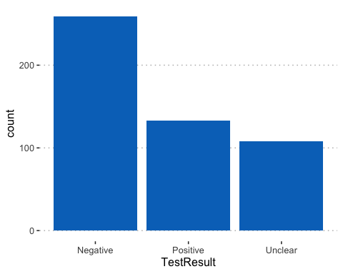 **GPS Plot in R Studio** # A plot of COVID-19 positive cases in Boston and Dartmouth location = dbFetch(dbSendQuery(conn,“SELECT p.latitude as Longitude,p.longitude as Latitude FROM place p,AppUser,HealthReportCheck WHERE p.placeid=AppUser.AddressID AND AppUser.UserID=HealthReportCheck.UserID AND HealthReportCheck.TestResult=‘POSITIVE’;”)) location library(leaflet) leaflet() %>% addTiles() %>% addMarkers(as.vector(location[1:134,“Latitude”]),as.vector(location[1:134,“Longitude”]), icon = list(iconUrl = ‘<https://amanbatra.in/static/img3/covid.png>’, iconSize = c(25, 25) )) 